UNITED STATES
SECURITIES AND EXCHANGE COMMISSION
Washington, D.C. 20549

FORM 8-K

CURRENT REPORT
Pursuant to Section 13 or 15(d) of the
Securities Exchange Act of 1934
Date of Report (Date of earliest event reported): May 28, 2024

Robinhood Markets, Inc.
(Exact name of registrant as specified in its charter)
Delaware |  |  |  |  |  | 001-40691 |  |  |  |  |  | 46-4364776
(State or other jurisdiction  of incorporation) |  |  |  |  |  | (Commission  File Number) |  |  |  |  |  | (IRS Employer  Identification No.)
85 Willow Road
Menlo Park, CA 94025
(Address of principal executive offices) (Zip Code)

(844) 428-5411
(Registrant’s telephone number, including area code)

not applicable
(Former name or former address, if changed since last report)

Check the appropriate box below if the Form 8-K filing is intended to simultaneously satisfy the filing obligation of the registrant under any of the following provisions:
☐ |  |  |  |  |  | Written communications pursuant to Rule 425 under the Securities Act (17 CFR 230.425)
☐ |  |  |  |  |  | Soliciting material pursuant to Rule 14a-12 under the Exchange Act (17 CFR 240.14a-12)
☐ |  |  |  |  |  | Pre-commencement communications pursuant to Rule 14d-2(b) under the Exchange Act (17 CFR 240.14d-2(b))
☐ |  |  |  |  |  | Pre-commencement communications pursuant to Rule 13e-4(c) under the Exchange Act (17 CFR 240.13e-4(c))
Securities registered pursuant to Section 12(b) of the Act:
Title of each class |  |  | Trading Symbol(s) |  |  | Name of each exchange on which registered
Class A Common Stock, $0.0001 par value per share |  |  | HOOD |  |  | The Nasdaq Stock Market LLC
Indicate by check mark whether the registrant is an emerging growth company as defined in Rule 405 of the Securities Act of 1933 (§230.405 of this chapter) or Rule 12b-2 of the Securities Exchange Act of 1934 (§240.12b-2 of this chapter).
Emerging growth company |  |  |  |  |  | ☐
If an emerging growth company, indicate by check mark if the registrant has elected not to use the extended transition period for complying with any new or revised financial accounting standards provided pursuant to Section 13(a) of the Exchange Act. |  |  |  |  |  | ☐

Item 7.01 Regulation FD Disclosure.

On May 28, 2024, Robinhood Markets, Inc. (the “Company” or "Robinhood") announced that its board of directors approved a share repurchase program (the “Repurchase Program”) authorizing the Company to repurchase up to $1 billion of its outstanding Class A common stock. While the Repurchase Program does not have an expiration date, the Company’s management currently expects to conduct the Repurchase Program over a period of two to three years, beginning in the third quarter of 2024.

The timing and amount of repurchase transactions will be determined by the Company from time to time at its discretion based on its evaluation of market conditions, share price, and other factors, and repurchase transactions may be made using a variety of methods, such as open market share repurchases, including the use of trading plans intended to qualify under Rule 10b5-1 under the Securities Exchange Act of 1934, as amended (the “Exchange Act”), or other financial arrangements or transactions. The Repurchase Program does not obligate the Company to acquire any particular amount of Class A common stock, and the Repurchase Program may be suspended or discontinued at any time at the Company’s discretion.

A copy of a blog post announcing the approval of the Repurchase Program is furnished as Exhibit 99.1 to this report and is incorporated herein by reference into this Item 7.01.

Robinhood uses the “Overview” tab of its Investor Relations website (accessible at investors.robinhood.com/overview) and its Newsroom (accessible at newsroom.aboutrobinhood.com), as means of disclosing information to the public in a broad, non-exclusionary manner for purposes of the U.S. Securities and Exchange Commission’s (“SEC”) Regulation Fair Disclosure (Reg. FD). Investors should routinely monitor those web pages, in addition to Robinhood’s press releases, SEC filings, and public conference calls and webcasts, as information posted on them could be deemed to be material information.

The information furnished with Item 7.01, including Exhibit 99.1, shall not be deemed “filed” for purposes of Section 18 of the Exchange Act, or otherwise subject to the liabilities of that section, nor shall it be deemed incorporated by reference into any other filing under the Securities Act of 1933, as amended, or the Exchange Act, except as expressly set forth by specific reference in such a filing.

Cautionary Note Regarding Forward-Looking Statements

This Current Report contains forward-looking statements, including with respect to the Repurchase Program and our current expectations with respect to timing. Our forward-looking statements are subject to a number of known and unknown risks, uncertainties, assumptions, and other factors that may cause our actual future results, performance, or achievements to differ materially from any future results expressed or implied in this Current Report. Factors that contribute to the uncertain nature of our forward-looking statements include, among others, the fluctuations in our financial results and key metrics from quarter to quarter; our reliance on transaction-based revenue, including payment for order flow (“PFOF”), and the risk of new regulation or bans on PFOF and similar practices; our exposure to fluctuations in interest rates and rapidly changing interest rate environments; the need to maintain capital levels required by regulators and self-regulatory organizations; the risk that changes in business, economic, or political conditions that impact the global financial markets, or a systemic market event, might harm our business; and our need to innovate and invest in new products, services, technologies, and geographies in order to attract and retain customers and deepen their engagement with us in order to maintain growth. Because some of these risks and uncertainties cannot be predicted or quantified and some are beyond our control, you should not rely on our forward-looking statements as predictions of future events. More information about potential risks and uncertainties that could affect our business and financial results is included in Part II, Item 1A of our Quarterly Report on Form 10-Q for the quarter ended March 31, 2024, as well as our other filings with the SEC, which are available on the SEC’s web site at www.sec.gov. Except as otherwise noted, all forward-looking statements are made as of the filing date of this Current Report and are based on information and estimates available to us at this time. Except as required by law, we assume no obligation to update any of the statements in this Current Report whether as a result of any new information, future events, changed circumstances, or otherwise. You should read this Current Report with the understanding that our actual future results, performance, events, and circumstances might be materially different from what we expect.

Item 9.01 Financial Statements and Exhibits.

(d) Exhibits
Exhibit Number |  |  |  |  |  | Description
99.1 |  |  |  |  |  | Blog post dated May 28, 2024
104 |  |  |  |  |  | Cover Page Interactive Data File (the cover page XBRL tags are embedded within the Inline XBRL document)

SIGNATURE
Pursuant to the requirements of the Securities Exchange Act of 1934, the Registrant has duly caused this report to be signed on its behalf by the undersigned hereunto duly authorized.
 |  |  |  |  |  | Robinhood Markets, Inc.
Date: |  |  | May 28, 2024 |  |  | By: |  |  | /s/ Jason Warnick
 |  |  |  |  |  |  |  |  | Name: Jason Warnick
 |  |  |  |  |  |  |  |  | Title: Chief Financial Officer

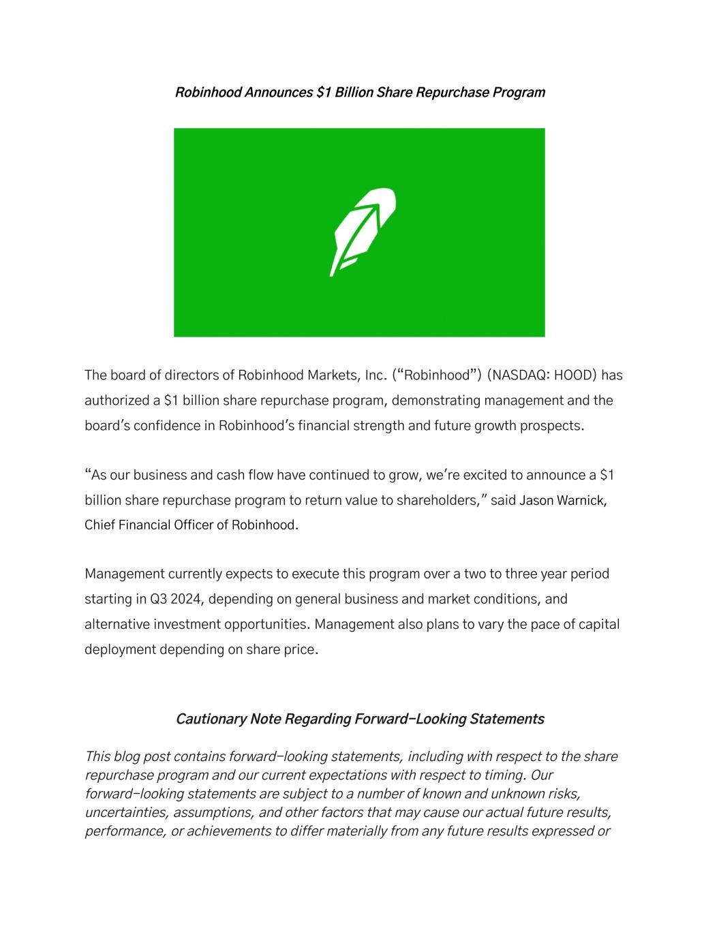

Robinhood Announces $1 Billion Share Repurchase Program The board of directors of Robinhood Markets, Inc. (“Robinhood”) (NASDAQ: HOOD) has authorized a $1 billion share repurchase program, demonstrating management and the board's confidence in Robinhood's financial strength and future growth prospects. “As our business and cash flow have continued to grow, we're excited to announce a $1 billion share repurchase program to return value to shareholders," said Jason Warnick, Chief Financial Officer of Robinhood. Management currently expects to execute this program over a two to three year period starting in Q3 2024, depending on general business and market conditions, and alternative investment opportunities. Management also plans to vary the pace of capital deployment depending on share price. Cautionary Note Regarding Forward-Looking Statements This blog post contains forward-looking statements, including with respect to the share repurchase program and our current expectations with respect to timing. Our forward-looking statements are subject to a number of known and unknown risks, uncertainties, assumptions, and other factors that may cause our actual future results, performance, or achievements to differ materially from any future results expressed or

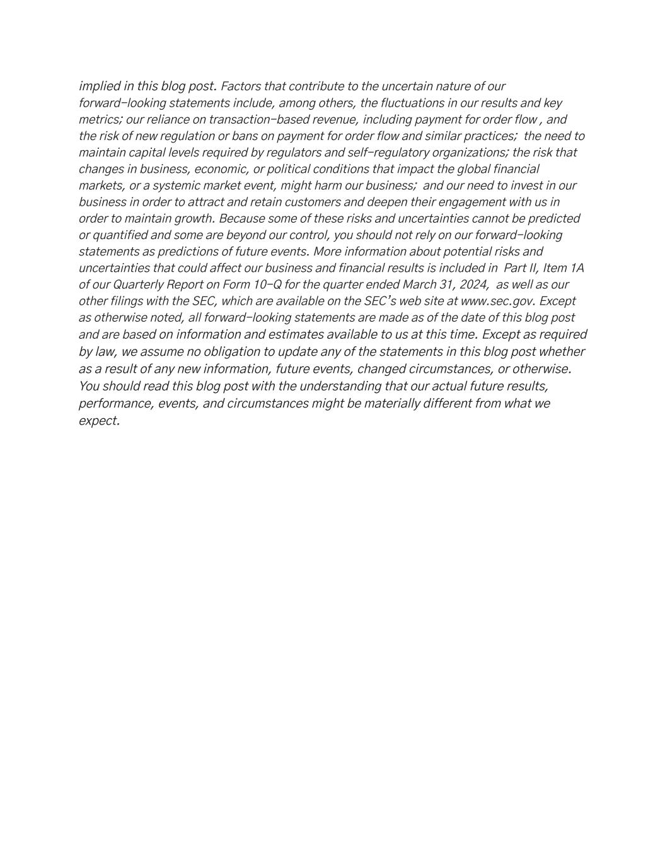
implied in this blog post. Factors that contribute to the uncertain nature of our forward-looking statements include, among others, the fluctuations in our results and key metrics; our reliance on transaction-based revenue, including payment for order flow , and the risk of new regulation or bans on payment for order flow and similar practices; the need to maintain capital levels required by regulators and self-regulatory organizations; the risk that changes in business, economic, or political conditions that impact the global financial markets, or a systemic market event, might harm our business; and our need to invest in our business in order to attract and retain customers and deepen their engagement with us in order to maintain growth. Because some of these risks and uncertainties cannot be predicted or quantified and some are beyond our control, you should not rely on our forward-looking statements as predictions of future events. More information about potential risks and uncertainties that could affect our business and financial results is included in Part II, Item 1A of our Quarterly Report on Form 10-Q for the quarter ended March 31, 2024, as well as our other filings with the SEC, which are available on the SEC’s web site at www.sec.gov. Except as otherwise noted, all forward-looking statements are made as of the date of this blog post and are based on information and estimates available to us at this time. Except as required by law, we assume no obligation to update any of the statements in this blog post whether as a result of any new information, future events, changed circumstances, or otherwise. You should read this blog post with the understanding that our actual future results, performance, events, and circumstances might be materially different from what we expect.

