UNITED STATES
SECURITIES AND EXCHANGE COMMISSION
Washington, D.C. 20549

FORM 8-K

CURRENT REPORT
Pursuant to Section 13 or 15(d) of the
Securities Exchange Act of 1934
Date of Report (Date of earliest event reported): April 30, 2024

Robinhood Markets, Inc.
(Exact name of registrant as specified in its charter)
Delaware |  |  |  |  |  | 001-40691 |  |  |  |  |  | 46-4364776
(State or other jurisdiction  of incorporation) |  |  |  |  |  | (Commission  File Number) |  |  |  |  |  | (IRS Employer  Identification No.)
85 Willow Road
Menlo Park, CA 94025
(Address of principal executive offices) (Zip Code)

(844) 428-5411
(Registrant’s telephone number, including area code)

Not Applicable
(Former name or former address, if changed since last report)

Check the appropriate box below if the Form 8-K filing is intended to simultaneously satisfy the filing obligation of the registrant under any of the following provisions:
☐ |  |  |  |  |  | Written communications pursuant to Rule 425 under the Securities Act (17 CFR 230.425)
☐ |  |  |  |  |  | Soliciting material pursuant to Rule 14a-12 under the Exchange Act (17 CFR 240.14a-12)
☐ |  |  |  |  |  | Pre-commencement communications pursuant to Rule 14d-2(b) under the Exchange Act (17 CFR 240.14d-2(b))
☐ |  |  |  |  |  | Pre-commencement communications pursuant to Rule 13e-4(c) under the Exchange Act (17 CFR 240.13e-4(c))
Securities registered pursuant to Section 12(b) of the Act:
Title of each class |  |  | Trading Symbol(s) |  |  | Name of each exchange on which registered
Class A Common Stock, $0.0001 par value per share |  |  | HOOD |  |  | The Nasdaq Stock Market LLC
Indicate by check mark whether the registrant is an emerging growth company as defined in Rule 405 of the Securities Act of 1933 (§230.405 of this chapter) or Rule 12b-2 of the Securities Exchange Act of 1934 (§240.12b-2 of this chapter).
Emerging growth company |  |  |  |  |  | ☐
If an emerging growth company, indicate by check mark if the registrant has elected not to use the extended transition period for complying with any new or revised financial accounting standards provided pursuant to Section 13(a) of the Exchange Act. |  |  |  |  |  | ☐

Item 2.02 Results of Operations and Financial Condition.

The information contained in Item 7.01 of this report is incorporated herein by reference.

Item 7.01 Regulation FD Disclosure.

Robinhood’s Broker-Dealer Subsidiaries Release Reports Pursuant to SEC Rule 606(a) for the First Quarter of 2024

Robinhood Markets, Inc. (“Robinhood” or the "Company") is furnishing as Exhibits 99.1 and 99.2 hereto the Held NMS Stocks and Options Order Routing Public Reports (“606-Reports”) for the first quarter of 2024 for each of its broker-dealer subsidiaries, Robinhood Financial LLC (“RHF”) and Robinhood Securities, LLC (“RHS”).

As subsidiary reports, these 606-Reports do not present the Company’s consolidated results. These 606-Reports were prepared to comply with U.S. Securities and Exchange Commission (“SEC”) Rule 606(a) of Regulation National Market System (Reg. NMS) under the Securities Exchange Act of 1934, as amended (the “Exchange Act”), which requires broker-dealers to make available specified quarterly reports regarding the routing of certain non-directed orders. As required by such rule and related regulatory guidance, the 606-Reports present some (but not necessarily all) of the payment for order flow (“PFOF”) received from venues to which orders were routed. (As disclosed on the 606-Reports, RHS shares the PFOF it receives with RHF pursuant to a revenue and cost allocation agreement.)

The 606-Reports are unaudited, made available without commentary, and should be read together with Robinhood’s most recent quarterly and annual consolidated results on Forms 10-Q and 10-K (as well as Robinhood’s other SEC filings), which are or will be available on the Financials tab of Robinhood’s Investor Relations website at investors.robinhood.com.

Robinhood uses the "Overview" tab of its Investor Relations website (accessible at investors.robinhood.com/overview) and its Newsroom (accessible at newsroom.aboutrobinhood.com), as means of disclosing information to the public in a broad, non-exclusionary manner for purposes of the Securities and Exchange Commission's ("SEC") Regulation Fair Disclosure (Reg. FD). Investors should routinely monitor those web pages, in addition to Robinhood’s press releases, SEC filings, and public conference calls and webcasts, as information posted on them could be deemed to be material information.

The information furnished with Item 2.02 and Item 7.01, including Exhibits 99.1 and 99.2, shall not be deemed “filed” for purposes of Section 18 of the Exchange Act, or otherwise subject to the liabilities of that section, nor shall it be deemed incorporated by reference into any other filing under the Securities Act of 1933, as amended, or the Exchange Act, except as expressly set forth by specific reference in such a filing.

Item 9.01 Financial Statements and Exhibits.

(d) Exhibits
Exhibit Number |  |  |  |  |  | Description
99.1 |  |  |  |  |  | Robinhood Financial LLC – Held NMS Stocks and Options Order Routing Public Report
99.2 |  |  |  |  |  | Robinhood Securities, LLC – Held NMS Stocks and Options Order Routing Public Report
104 |  |  |  |  |  | Cover Page Interactive Data File (the cover page XBRL tags are embedded within the Inline XBRL document)

SIGNATURE
Pursuant to the requirements of the Securities Exchange Act of 1934, the Registrant has duly caused this report to be signed on its behalf by the undersigned hereunto duly authorized.
 |  |  |  |  |  | Robinhood Markets, Inc.
Date: |  |  | April 30, 2024 |  |  | By: |  |  | /s/ Jason Warnick
 |  |  |  |  |  |  |  |  | Name: Jason Warnick
 |  |  |  |  |  |  |  |  | Title: Chief Financial Officer

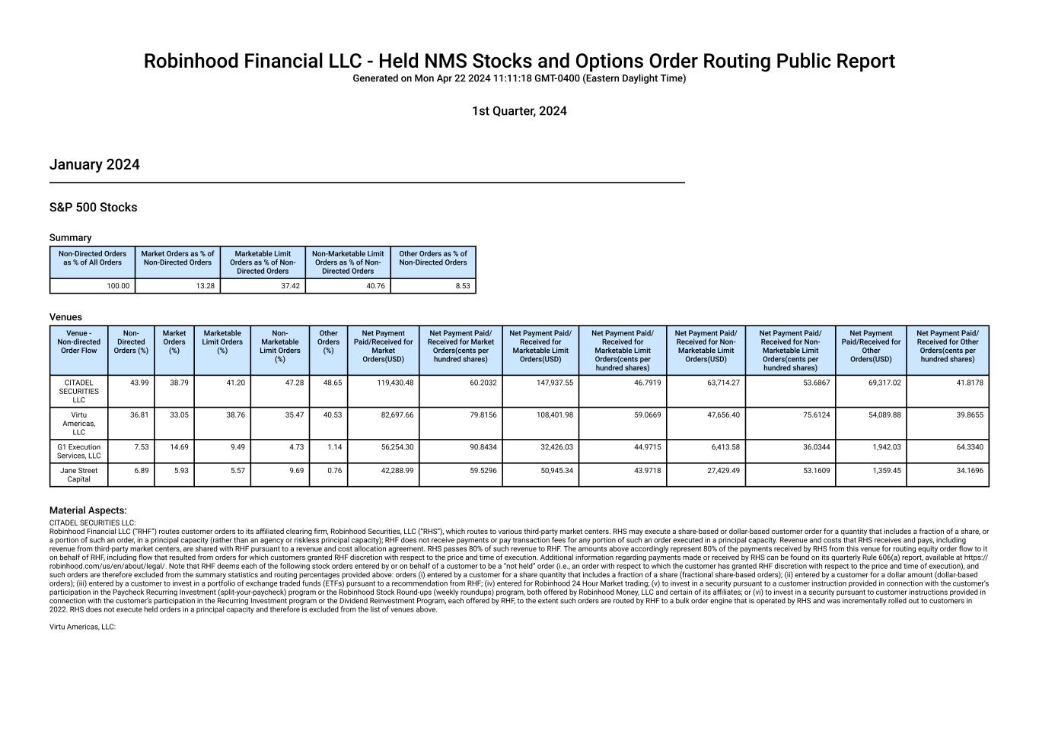

Robinhood Financial LLC - Held NMS Stocks and Options Order Routing Public Report Generated on Mon Apr 22 2024 11:11:18 GMT-0400 (Eastern Daylight Time) 1st Quarter, 2024 January 2024 S&P 500 Stocks Summary Non-Directed Orders as % of All Orders Market Orders as % of Non-Directed Orders Marketable Limit Orders as % of Non- Directed Orders Non-Marketable Limit Orders as % of Non- Directed Orders Other Orders as % of Non-Directed Orders 100.00 13.28 37.42 40.76 8.53 Venues Venue - Non-directed Order Flow Non- Directed Orders (%) Market Orders (%) Marketable Limit Orders (%) Non- Marketable Limit Orders (%) Other Orders (%) Net Payment Paid/Received for Market Orders(USD) Net Payment Paid/ Received for Market Orders(cents per hundred shares) Net Payment Paid/ Received for Marketable Limit Orders(USD) Net Payment Paid/ Received for Marketable Limit Orders(cents per hundred shares) Net Payment Paid/ Received for Non- Marketable Limit Orders(USD) Net Payment Paid/ Received for Non- Marketable Limit Orders(cents per hundred shares) Net Payment Paid/Received for Other Orders(USD) Net Payment Paid/ Received for Other Orders(cents per hundred shares) CITADEL SECURITIES LLC 43.99 38.79 41.20 47.28 48.65 119,430.48 60.2032 147,937.55 46.7919 63,714.27 53.6867 69,317.02 41.8178 Virtu Americas, LLC 36.81 33.05 38.76 35.47 40.53 82,697.66 79.8156 108,401.98 59.0669 47,656.40 75.6124 54,089.88 39.8655 G1 Execution Services, LLC 7.53 14.69 9.49 4.73 1.14 56,254.30 90.8434 32,426.03 44.9715 6,413.58 36.0344 1,942.03 64.3340 Jane Street Capital 6.89 5.93 5.57 9.69 0.76 42,288.99 59.5296 50,945.34 43.9718 27,429.49 53.1609 1,359.45 34.1696 Material Aspects: CITADEL SECURITIES LLC: Robinhood Financial LLC (“RHF”) routes customer orders to its affiliated clearing firm, Robinhood Securities, LLC (“RHS”), which routes to various third-party market centers. RHS may execute a share-based or dollar-based customer order for a quantity that includes a fraction of a share, or a portion of such an order, in a principal capacity (rather than an agency or riskless principal capacity); RHF does not receive payments or pay transaction fees for any portion of such an order executed in a principal capacity. Revenue and costs that RHS receives and pays, including revenue from third-party market centers, are shared with RHF pursuant to a revenue and cost allocation agreement. RHS passes 80% of such revenue to RHF. The amounts above accordingly represent 80% of the payments received by RHS from this venue for routing equity order flow to it on behalf of RHF, including flow that resulted from orders for which customers granted RHF discretion with respect to the price and time of execution. Additional information regarding payments made or received by RHS can be found on its quarterly Rule 606(a) report, available at https:// robinhood.com/us/en/about/legal/. Note that RHF deems each of the following stock orders entered by or on behalf of a customer to be a “not held” order (i.e., an order with respect to which the customer has granted RHF discretion with respect to the price and time of execution), and such orders are therefore excluded from the summary statistics and routing percentages provided above: orders (i) entered by a customer for a share quantity that includes a fraction of a share (fractional share-based orders); (ii) entered by a customer for a dollar amount (dollar-based orders); (iii) entered by a customer to invest in a portfolio of exchange traded funds (ETFs) pursuant to a recommendation from RHF; (iv) entered for Robinhood 24 Hour Market trading; (v) to invest in a security pursuant to a customer instruction provided in connection with the customer’s participation in the Paycheck Recurring Investment (split-your-paycheck) program or the Robinhood Stock Round-ups (weekly roundups) program, both offered by Robinhood Money, LLC and certain of its affiliates; or (vi) to invest in a security pursuant to customer instructions provided in connection with the customer’s participation in the Recurring Investment program or the Dividend Reinvestment Program, each offered by RHF, to the extent such orders are routed by RHF to a bulk order engine that is operated by RHS and was incrementally rolled out to customers in 2022. RHS does not execute held orders in a principal capacity and therefore is excluded from the list of venues above. Virtu Americas, LLC:

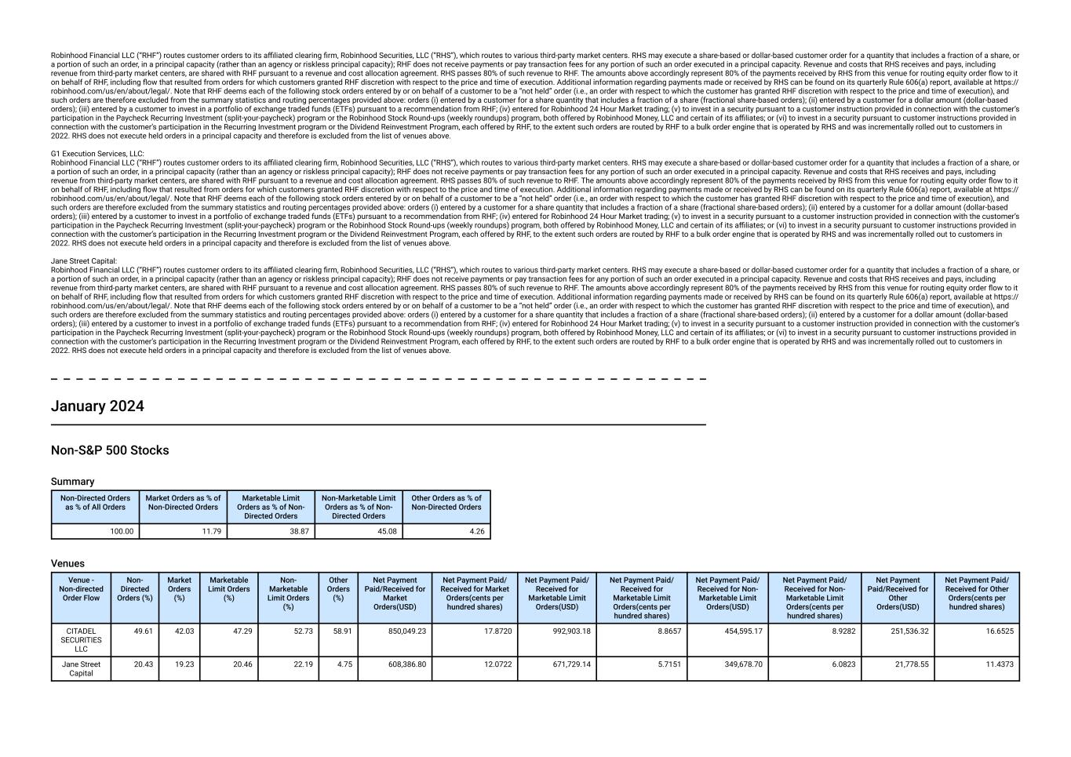
Robinhood Financial LLC (“RHF”) routes customer orders to its affiliated clearing firm, Robinhood Securities, LLC (“RHS”), which routes to various third-party market centers. RHS may execute a share-based or dollar-based customer order for a quantity that includes a fraction of a share, or a portion of such an order, in a principal capacity (rather than an agency or riskless principal capacity); RHF does not receive payments or pay transaction fees for any portion of such an order executed in a principal capacity. Revenue and costs that RHS receives and pays, including revenue from third-party market centers, are shared with RHF pursuant to a revenue and cost allocation agreement. RHS passes 80% of such revenue to RHF. The amounts above accordingly represent 80% of the payments received by RHS from this venue for routing equity order flow to it on behalf of RHF, including flow that resulted from orders for which customers granted RHF discretion with respect to the price and time of execution. Additional information regarding payments made or received by RHS can be found on its quarterly Rule 606(a) report, available at https:// robinhood.com/us/en/about/legal/. Note that RHF deems each of the following stock orders entered by or on behalf of a customer to be a “not held” order (i.e., an order with respect to which the customer has granted RHF discretion with respect to the price and time of execution), and such orders are therefore excluded from the summary statistics and routing percentages provided above: orders (i) entered by a customer for a share quantity that includes a fraction of a share (fractional share-based orders); (ii) entered by a customer for a dollar amount (dollar-based orders); (iii) entered by a customer to invest in a portfolio of exchange traded funds (ETFs) pursuant to a recommendation from RHF; (iv) entered for Robinhood 24 Hour Market trading; (v) to invest in a security pursuant to a customer instruction provided in connection with the customer’s participation in the Paycheck Recurring Investment (split-your-paycheck) program or the Robinhood Stock Round-ups (weekly roundups) program, both offered by Robinhood Money, LLC and certain of its affiliates; or (vi) to invest in a security pursuant to customer instructions provided in connection with the customer’s participation in the Recurring Investment program or the Dividend Reinvestment Program, each offered by RHF, to the extent such orders are routed by RHF to a bulk order engine that is operated by RHS and was incrementally rolled out to customers in 2022. RHS does not execute held orders in a principal capacity and therefore is excluded from the list of venues above. G1 Execution Services, LLC: Robinhood Financial LLC (“RHF”) routes customer orders to its affiliated clearing firm, Robinhood Securities, LLC (“RHS”), which routes to various third-party market centers. RHS may execute a share-based or dollar-based customer order for a quantity that includes a fraction of a share, or a portion of such an order, in a principal capacity (rather than an agency or riskless principal capacity); RHF does not receive payments or pay transaction fees for any portion of such an order executed in a principal capacity. Revenue and costs that RHS receives and pays, including revenue from third-party market centers, are shared with RHF pursuant to a revenue and cost allocation agreement. RHS passes 80% of such revenue to RHF. The amounts above accordingly represent 80% of the payments received by RHS from this venue for routing equity order flow to it on behalf of RHF, including flow that resulted from orders for which customers granted RHF discretion with respect to the price and time of execution. Additional information regarding payments made or received by RHS can be found on its quarterly Rule 606(a) report, available at https:// robinhood.com/us/en/about/legal/. Note that RHF deems each of the following stock orders entered by or on behalf of a customer to be a “not held” order (i.e., an order with respect to which the customer has granted RHF discretion with respect to the price and time of execution), and such orders are therefore excluded from the summary statistics and routing percentages provided above: orders (i) entered by a customer for a share quantity that includes a fraction of a share (fractional share-based orders); (ii) entered by a customer for a dollar amount (dollar-based orders); (iii) entered by a customer to invest in a portfolio of exchange traded funds (ETFs) pursuant to a recommendation from RHF; (iv) entered for Robinhood 24 Hour Market trading; (v) to invest in a security pursuant to a customer instruction provided in connection with the customer’s participation in the Paycheck Recurring Investment (split-your-paycheck) program or the Robinhood Stock Round-ups (weekly roundups) program, both offered by Robinhood Money, LLC and certain of its affiliates; or (vi) to invest in a security pursuant to customer instructions provided in connection with the customer’s participation in the Recurring Investment program or the Dividend Reinvestment Program, each offered by RHF, to the extent such orders are routed by RHF to a bulk order engine that is operated by RHS and was incrementally rolled out to customers in 2022. RHS does not execute held orders in a principal capacity and therefore is excluded from the list of venues above. Jane Street Capital: Robinhood Financial LLC (“RHF”) routes customer orders to its affiliated clearing firm, Robinhood Securities, LLC (“RHS”), which routes to various third-party market centers. RHS may execute a share-based or dollar-based customer order for a quantity that includes a fraction of a share, or a portion of such an order, in a principal capacity (rather than an agency or riskless principal capacity); RHF does not receive payments or pay transaction fees for any portion of such an order executed in a principal capacity. Revenue and costs that RHS receives and pays, including revenue from third-party market centers, are shared with RHF pursuant to a revenue and cost allocation agreement. RHS passes 80% of such revenue to RHF. The amounts above accordingly represent 80% of the payments received by RHS from this venue for routing equity order flow to it on behalf of RHF, including flow that resulted from orders for which customers granted RHF discretion with respect to the price and time of execution. Additional information regarding payments made or received by RHS can be found on its quarterly Rule 606(a) report, available at https:// robinhood.com/us/en/about/legal/. Note that RHF deems each of the following stock orders entered by or on behalf of a customer to be a “not held” order (i.e., an order with respect to which the customer has granted RHF discretion with respect to the price and time of execution), and such orders are therefore excluded from the summary statistics and routing percentages provided above: orders (i) entered by a customer for a share quantity that includes a fraction of a share (fractional share-based orders); (ii) entered by a customer for a dollar amount (dollar-based orders); (iii) entered by a customer to invest in a portfolio of exchange traded funds (ETFs) pursuant to a recommendation from RHF; (iv) entered for Robinhood 24 Hour Market trading; (v) to invest in a security pursuant to a customer instruction provided in connection with the customer’s participation in the Paycheck Recurring Investment (split-your-paycheck) program or the Robinhood Stock Round-ups (weekly roundups) program, both offered by Robinhood Money, LLC and certain of its affiliates; or (vi) to invest in a security pursuant to customer instructions provided in connection with the customer’s participation in the Recurring Investment program or the Dividend Reinvestment Program, each offered by RHF, to the extent such orders are routed by RHF to a bulk order engine that is operated by RHS and was incrementally rolled out to customers in 2022. RHS does not execute held orders in a principal capacity and therefore is excluded from the list of venues above. January 2024 Non-S&P 500 Stocks Summary Non-Directed Orders as % of All Orders Market Orders as % of Non-Directed Orders Marketable Limit Orders as % of Non- Directed Orders Non-Marketable Limit Orders as % of Non- Directed Orders Other Orders as % of Non-Directed Orders 100.00 11.79 38.87 45.08 4.26 Venues Venue - Non-directed Order Flow Non- Directed Orders (%) Market Orders (%) Marketable Limit Orders (%) Non- Marketable Limit Orders (%) Other Orders (%) Net Payment Paid/Received for Market Orders(USD) Net Payment Paid/ Received for Market Orders(cents per hundred shares) Net Payment Paid/ Received for Marketable Limit Orders(USD) Net Payment Paid/ Received for Marketable Limit Orders(cents per hundred shares) Net Payment Paid/ Received for Non- Marketable Limit Orders(USD) Net Payment Paid/ Received for Non- Marketable Limit Orders(cents per hundred shares) Net Payment Paid/Received for Other Orders(USD) Net Payment Paid/ Received for Other Orders(cents per hundred shares) CITADEL SECURITIES LLC 49.61 42.03 47.29 52.73 58.91 850,049.23 17.8720 992,903.18 8.8657 454,595.17 8.9282 251,536.32 16.6525 Jane Street Capital 20.43 19.23 20.46 22.19 4.75 608,386.80 12.0722 671,729.14 5.7151 349,678.70 6.0823 21,778.55 11.4373

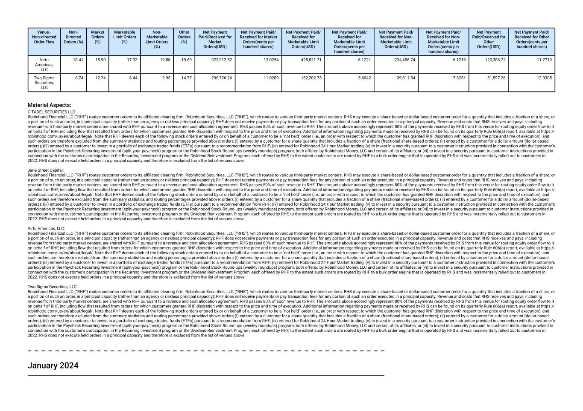
Venue - Non-directed Order Flow Non- Directed Orders (%) Market Orders (%) Marketable Limit Orders (%) Non- Marketable Limit Orders (%) Other Orders (%) Net Payment Paid/Received for Market Orders(USD) Net Payment Paid/ Received for Market Orders(cents per hundred shares) Net Payment Paid/ Received for Marketable Limit Orders(USD) Net Payment Paid/ Received for Marketable Limit Orders(cents per hundred shares) Net Payment Paid/ Received for Non- Marketable Limit Orders(USD) Net Payment Paid/ Received for Non- Marketable Limit Orders(cents per hundred shares) Net Payment Paid/Received for Other Orders(USD) Net Payment Paid/ Received for Other Orders(cents per hundred shares) Virtu Americas, LLC 18.41 15.90 17.33 19.88 19.69 373,312.52 12.0254 428,821.71 6.1221 224,456.74 6.1219 120,388.22 11.7719 Two Sigma Securities, LLC 6.74 12.74 8.44 2.95 14.77 296,726.26 11.0209 182,202.75 5.6042 39,611.54 7.3251 31,597.26 12.0305 Material Aspects: CITADEL SECURITIES LLC: Robinhood Financial LLC (“RHF”) routes customer orders to its affiliated clearing firm, Robinhood Securities, LLC (“RHS”), which routes to various third-party market centers. RHS may execute a share-based or dollar-based customer order for a quantity that includes a fraction of a share, or a portion of such an order, in a principal capacity (rather than an agency or riskless principal capacity); RHF does not receive payments or pay transaction fees for any portion of such an order executed in a principal capacity. Revenue and costs that RHS receives and pays, including revenue from third-party market centers, are shared with RHF pursuant to a revenue and cost allocation agreement. RHS passes 80% of such revenue to RHF. The amounts above accordingly represent 80% of the payments received by RHS from this venue for routing equity order flow to it on behalf of RHF, including flow that resulted from orders for which customers granted RHF discretion with respect to the price and time of execution. Additional information regarding payments made or received by RHS can be found on its quarterly Rule 606(a) report, available at https:// robinhood.com/us/en/about/legal/. Note that RHF deems each of the following stock orders entered by or on behalf of a customer to be a “not held” order (i.e., an order with respect to which the customer has granted RHF discretion with respect to the price and time of execution), and such orders are therefore excluded from the summary statistics and routing percentages provided above: orders (i) entered by a customer for a share quantity that includes a fraction of a share (fractional share-based orders); (ii) entered by a customer for a dollar amount (dollar-based orders); (iii) entered by a customer to invest in a portfolio of exchange traded funds (ETFs) pursuant to a recommendation from RHF; (iv) entered for Robinhood 24 Hour Market trading; (v) to invest in a security pursuant to a customer instruction provided in connection with the customer’s participation in the Paycheck Recurring Investment (split-your-paycheck) program or the Robinhood Stock Round-ups (weekly roundups) program, both offered by Robinhood Money, LLC and certain of its affiliates; or (vi) to invest in a security pursuant to customer instructions provided in connection with the customer’s participation in the Recurring Investment program or the Dividend Reinvestment Program, each offered by RHF, to the extent such orders are routed by RHF to a bulk order engine that is operated by RHS and was incrementally rolled out to customers in 2022. RHS does not execute held orders in a principal capacity and therefore is excluded from the list of venues above. Jane Street Capital: Robinhood Financial LLC (“RHF”) routes customer orders to its affiliated clearing firm, Robinhood Securities, LLC (“RHS”), which routes to various third-party market centers. RHS may execute a share-based or dollar-based customer order for a quantity that includes a fraction of a share, or a portion of such an order, in a principal capacity (rather than an agency or riskless principal capacity); RHF does not receive payments or pay transaction fees for any portion of such an order executed in a principal capacity. Revenue and costs that RHS receives and pays, including revenue from third-party market centers, are shared with RHF pursuant to a revenue and cost allocation agreement. RHS passes 80% of such revenue to RHF. The amounts above accordingly represent 80% of the payments received by RHS from this venue for routing equity order flow to it on behalf of RHF, including flow that resulted from orders for which customers granted RHF discretion with respect to the price and time of execution. Additional information regarding payments made or received by RHS can be found on its quarterly Rule 606(a) report, available at https:// robinhood.com/us/en/about/legal/. Note that RHF deems each of the following stock orders entered by or on behalf of a customer to be a “not held” order (i.e., an order with respect to which the customer has granted RHF discretion with respect to the price and time of execution), and such orders are therefore excluded from the summary statistics and routing percentages provided above: orders (i) entered by a customer for a share quantity that includes a fraction of a share (fractional share-based orders); (ii) entered by a customer for a dollar amount (dollar-based orders); (iii) entered by a customer to invest in a portfolio of exchange traded funds (ETFs) pursuant to a recommendation from RHF; (iv) entered for Robinhood 24 Hour Market trading; (v) to invest in a security pursuant to a customer instruction provided in connection with the customer’s participation in the Paycheck Recurring Investment (split-your-paycheck) program or the Robinhood Stock Round-ups (weekly roundups) program, both offered by Robinhood Money, LLC and certain of its affiliates; or (vi) to invest in a security pursuant to customer instructions provided in connection with the customer’s participation in the Recurring Investment program or the Dividend Reinvestment Program, each offered by RHF, to the extent such orders are routed by RHF to a bulk order engine that is operated by RHS and was incrementally rolled out to customers in 2022. RHS does not execute held orders in a principal capacity and therefore is excluded from the list of venues above. Virtu Americas, LLC: Robinhood Financial LLC (“RHF”) routes customer orders to its affiliated clearing firm, Robinhood Securities, LLC (“RHS”), which routes to various third-party market centers. RHS may execute a share-based or dollar-based customer order for a quantity that includes a fraction of a share, or a portion of such an order, in a principal capacity (rather than an agency or riskless principal capacity); RHF does not receive payments or pay transaction fees for any portion of such an order executed in a principal capacity. Revenue and costs that RHS receives and pays, including revenue from third-party market centers, are shared with RHF pursuant to a revenue and cost allocation agreement. RHS passes 80% of such revenue to RHF. The amounts above accordingly represent 80% of the payments received by RHS from this venue for routing equity order flow to it on behalf of RHF, including flow that resulted from orders for which customers granted RHF discretion with respect to the price and time of execution. Additional information regarding payments made or received by RHS can be found on its quarterly Rule 606(a) report, available at https:// robinhood.com/us/en/about/legal/. Note that RHF deems each of the following stock orders entered by or on behalf of a customer to be a “not held” order (i.e., an order with respect to which the customer has granted RHF discretion with respect to the price and time of execution), and such orders are therefore excluded from the summary statistics and routing percentages provided above: orders (i) entered by a customer for a share quantity that includes a fraction of a share (fractional share-based orders); (ii) entered by a customer for a dollar amount (dollar-based orders); (iii) entered by a customer to invest in a portfolio of exchange traded funds (ETFs) pursuant to a recommendation from RHF; (iv) entered for Robinhood 24 Hour Market trading; (v) to invest in a security pursuant to a customer instruction provided in connection with the customer’s participation in the Paycheck Recurring Investment (split-your-paycheck) program or the Robinhood Stock Round-ups (weekly roundups) program, both offered by Robinhood Money, LLC and certain of its affiliates; or (vi) to invest in a security pursuant to customer instructions provided in connection with the customer’s participation in the Recurring Investment program or the Dividend Reinvestment Program, each offered by RHF, to the extent such orders are routed by RHF to a bulk order engine that is operated by RHS and was incrementally rolled out to customers in 2022. RHS does not execute held orders in a principal capacity and therefore is excluded from the list of venues above. Two Sigma Securities, LLC: Robinhood Financial LLC (“RHF”) routes customer orders to its affiliated clearing firm, Robinhood Securities, LLC (“RHS”), which routes to various third-party market centers. RHS may execute a share-based or dollar-based customer order for a quantity that includes a fraction of a share, or a portion of such an order, in a principal capacity (rather than an agency or riskless principal capacity); RHF does not receive payments or pay transaction fees for any portion of such an order executed in a principal capacity. Revenue and costs that RHS receives and pays, including revenue from third-party market centers, are shared with RHF pursuant to a revenue and cost allocation agreement. RHS passes 80% of such revenue to RHF. The amounts above accordingly represent 80% of the payments received by RHS from this venue for routing equity order flow to it on behalf of RHF, including flow that resulted from orders for which customers granted RHF discretion with respect to the price and time of execution. Additional information regarding payments made or received by RHS can be found on its quarterly Rule 606(a) report, available at https:// robinhood.com/us/en/about/legal/. Note that RHF deems each of the following stock orders entered by or on behalf of a customer to be a “not held” order (i.e., an order with respect to which the customer has granted RHF discretion with respect to the price and time of execution), and such orders are therefore excluded from the summary statistics and routing percentages provided above: orders (i) entered by a customer for a share quantity that includes a fraction of a share (fractional share-based orders); (ii) entered by a customer for a dollar amount (dollar-based orders); (iii) entered by a customer to invest in a portfolio of exchange traded funds (ETFs) pursuant to a recommendation from RHF; (iv) entered for Robinhood 24 Hour Market trading; (v) to invest in a security pursuant to a customer instruction provided in connection with the customer’s participation in the Paycheck Recurring Investment (split-your-paycheck) program or the Robinhood Stock Round-ups (weekly roundups) program, both offered by Robinhood Money, LLC and certain of its affiliates; or (vi) to invest in a security pursuant to customer instructions provided in connection with the customer’s participation in the Recurring Investment program or the Dividend Reinvestment Program, each offered by RHF, to the extent such orders are routed by RHF to a bulk order engine that is operated by RHS and was incrementally rolled out to customers in 2022. RHS does not execute held orders in a principal capacity and therefore is excluded from the list of venues above. January 2024

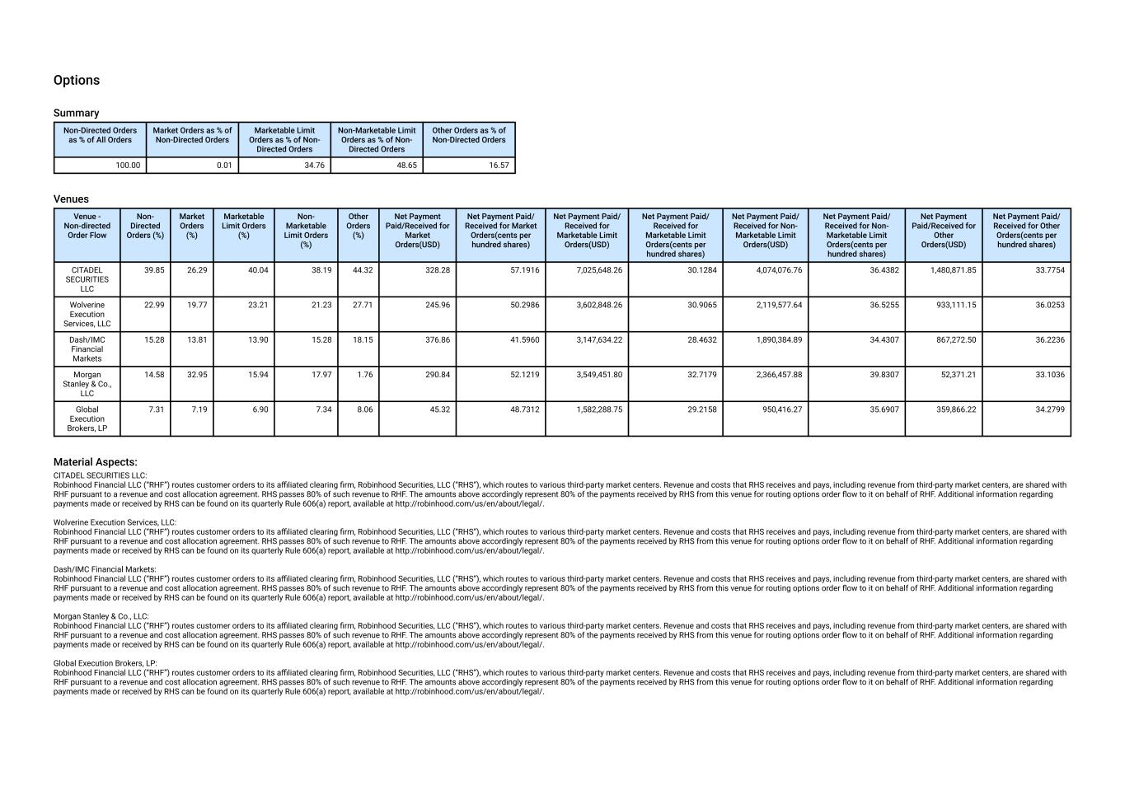
Options Summary Non-Directed Orders as % of All Orders Market Orders as % of Non-Directed Orders Marketable Limit Orders as % of Non- Directed Orders Non-Marketable Limit Orders as % of Non- Directed Orders Other Orders as % of Non-Directed Orders 100.00 0.01 34.76 48.65 16.57 Venues Venue - Non-directed Order Flow Non- Directed Orders (%) Market Orders (%) Marketable Limit Orders (%) Non- Marketable Limit Orders (%) Other Orders (%) Net Payment Paid/Received for Market Orders(USD) Net Payment Paid/ Received for Market Orders(cents per hundred shares) Net Payment Paid/ Received for Marketable Limit Orders(USD) Net Payment Paid/ Received for Marketable Limit Orders(cents per hundred shares) Net Payment Paid/ Received for Non- Marketable Limit Orders(USD) Net Payment Paid/ Received for Non- Marketable Limit Orders(cents per hundred shares) Net Payment Paid/Received for Other Orders(USD) Net Payment Paid/ Received for Other Orders(cents per hundred shares) CITADEL SECURITIES LLC 39.85 26.29 40.04 38.19 44.32 328.28 57.1916 7,025,648.26 30.1284 4,074,076.76 36.4382 1,480,871.85 33.7754 Wolverine Execution Services, LLC 22.99 19.77 23.21 21.23 27.71 245.96 50.2986 3,602,848.26 30.9065 2,119,577.64 36.5255 933,111.15 36.0253 Dash/IMC Financial Markets 15.28 13.81 13.90 15.28 18.15 376.86 41.5960 3,147,634.22 28.4632 1,890,384.89 34.4307 867,272.50 36.2236 Morgan Stanley & Co., LLC 14.58 32.95 15.94 17.97 1.76 290.84 52.1219 3,549,451.80 32.7179 2,366,457.88 39.8307 52,371.21 33.1036 Global Execution Brokers, LP 7.31 7.19 6.90 7.34 8.06 45.32 48.7312 1,582,288.75 29.2158 950,416.27 35.6907 359,866.22 34.2799 Material Aspects: CITADEL SECURITIES LLC: Robinhood Financial LLC (“RHF”) routes customer orders to its affiliated clearing firm, Robinhood Securities, LLC (“RHS”), which routes to various third-party market centers. Revenue and costs that RHS receives and pays, including revenue from third-party market centers, are shared with RHF pursuant to a revenue and cost allocation agreement. RHS passes 80% of such revenue to RHF. The amounts above accordingly represent 80% of the payments received by RHS from this venue for routing options order flow to it on behalf of RHF. Additional information regarding payments made or received by RHS can be found on its quarterly Rule 606(a) report, available at http://robinhood.com/us/en/about/legal/. Wolverine Execution Services, LLC: Robinhood Financial LLC (“RHF”) routes customer orders to its affiliated clearing firm, Robinhood Securities, LLC (“RHS”), which routes to various third-party market centers. Revenue and costs that RHS receives and pays, including revenue from third-party market centers, are shared with RHF pursuant to a revenue and cost allocation agreement. RHS passes 80% of such revenue to RHF. The amounts above accordingly represent 80% of the payments received by RHS from this venue for routing options order flow to it on behalf of RHF. Additional information regarding payments made or received by RHS can be found on its quarterly Rule 606(a) report, available at http://robinhood.com/us/en/about/legal/. Dash/IMC Financial Markets: Robinhood Financial LLC (“RHF”) routes customer orders to its affiliated clearing firm, Robinhood Securities, LLC (“RHS”), which routes to various third-party market centers. Revenue and costs that RHS receives and pays, including revenue from third-party market centers, are shared with RHF pursuant to a revenue and cost allocation agreement. RHS passes 80% of such revenue to RHF. The amounts above accordingly represent 80% of the payments received by RHS from this venue for routing options order flow to it on behalf of RHF. Additional information regarding payments made or received by RHS can be found on its quarterly Rule 606(a) report, available at http://robinhood.com/us/en/about/legal/. Morgan Stanley & Co., LLC: Robinhood Financial LLC (“RHF”) routes customer orders to its affiliated clearing firm, Robinhood Securities, LLC (“RHS”), which routes to various third-party market centers. Revenue and costs that RHS receives and pays, including revenue from third-party market centers, are shared with RHF pursuant to a revenue and cost allocation agreement. RHS passes 80% of such revenue to RHF. The amounts above accordingly represent 80% of the payments received by RHS from this venue for routing options order flow to it on behalf of RHF. Additional information regarding payments made or received by RHS can be found on its quarterly Rule 606(a) report, available at http://robinhood.com/us/en/about/legal/. Global Execution Brokers, LP: Robinhood Financial LLC (“RHF”) routes customer orders to its affiliated clearing firm, Robinhood Securities, LLC (“RHS”), which routes to various third-party market centers. Revenue and costs that RHS receives and pays, including revenue from third-party market centers, are shared with RHF pursuant to a revenue and cost allocation agreement. RHS passes 80% of such revenue to RHF. The amounts above accordingly represent 80% of the payments received by RHS from this venue for routing options order flow to it on behalf of RHF. Additional information regarding payments made or received by RHS can be found on its quarterly Rule 606(a) report, available at http://robinhood.com/us/en/about/legal/.

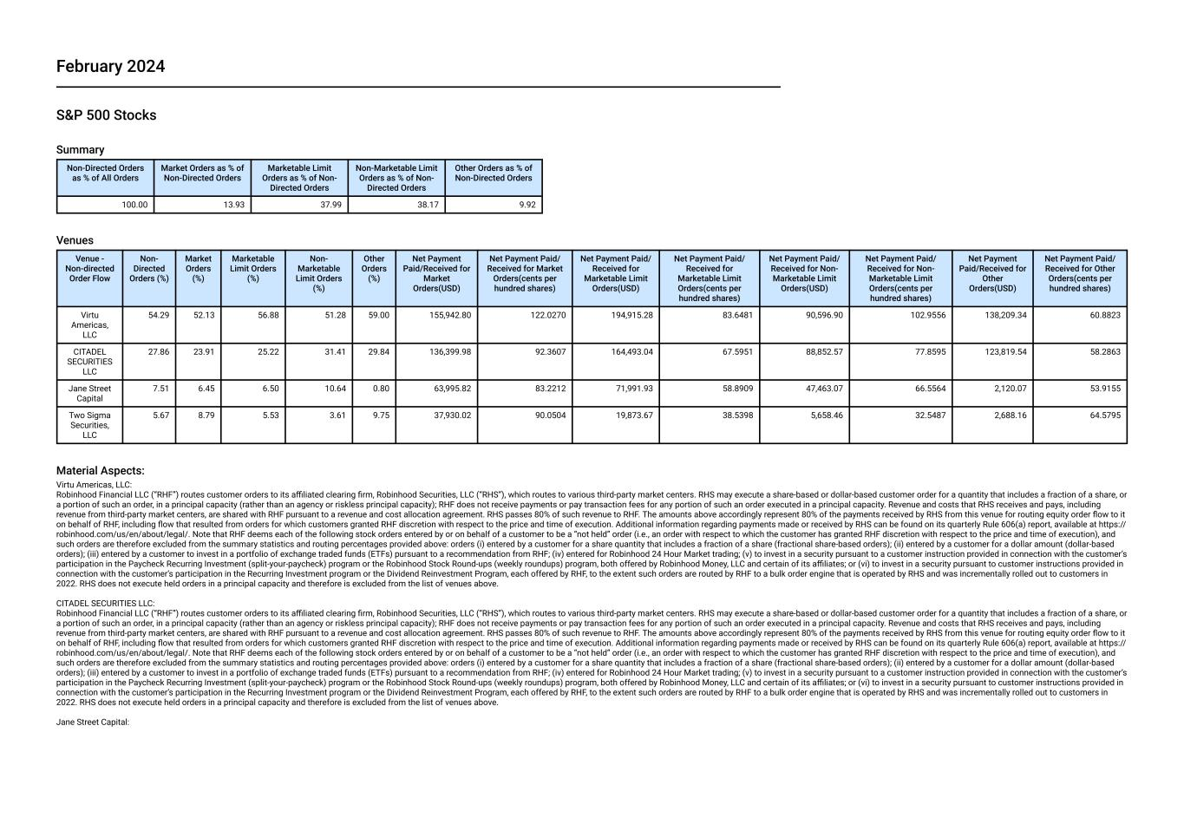
February 2024 S&P 500 Stocks Summary Non-Directed Orders as % of All Orders Market Orders as % of Non-Directed Orders Marketable Limit Orders as % of Non- Directed Orders Non-Marketable Limit Orders as % of Non- Directed Orders Other Orders as % of Non-Directed Orders 100.00 13.93 37.99 38.17 9.92 Venues Venue - Non-directed Order Flow Non- Directed Orders (%) Market Orders (%) Marketable Limit Orders (%) Non- Marketable Limit Orders (%) Other Orders (%) Net Payment Paid/Received for Market Orders(USD) Net Payment Paid/ Received for Market Orders(cents per hundred shares) Net Payment Paid/ Received for Marketable Limit Orders(USD) Net Payment Paid/ Received for Marketable Limit Orders(cents per hundred shares) Net Payment Paid/ Received for Non- Marketable Limit Orders(USD) Net Payment Paid/ Received for Non- Marketable Limit Orders(cents per hundred shares) Net Payment Paid/Received for Other Orders(USD) Net Payment Paid/ Received for Other Orders(cents per hundred shares) Virtu Americas, LLC 54.29 52.13 56.88 51.28 59.00 155,942.80 122.0270 194,915.28 83.6481 90,596.90 102.9556 138,209.34 60.8823 CITADEL SECURITIES LLC 27.86 23.91 25.22 31.41 29.84 136,399.98 92.3607 164,493.04 67.5951 88,852.57 77.8595 123,819.54 58.2863 Jane Street Capital 7.51 6.45 6.50 10.64 0.80 63,995.82 83.2212 71,991.93 58.8909 47,463.07 66.5564 2,120.07 53.9155 Two Sigma Securities, LLC 5.67 8.79 5.53 3.61 9.75 37,930.02 90.0504 19,873.67 38.5398 5,658.46 32.5487 2,688.16 64.5795 Material Aspects: Virtu Americas, LLC: Robinhood Financial LLC (“RHF”) routes customer orders to its affiliated clearing firm, Robinhood Securities, LLC (“RHS”), which routes to various third-party market centers. RHS may execute a share-based or dollar-based customer order for a quantity that includes a fraction of a share, or a portion of such an order, in a principal capacity (rather than an agency or riskless principal capacity); RHF does not receive payments or pay transaction fees for any portion of such an order executed in a principal capacity. Revenue and costs that RHS receives and pays, including revenue from third-party market centers, are shared with RHF pursuant to a revenue and cost allocation agreement. RHS passes 80% of such revenue to RHF. The amounts above accordingly represent 80% of the payments received by RHS from this venue for routing equity order flow to it on behalf of RHF, including flow that resulted from orders for which customers granted RHF discretion with respect to the price and time of execution. Additional information regarding payments made or received by RHS can be found on its quarterly Rule 606(a) report, available at https:// robinhood.com/us/en/about/legal/. Note that RHF deems each of the following stock orders entered by or on behalf of a customer to be a “not held” order (i.e., an order with respect to which the customer has granted RHF discretion with respect to the price and time of execution), and such orders are therefore excluded from the summary statistics and routing percentages provided above: orders (i) entered by a customer for a share quantity that includes a fraction of a share (fractional share-based orders); (ii) entered by a customer for a dollar amount (dollar-based orders); (iii) entered by a customer to invest in a portfolio of exchange traded funds (ETFs) pursuant to a recommendation from RHF; (iv) entered for Robinhood 24 Hour Market trading; (v) to invest in a security pursuant to a customer instruction provided in connection with the customer’s participation in the Paycheck Recurring Investment (split-your-paycheck) program or the Robinhood Stock Round-ups (weekly roundups) program, both offered by Robinhood Money, LLC and certain of its affiliates; or (vi) to invest in a security pursuant to customer instructions provided in connection with the customer’s participation in the Recurring Investment program or the Dividend Reinvestment Program, each offered by RHF, to the extent such orders are routed by RHF to a bulk order engine that is operated by RHS and was incrementally rolled out to customers in 2022. RHS does not execute held orders in a principal capacity and therefore is excluded from the list of venues above. CITADEL SECURITIES LLC: Robinhood Financial LLC (“RHF”) routes customer orders to its affiliated clearing firm, Robinhood Securities, LLC (“RHS”), which routes to various third-party market centers. RHS may execute a share-based or dollar-based customer order for a quantity that includes a fraction of a share, or a portion of such an order, in a principal capacity (rather than an agency or riskless principal capacity); RHF does not receive payments or pay transaction fees for any portion of such an order executed in a principal capacity. Revenue and costs that RHS receives and pays, including revenue from third-party market centers, are shared with RHF pursuant to a revenue and cost allocation agreement. RHS passes 80% of such revenue to RHF. The amounts above accordingly represent 80% of the payments received by RHS from this venue for routing equity order flow to it on behalf of RHF, including flow that resulted from orders for which customers granted RHF discretion with respect to the price and time of execution. Additional information regarding payments made or received by RHS can be found on its quarterly Rule 606(a) report, available at https:// robinhood.com/us/en/about/legal/. Note that RHF deems each of the following stock orders entered by or on behalf of a customer to be a “not held” order (i.e., an order with respect to which the customer has granted RHF discretion with respect to the price and time of execution), and such orders are therefore excluded from the summary statistics and routing percentages provided above: orders (i) entered by a customer for a share quantity that includes a fraction of a share (fractional share-based orders); (ii) entered by a customer for a dollar amount (dollar-based orders); (iii) entered by a customer to invest in a portfolio of exchange traded funds (ETFs) pursuant to a recommendation from RHF; (iv) entered for Robinhood 24 Hour Market trading; (v) to invest in a security pursuant to a customer instruction provided in connection with the customer’s participation in the Paycheck Recurring Investment (split-your-paycheck) program or the Robinhood Stock Round-ups (weekly roundups) program, both offered by Robinhood Money, LLC and certain of its affiliates; or (vi) to invest in a security pursuant to customer instructions provided in connection with the customer’s participation in the Recurring Investment program or the Dividend Reinvestment Program, each offered by RHF, to the extent such orders are routed by RHF to a bulk order engine that is operated by RHS and was incrementally rolled out to customers in 2022. RHS does not execute held orders in a principal capacity and therefore is excluded from the list of venues above. Jane Street Capital:

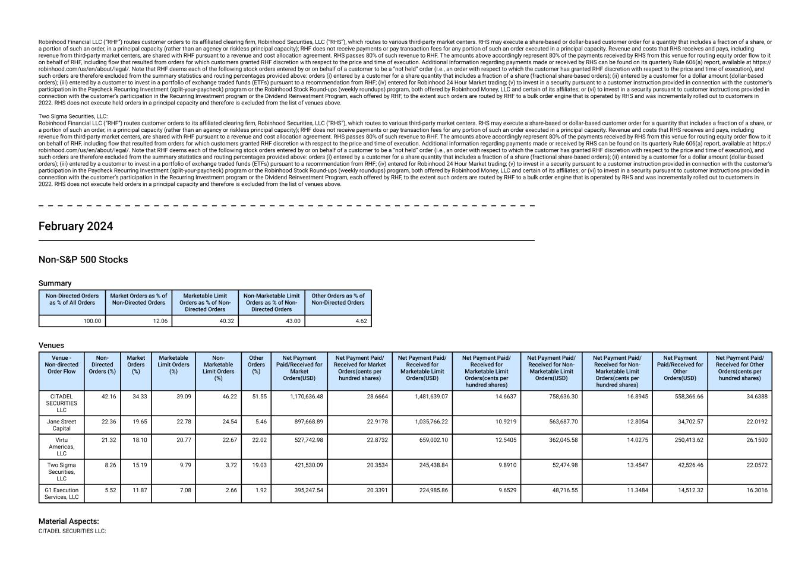
Robinhood Financial LLC (“RHF”) routes customer orders to its affiliated clearing firm, Robinhood Securities, LLC (“RHS”), which routes to various third-party market centers. RHS may execute a share-based or dollar-based customer order for a quantity that includes a fraction of a share, or a portion of such an order, in a principal capacity (rather than an agency or riskless principal capacity); RHF does not receive payments or pay transaction fees for any portion of such an order executed in a principal capacity. Revenue and costs that RHS receives and pays, including revenue from third-party market centers, are shared with RHF pursuant to a revenue and cost allocation agreement. RHS passes 80% of such revenue to RHF. The amounts above accordingly represent 80% of the payments received by RHS from this venue for routing equity order flow to it on behalf of RHF, including flow that resulted from orders for which customers granted RHF discretion with respect to the price and time of execution. Additional information regarding payments made or received by RHS can be found on its quarterly Rule 606(a) report, available at https:// robinhood.com/us/en/about/legal/. Note that RHF deems each of the following stock orders entered by or on behalf of a customer to be a “not held” order (i.e., an order with respect to which the customer has granted RHF discretion with respect to the price and time of execution), and such orders are therefore excluded from the summary statistics and routing percentages provided above: orders (i) entered by a customer for a share quantity that includes a fraction of a share (fractional share-based orders); (ii) entered by a customer for a dollar amount (dollar-based orders); (iii) entered by a customer to invest in a portfolio of exchange traded funds (ETFs) pursuant to a recommendation from RHF; (iv) entered for Robinhood 24 Hour Market trading; (v) to invest in a security pursuant to a customer instruction provided in connection with the customer’s participation in the Paycheck Recurring Investment (split-your-paycheck) program or the Robinhood Stock Round-ups (weekly roundups) program, both offered by Robinhood Money, LLC and certain of its affiliates; or (vi) to invest in a security pursuant to customer instructions provided in connection with the customer’s participation in the Recurring Investment program or the Dividend Reinvestment Program, each offered by RHF, to the extent such orders are routed by RHF to a bulk order engine that is operated by RHS and was incrementally rolled out to customers in 2022. RHS does not execute held orders in a principal capacity and therefore is excluded from the list of venues above. Two Sigma Securities, LLC: Robinhood Financial LLC (“RHF”) routes customer orders to its affiliated clearing firm, Robinhood Securities, LLC (“RHS”), which routes to various third-party market centers. RHS may execute a share-based or dollar-based customer order for a quantity that includes a fraction of a share, or a portion of such an order, in a principal capacity (rather than an agency or riskless principal capacity); RHF does not receive payments or pay transaction fees for any portion of such an order executed in a principal capacity. Revenue and costs that RHS receives and pays, including revenue from third-party market centers, are shared with RHF pursuant to a revenue and cost allocation agreement. RHS passes 80% of such revenue to RHF. The amounts above accordingly represent 80% of the payments received by RHS from this venue for routing equity order flow to it on behalf of RHF, including flow that resulted from orders for which customers granted RHF discretion with respect to the price and time of execution. Additional information regarding payments made or received by RHS can be found on its quarterly Rule 606(a) report, available at https:// robinhood.com/us/en/about/legal/. Note that RHF deems each of the following stock orders entered by or on behalf of a customer to be a “not held” order (i.e., an order with respect to which the customer has granted RHF discretion with respect to the price and time of execution), and such orders are therefore excluded from the summary statistics and routing percentages provided above: orders (i) entered by a customer for a share quantity that includes a fraction of a share (fractional share-based orders); (ii) entered by a customer for a dollar amount (dollar-based orders); (iii) entered by a customer to invest in a portfolio of exchange traded funds (ETFs) pursuant to a recommendation from RHF; (iv) entered for Robinhood 24 Hour Market trading; (v) to invest in a security pursuant to a customer instruction provided in connection with the customer’s participation in the Paycheck Recurring Investment (split-your-paycheck) program or the Robinhood Stock Round-ups (weekly roundups) program, both offered by Robinhood Money, LLC and certain of its affiliates; or (vi) to invest in a security pursuant to customer instructions provided in connection with the customer’s participation in the Recurring Investment program or the Dividend Reinvestment Program, each offered by RHF, to the extent such orders are routed by RHF to a bulk order engine that is operated by RHS and was incrementally rolled out to customers in 2022. RHS does not execute held orders in a principal capacity and therefore is excluded from the list of venues above. February 2024 Non-S&P 500 Stocks Summary Non-Directed Orders as % of All Orders Market Orders as % of Non-Directed Orders Marketable Limit Orders as % of Non- Directed Orders Non-Marketable Limit Orders as % of Non- Directed Orders Other Orders as % of Non-Directed Orders 100.00 12.06 40.32 43.00 4.62 Venues Venue - Non-directed Order Flow Non- Directed Orders (%) Market Orders (%) Marketable Limit Orders (%) Non- Marketable Limit Orders (%) Other Orders (%) Net Payment Paid/Received for Market Orders(USD) Net Payment Paid/ Received for Market Orders(cents per hundred shares) Net Payment Paid/ Received for Marketable Limit Orders(USD) Net Payment Paid/ Received for Marketable Limit Orders(cents per hundred shares) Net Payment Paid/ Received for Non- Marketable Limit Orders(USD) Net Payment Paid/ Received for Non- Marketable Limit Orders(cents per hundred shares) Net Payment Paid/Received for Other Orders(USD) Net Payment Paid/ Received for Other Orders(cents per hundred shares) CITADEL SECURITIES LLC 42.16 34.33 39.09 46.22 51.55 1,170,636.48 28.6664 1,481,639.07 14.6637 758,636.30 16.8945 558,366.66 34.6388 Jane Street Capital 22.36 19.65 22.78 24.54 5.46 897,668.89 22.9178 1,035,766.22 10.9219 563,687.70 12.8054 34,702.57 22.0192 Virtu Americas, LLC 21.32 18.10 20.77 22.67 22.02 527,742.98 22.8732 659,002.10 12.5405 362,045.58 14.0275 250,413.62 26.1500 Two Sigma Securities, LLC 8.26 15.19 9.79 3.72 19.03 421,530.09 20.3534 245,438.84 9.8910 52,474.98 13.4547 42,526.46 22.0572 G1 Execution Services, LLC 5.52 11.87 7.08 2.66 1.92 395,247.54 20.3391 224,985.86 9.6529 48,716.55 11.3484 14,512.32 16.3016 Material Aspects: CITADEL SECURITIES LLC:

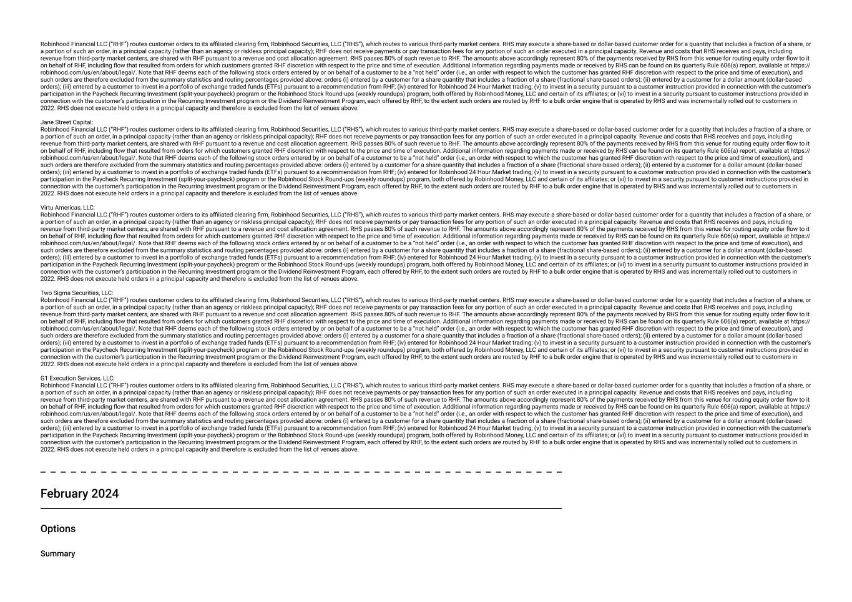
Robinhood Financial LLC (“RHF”) routes customer orders to its affiliated clearing firm, Robinhood Securities, LLC (“RHS”), which routes to various third-party market centers. RHS may execute a share-based or dollar-based customer order for a quantity that includes a fraction of a share, or a portion of such an order, in a principal capacity (rather than an agency or riskless principal capacity); RHF does not receive payments or pay transaction fees for any portion of such an order executed in a principal capacity. Revenue and costs that RHS receives and pays, including revenue from third-party market centers, are shared with RHF pursuant to a revenue and cost allocation agreement. RHS passes 80% of such revenue to RHF. The amounts above accordingly represent 80% of the payments received by RHS from this venue for routing equity order flow to it on behalf of RHF, including flow that resulted from orders for which customers granted RHF discretion with respect to the price and time of execution. Additional information regarding payments made or received by RHS can be found on its quarterly Rule 606(a) report, available at https:// robinhood.com/us/en/about/legal/. Note that RHF deems each of the following stock orders entered by or on behalf of a customer to be a “not held” order (i.e., an order with respect to which the customer has granted RHF discretion with respect to the price and time of execution), and such orders are therefore excluded from the summary statistics and routing percentages provided above: orders (i) entered by a customer for a share quantity that includes a fraction of a share (fractional share-based orders); (ii) entered by a customer for a dollar amount (dollar-based orders); (iii) entered by a customer to invest in a portfolio of exchange traded funds (ETFs) pursuant to a recommendation from RHF; (iv) entered for Robinhood 24 Hour Market trading; (v) to invest in a security pursuant to a customer instruction provided in connection with the customer’s participation in the Paycheck Recurring Investment (split-your-paycheck) program or the Robinhood Stock Round-ups (weekly roundups) program, both offered by Robinhood Money, LLC and certain of its affiliates; or (vi) to invest in a security pursuant to customer instructions provided in connection with the customer’s participation in the Recurring Investment program or the Dividend Reinvestment Program, each offered by RHF, to the extent such orders are routed by RHF to a bulk order engine that is operated by RHS and was incrementally rolled out to customers in 2022. RHS does not execute held orders in a principal capacity and therefore is excluded from the list of venues above. Jane Street Capital: Robinhood Financial LLC (“RHF”) routes customer orders to its affiliated clearing firm, Robinhood Securities, LLC (“RHS”), which routes to various third-party market centers. RHS may execute a share-based or dollar-based customer order for a quantity that includes a fraction of a share, or a portion of such an order, in a principal capacity (rather than an agency or riskless principal capacity); RHF does not receive payments or pay transaction fees for any portion of such an order executed in a principal capacity. Revenue and costs that RHS receives and pays, including revenue from third-party market centers, are shared with RHF pursuant to a revenue and cost allocation agreement. RHS passes 80% of such revenue to RHF. The amounts above accordingly represent 80% of the payments received by RHS from this venue for routing equity order flow to it on behalf of RHF, including flow that resulted from orders for which customers granted RHF discretion with respect to the price and time of execution. Additional information regarding payments made or received by RHS can be found on its quarterly Rule 606(a) report, available at https:// robinhood.com/us/en/about/legal/. Note that RHF deems each of the following stock orders entered by or on behalf of a customer to be a “not held” order (i.e., an order with respect to which the customer has granted RHF discretion with respect to the price and time of execution), and such orders are therefore excluded from the summary statistics and routing percentages provided above: orders (i) entered by a customer for a share quantity that includes a fraction of a share (fractional share-based orders); (ii) entered by a customer for a dollar amount (dollar-based orders); (iii) entered by a customer to invest in a portfolio of exchange traded funds (ETFs) pursuant to a recommendation from RHF; (iv) entered for Robinhood 24 Hour Market trading; (v) to invest in a security pursuant to a customer instruction provided in connection with the customer’s participation in the Paycheck Recurring Investment (split-your-paycheck) program or the Robinhood Stock Round-ups (weekly roundups) program, both offered by Robinhood Money, LLC and certain of its affiliates; or (vi) to invest in a security pursuant to customer instructions provided in connection with the customer’s participation in the Recurring Investment program or the Dividend Reinvestment Program, each offered by RHF, to the extent such orders are routed by RHF to a bulk order engine that is operated by RHS and was incrementally rolled out to customers in 2022. RHS does not execute held orders in a principal capacity and therefore is excluded from the list of venues above. Virtu Americas, LLC: Robinhood Financial LLC (“RHF”) routes customer orders to its affiliated clearing firm, Robinhood Securities, LLC (“RHS”), which routes to various third-party market centers. RHS may execute a share-based or dollar-based customer order for a quantity that includes a fraction of a share, or a portion of such an order, in a principal capacity (rather than an agency or riskless principal capacity); RHF does not receive payments or pay transaction fees for any portion of such an order executed in a principal capacity. Revenue and costs that RHS receives and pays, including revenue from third-party market centers, are shared with RHF pursuant to a revenue and cost allocation agreement. RHS passes 80% of such revenue to RHF. The amounts above accordingly represent 80% of the payments received by RHS from this venue for routing equity order flow to it on behalf of RHF, including flow that resulted from orders for which customers granted RHF discretion with respect to the price and time of execution. Additional information regarding payments made or received by RHS can be found on its quarterly Rule 606(a) report, available at https:// robinhood.com/us/en/about/legal/. Note that RHF deems each of the following stock orders entered by or on behalf of a customer to be a “not held” order (i.e., an order with respect to which the customer has granted RHF discretion with respect to the price and time of execution), and such orders are therefore excluded from the summary statistics and routing percentages provided above: orders (i) entered by a customer for a share quantity that includes a fraction of a share (fractional share-based orders); (ii) entered by a customer for a dollar amount (dollar-based orders); (iii) entered by a customer to invest in a portfolio of exchange traded funds (ETFs) pursuant to a recommendation from RHF; (iv) entered for Robinhood 24 Hour Market trading; (v) to invest in a security pursuant to a customer instruction provided in connection with the customer’s participation in the Paycheck Recurring Investment (split-your-paycheck) program or the Robinhood Stock Round-ups (weekly roundups) program, both offered by Robinhood Money, LLC and certain of its affiliates; or (vi) to invest in a security pursuant to customer instructions provided in connection with the customer’s participation in the Recurring Investment program or the Dividend Reinvestment Program, each offered by RHF, to the extent such orders are routed by RHF to a bulk order engine that is operated by RHS and was incrementally rolled out to customers in 2022. RHS does not execute held orders in a principal capacity and therefore is excluded from the list of venues above. Two Sigma Securities, LLC: Robinhood Financial LLC (“RHF”) routes customer orders to its affiliated clearing firm, Robinhood Securities, LLC (“RHS”), which routes to various third-party market centers. RHS may execute a share-based or dollar-based customer order for a quantity that includes a fraction of a share, or a portion of such an order, in a principal capacity (rather than an agency or riskless principal capacity); RHF does not receive payments or pay transaction fees for any portion of such an order executed in a principal capacity. Revenue and costs that RHS receives and pays, including revenue from third-party market centers, are shared with RHF pursuant to a revenue and cost allocation agreement. RHS passes 80% of such revenue to RHF. The amounts above accordingly represent 80% of the payments received by RHS from this venue for routing equity order flow to it on behalf of RHF, including flow that resulted from orders for which customers granted RHF discretion with respect to the price and time of execution. Additional information regarding payments made or received by RHS can be found on its quarterly Rule 606(a) report, available at https:// robinhood.com/us/en/about/legal/. Note that RHF deems each of the following stock orders entered by or on behalf of a customer to be a “not held” order (i.e., an order with respect to which the customer has granted RHF discretion with respect to the price and time of execution), and such orders are therefore excluded from the summary statistics and routing percentages provided above: orders (i) entered by a customer for a share quantity that includes a fraction of a share (fractional share-based orders); (ii) entered by a customer for a dollar amount (dollar-based orders); (iii) entered by a customer to invest in a portfolio of exchange traded funds (ETFs) pursuant to a recommendation from RHF; (iv) entered for Robinhood 24 Hour Market trading; (v) to invest in a security pursuant to a customer instruction provided in connection with the customer’s participation in the Paycheck Recurring Investment (split-your-paycheck) program or the Robinhood Stock Round-ups (weekly roundups) program, both offered by Robinhood Money, LLC and certain of its affiliates; or (vi) to invest in a security pursuant to customer instructions provided in connection with the customer’s participation in the Recurring Investment program or the Dividend Reinvestment Program, each offered by RHF, to the extent such orders are routed by RHF to a bulk order engine that is operated by RHS and was incrementally rolled out to customers in 2022. RHS does not execute held orders in a principal capacity and therefore is excluded from the list of venues above. G1 Execution Services, LLC: Robinhood Financial LLC (“RHF”) routes customer orders to its affiliated clearing firm, Robinhood Securities, LLC (“RHS”), which routes to various third-party market centers. RHS may execute a share-based or dollar-based customer order for a quantity that includes a fraction of a share, or a portion of such an order, in a principal capacity (rather than an agency or riskless principal capacity); RHF does not receive payments or pay transaction fees for any portion of such an order executed in a principal capacity. Revenue and costs that RHS receives and pays, including revenue from third-party market centers, are shared with RHF pursuant to a revenue and cost allocation agreement. RHS passes 80% of such revenue to RHF. The amounts above accordingly represent 80% of the payments received by RHS from this venue for routing equity order flow to it on behalf of RHF, including flow that resulted from orders for which customers granted RHF discretion with respect to the price and time of execution. Additional information regarding payments made or received by RHS can be found on its quarterly Rule 606(a) report, available at https:// robinhood.com/us/en/about/legal/. Note that RHF deems each of the following stock orders entered by or on behalf of a customer to be a “not held” order (i.e., an order with respect to which the customer has granted RHF discretion with respect to the price and time of execution), and such orders are therefore excluded from the summary statistics and routing percentages provided above: orders (i) entered by a customer for a share quantity that includes a fraction of a share (fractional share-based orders); (ii) entered by a customer for a dollar amount (dollar-based orders); (iii) entered by a customer to invest in a portfolio of exchange traded funds (ETFs) pursuant to a recommendation from RHF; (iv) entered for Robinhood 24 Hour Market trading; (v) to invest in a security pursuant to a customer instruction provided in connection with the customer’s participation in the Paycheck Recurring Investment (split-your-paycheck) program or the Robinhood Stock Round-ups (weekly roundups) program, both offered by Robinhood Money, LLC and certain of its affiliates; or (vi) to invest in a security pursuant to customer instructions provided in connection with the customer’s participation in the Recurring Investment program or the Dividend Reinvestment Program, each offered by RHF, to the extent such orders are routed by RHF to a bulk order engine that is operated by RHS and was incrementally rolled out to customers in 2022. RHS does not execute held orders in a principal capacity and therefore is excluded from the list of venues above. February 2024 Options Summary

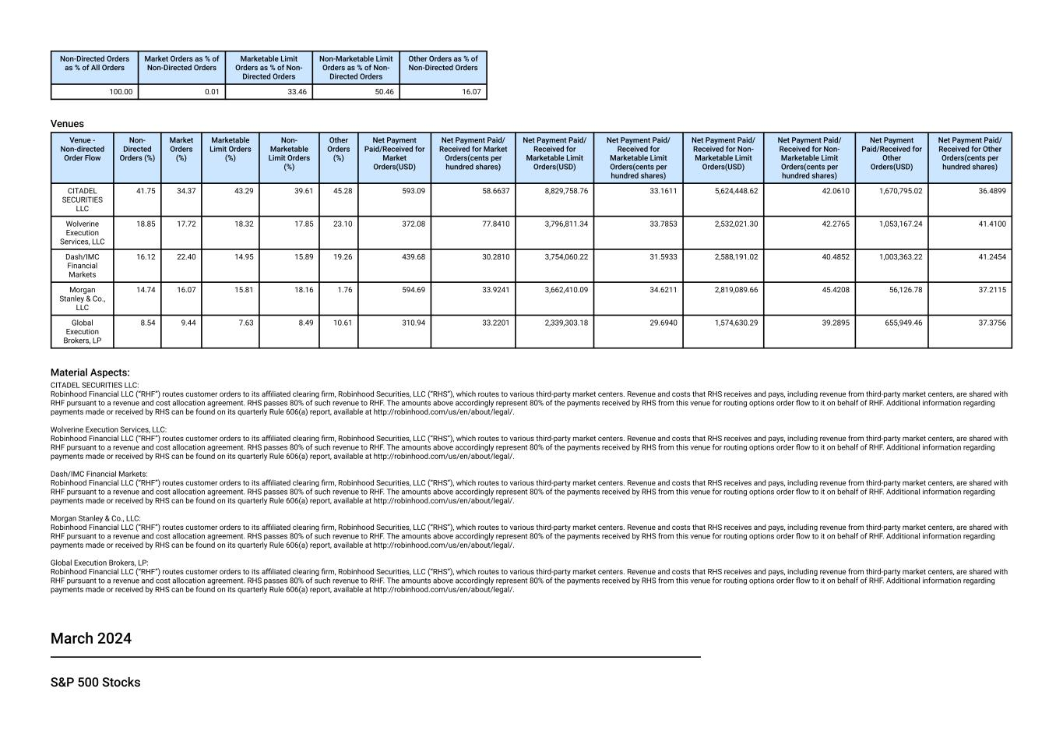
Non-Directed Orders as % of All Orders Market Orders as % of Non-Directed Orders Marketable Limit Orders as % of Non- Directed Orders Non-Marketable Limit Orders as % of Non- Directed Orders Other Orders as % of Non-Directed Orders 100.00 0.01 33.46 50.46 16.07 Venues Venue - Non-directed Order Flow Non- Directed Orders (%) Market Orders (%) Marketable Limit Orders (%) Non- Marketable Limit Orders (%) Other Orders (%) Net Payment Paid/Received for Market Orders(USD) Net Payment Paid/ Received for Market Orders(cents per hundred shares) Net Payment Paid/ Received for Marketable Limit Orders(USD) Net Payment Paid/ Received for Marketable Limit Orders(cents per hundred shares) Net Payment Paid/ Received for Non- Marketable Limit Orders(USD) Net Payment Paid/ Received for Non- Marketable Limit Orders(cents per hundred shares) Net Payment Paid/Received for Other Orders(USD) Net Payment Paid/ Received for Other Orders(cents per hundred shares) CITADEL SECURITIES LLC 41.75 34.37 43.29 39.61 45.28 593.09 58.6637 8,829,758.76 33.1611 5,624,448.62 42.0610 1,670,795.02 36.4899 Wolverine Execution Services, LLC 18.85 17.72 18.32 17.85 23.10 372.08 77.8410 3,796,811.34 33.7853 2,532,021.30 42.2765 1,053,167.24 41.4100 Dash/IMC Financial Markets 16.12 22.40 14.95 15.89 19.26 439.68 30.2810 3,754,060.22 31.5933 2,588,191.02 40.4852 1,003,363.22 41.2454 Morgan Stanley & Co., LLC 14.74 16.07 15.81 18.16 1.76 594.69 33.9241 3,662,410.09 34.6211 2,819,089.66 45.4208 56,126.78 37.2115 Global Execution Brokers, LP 8.54 9.44 7.63 8.49 10.61 310.94 33.2201 2,339,303.18 29.6940 1,574,630.29 39.2895 655,949.46 37.3756 Material Aspects: CITADEL SECURITIES LLC: Robinhood Financial LLC (“RHF”) routes customer orders to its affiliated clearing firm, Robinhood Securities, LLC (“RHS”), which routes to various third-party market centers. Revenue and costs that RHS receives and pays, including revenue from third-party market centers, are shared with RHF pursuant to a revenue and cost allocation agreement. RHS passes 80% of such revenue to RHF. The amounts above accordingly represent 80% of the payments received by RHS from this venue for routing options order flow to it on behalf of RHF. Additional information regarding payments made or received by RHS can be found on its quarterly Rule 606(a) report, available at http://robinhood.com/us/en/about/legal/. Wolverine Execution Services, LLC: Robinhood Financial LLC (“RHF”) routes customer orders to its affiliated clearing firm, Robinhood Securities, LLC (“RHS”), which routes to various third-party market centers. Revenue and costs that RHS receives and pays, including revenue from third-party market centers, are shared with RHF pursuant to a revenue and cost allocation agreement. RHS passes 80% of such revenue to RHF. The amounts above accordingly represent 80% of the payments received by RHS from this venue for routing options order flow to it on behalf of RHF. Additional information regarding payments made or received by RHS can be found on its quarterly Rule 606(a) report, available at http://robinhood.com/us/en/about/legal/. Dash/IMC Financial Markets: Robinhood Financial LLC (“RHF”) routes customer orders to its affiliated clearing firm, Robinhood Securities, LLC (“RHS”), which routes to various third-party market centers. Revenue and costs that RHS receives and pays, including revenue from third-party market centers, are shared with RHF pursuant to a revenue and cost allocation agreement. RHS passes 80% of such revenue to RHF. The amounts above accordingly represent 80% of the payments received by RHS from this venue for routing options order flow to it on behalf of RHF. Additional information regarding payments made or received by RHS can be found on its quarterly Rule 606(a) report, available at http://robinhood.com/us/en/about/legal/. Morgan Stanley & Co., LLC: Robinhood Financial LLC (“RHF”) routes customer orders to its affiliated clearing firm, Robinhood Securities, LLC (“RHS”), which routes to various third-party market centers. Revenue and costs that RHS receives and pays, including revenue from third-party market centers, are shared with RHF pursuant to a revenue and cost allocation agreement. RHS passes 80% of such revenue to RHF. The amounts above accordingly represent 80% of the payments received by RHS from this venue for routing options order flow to it on behalf of RHF. Additional information regarding payments made or received by RHS can be found on its quarterly Rule 606(a) report, available at http://robinhood.com/us/en/about/legal/. Global Execution Brokers, LP: Robinhood Financial LLC (“RHF”) routes customer orders to its affiliated clearing firm, Robinhood Securities, LLC (“RHS”), which routes to various third-party market centers. Revenue and costs that RHS receives and pays, including revenue from third-party market centers, are shared with RHF pursuant to a revenue and cost allocation agreement. RHS passes 80% of such revenue to RHF. The amounts above accordingly represent 80% of the payments received by RHS from this venue for routing options order flow to it on behalf of RHF. Additional information regarding payments made or received by RHS can be found on its quarterly Rule 606(a) report, available at http://robinhood.com/us/en/about/legal/. March 2024 S&P 500 Stocks

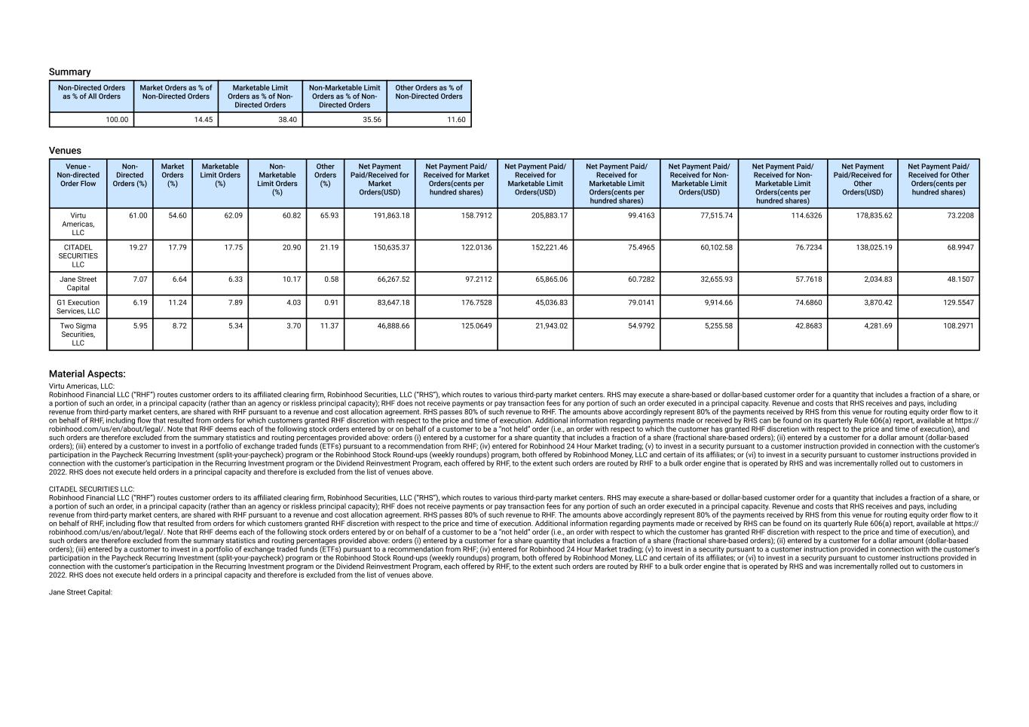
Summary Non-Directed Orders as % of All Orders Market Orders as % of Non-Directed Orders Marketable Limit Orders as % of Non- Directed Orders Non-Marketable Limit Orders as % of Non- Directed Orders Other Orders as % of Non-Directed Orders 100.00 14.45 38.40 35.56 11.60 Venues Venue - Non-directed Order Flow Non- Directed Orders (%) Market Orders (%) Marketable Limit Orders (%) Non- Marketable Limit Orders (%) Other Orders (%) Net Payment Paid/Received for Market Orders(USD) Net Payment Paid/ Received for Market Orders(cents per hundred shares) Net Payment Paid/ Received for Marketable Limit Orders(USD) Net Payment Paid/ Received for Marketable Limit Orders(cents per hundred shares) Net Payment Paid/ Received for Non- Marketable Limit Orders(USD) Net Payment Paid/ Received for Non- Marketable Limit Orders(cents per hundred shares) Net Payment Paid/Received for Other Orders(USD) Net Payment Paid/ Received for Other Orders(cents per hundred shares) Virtu Americas, LLC 61.00 54.60 62.09 60.82 65.93 191,863.18 158.7912 205,883.17 99.4163 77,515.74 114.6326 178,835.62 73.2208 CITADEL SECURITIES LLC 19.27 17.79 17.75 20.90 21.19 150,635.37 122.0136 152,221.46 75.4965 60,102.58 76.7234 138,025.19 68.9947 Jane Street Capital 7.07 6.64 6.33 10.17 0.58 66,267.52 97.2112 65,865.06 60.7282 32,655.93 57.7618 2,034.83 48.1507 G1 Execution Services, LLC 6.19 11.24 7.89 4.03 0.91 83,647.18 176.7528 45,036.83 79.0141 9,914.66 74.6860 3,870.42 129.5547 Two Sigma Securities, LLC 5.95 8.72 5.34 3.70 11.37 46,888.66 125.0649 21,943.02 54.9792 5,255.58 42.8683 4,281.69 108.2971 Material Aspects: Virtu Americas, LLC: Robinhood Financial LLC (“RHF”) routes customer orders to its affiliated clearing firm, Robinhood Securities, LLC (“RHS”), which routes to various third-party market centers. RHS may execute a share-based or dollar-based customer order for a quantity that includes a fraction of a share, or a portion of such an order, in a principal capacity (rather than an agency or riskless principal capacity); RHF does not receive payments or pay transaction fees for any portion of such an order executed in a principal capacity. Revenue and costs that RHS receives and pays, including revenue from third-party market centers, are shared with RHF pursuant to a revenue and cost allocation agreement. RHS passes 80% of such revenue to RHF. The amounts above accordingly represent 80% of the payments received by RHS from this venue for routing equity order flow to it on behalf of RHF, including flow that resulted from orders for which customers granted RHF discretion with respect to the price and time of execution. Additional information regarding payments made or received by RHS can be found on its quarterly Rule 606(a) report, available at https:// robinhood.com/us/en/about/legal/. Note that RHF deems each of the following stock orders entered by or on behalf of a customer to be a “not held” order (i.e., an order with respect to which the customer has granted RHF discretion with respect to the price and time of execution), and such orders are therefore excluded from the summary statistics and routing percentages provided above: orders (i) entered by a customer for a share quantity that includes a fraction of a share (fractional share-based orders); (ii) entered by a customer for a dollar amount (dollar-based orders); (iii) entered by a customer to invest in a portfolio of exchange traded funds (ETFs) pursuant to a recommendation from RHF; (iv) entered for Robinhood 24 Hour Market trading; (v) to invest in a security pursuant to a customer instruction provided in connection with the customer’s participation in the Paycheck Recurring Investment (split-your-paycheck) program or the Robinhood Stock Round-ups (weekly roundups) program, both offered by Robinhood Money, LLC and certain of its affiliates; or (vi) to invest in a security pursuant to customer instructions provided in connection with the customer’s participation in the Recurring Investment program or the Dividend Reinvestment Program, each offered by RHF, to the extent such orders are routed by RHF to a bulk order engine that is operated by RHS and was incrementally rolled out to customers in 2022. RHS does not execute held orders in a principal capacity and therefore is excluded from the list of venues above. CITADEL SECURITIES LLC: Robinhood Financial LLC (“RHF”) routes customer orders to its affiliated clearing firm, Robinhood Securities, LLC (“RHS”), which routes to various third-party market centers. RHS may execute a share-based or dollar-based customer order for a quantity that includes a fraction of a share, or a portion of such an order, in a principal capacity (rather than an agency or riskless principal capacity); RHF does not receive payments or pay transaction fees for any portion of such an order executed in a principal capacity. Revenue and costs that RHS receives and pays, including revenue from third-party market centers, are shared with RHF pursuant to a revenue and cost allocation agreement. RHS passes 80% of such revenue to RHF. The amounts above accordingly represent 80% of the payments received by RHS from this venue for routing equity order flow to it on behalf of RHF, including flow that resulted from orders for which customers granted RHF discretion with respect to the price and time of execution. Additional information regarding payments made or received by RHS can be found on its quarterly Rule 606(a) report, available at https:// robinhood.com/us/en/about/legal/. Note that RHF deems each of the following stock orders entered by or on behalf of a customer to be a “not held” order (i.e., an order with respect to which the customer has granted RHF discretion with respect to the price and time of execution), and such orders are therefore excluded from the summary statistics and routing percentages provided above: orders (i) entered by a customer for a share quantity that includes a fraction of a share (fractional share-based orders); (ii) entered by a customer for a dollar amount (dollar-based orders); (iii) entered by a customer to invest in a portfolio of exchange traded funds (ETFs) pursuant to a recommendation from RHF; (iv) entered for Robinhood 24 Hour Market trading; (v) to invest in a security pursuant to a customer instruction provided in connection with the customer’s participation in the Paycheck Recurring Investment (split-your-paycheck) program or the Robinhood Stock Round-ups (weekly roundups) program, both offered by Robinhood Money, LLC and certain of its affiliates; or (vi) to invest in a security pursuant to customer instructions provided in connection with the customer’s participation in the Recurring Investment program or the Dividend Reinvestment Program, each offered by RHF, to the extent such orders are routed by RHF to a bulk order engine that is operated by RHS and was incrementally rolled out to customers in 2022. RHS does not execute held orders in a principal capacity and therefore is excluded from the list of venues above. Jane Street Capital:

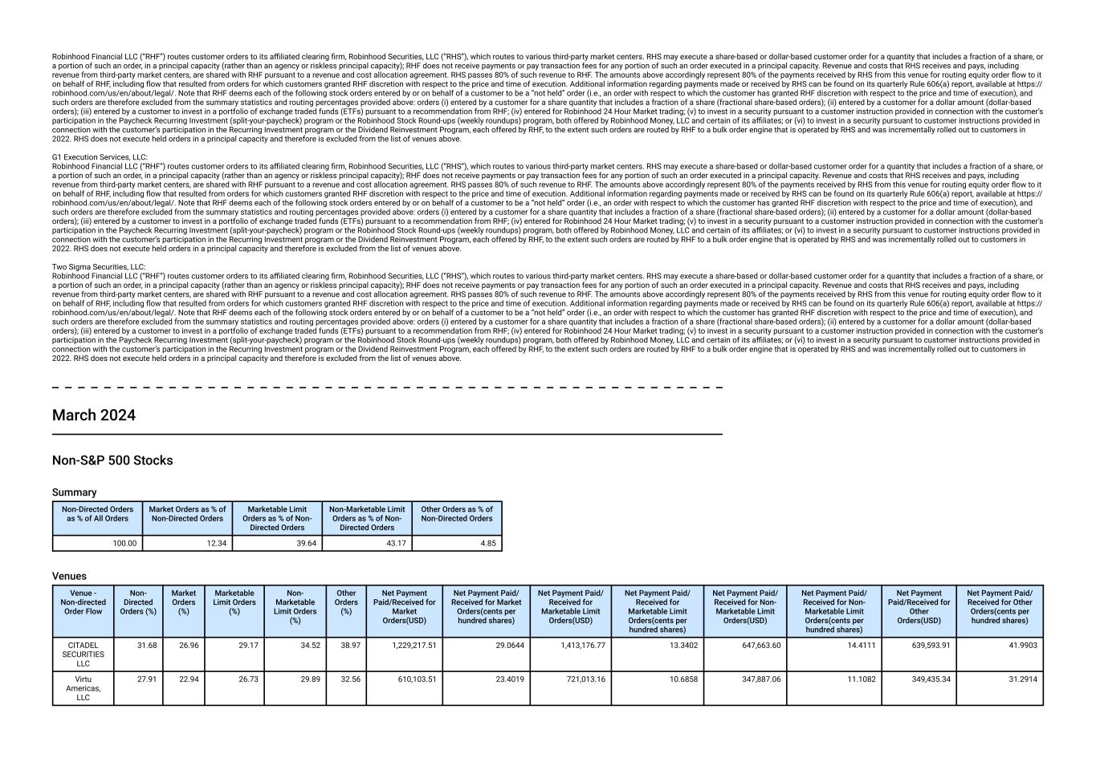
Robinhood Financial LLC (“RHF”) routes customer orders to its affiliated clearing firm, Robinhood Securities, LLC (“RHS”), which routes to various third-party market centers. RHS may execute a share-based or dollar-based customer order for a quantity that includes a fraction of a share, or a portion of such an order, in a principal capacity (rather than an agency or riskless principal capacity); RHF does not receive payments or pay transaction fees for any portion of such an order executed in a principal capacity. Revenue and costs that RHS receives and pays, including revenue from third-party market centers, are shared with RHF pursuant to a revenue and cost allocation agreement. RHS passes 80% of such revenue to RHF. The amounts above accordingly represent 80% of the payments received by RHS from this venue for routing equity order flow to it on behalf of RHF, including flow that resulted from orders for which customers granted RHF discretion with respect to the price and time of execution. Additional information regarding payments made or received by RHS can be found on its quarterly Rule 606(a) report, available at https:// robinhood.com/us/en/about/legal/. Note that RHF deems each of the following stock orders entered by or on behalf of a customer to be a “not held” order (i.e., an order with respect to which the customer has granted RHF discretion with respect to the price and time of execution), and such orders are therefore excluded from the summary statistics and routing percentages provided above: orders (i) entered by a customer for a share quantity that includes a fraction of a share (fractional share-based orders); (ii) entered by a customer for a dollar amount (dollar-based orders); (iii) entered by a customer to invest in a portfolio of exchange traded funds (ETFs) pursuant to a recommendation from RHF; (iv) entered for Robinhood 24 Hour Market trading; (v) to invest in a security pursuant to a customer instruction provided in connection with the customer’s participation in the Paycheck Recurring Investment (split-your-paycheck) program or the Robinhood Stock Round-ups (weekly roundups) program, both offered by Robinhood Money, LLC and certain of its affiliates; or (vi) to invest in a security pursuant to customer instructions provided in connection with the customer’s participation in the Recurring Investment program or the Dividend Reinvestment Program, each offered by RHF, to the extent such orders are routed by RHF to a bulk order engine that is operated by RHS and was incrementally rolled out to customers in 2022. RHS does not execute held orders in a principal capacity and therefore is excluded from the list of venues above. G1 Execution Services, LLC: Robinhood Financial LLC (“RHF”) routes customer orders to its affiliated clearing firm, Robinhood Securities, LLC (“RHS”), which routes to various third-party market centers. RHS may execute a share-based or dollar-based customer order for a quantity that includes a fraction of a share, or a portion of such an order, in a principal capacity (rather than an agency or riskless principal capacity); RHF does not receive payments or pay transaction fees for any portion of such an order executed in a principal capacity. Revenue and costs that RHS receives and pays, including revenue from third-party market centers, are shared with RHF pursuant to a revenue and cost allocation agreement. RHS passes 80% of such revenue to RHF. The amounts above accordingly represent 80% of the payments received by RHS from this venue for routing equity order flow to it on behalf of RHF, including flow that resulted from orders for which customers granted RHF discretion with respect to the price and time of execution. Additional information regarding payments made or received by RHS can be found on its quarterly Rule 606(a) report, available at https:// robinhood.com/us/en/about/legal/. Note that RHF deems each of the following stock orders entered by or on behalf of a customer to be a “not held” order (i.e., an order with respect to which the customer has granted RHF discretion with respect to the price and time of execution), and such orders are therefore excluded from the summary statistics and routing percentages provided above: orders (i) entered by a customer for a share quantity that includes a fraction of a share (fractional share-based orders); (ii) entered by a customer for a dollar amount (dollar-based orders); (iii) entered by a customer to invest in a portfolio of exchange traded funds (ETFs) pursuant to a recommendation from RHF; (iv) entered for Robinhood 24 Hour Market trading; (v) to invest in a security pursuant to a customer instruction provided in connection with the customer’s participation in the Paycheck Recurring Investment (split-your-paycheck) program or the Robinhood Stock Round-ups (weekly roundups) program, both offered by Robinhood Money, LLC and certain of its affiliates; or (vi) to invest in a security pursuant to customer instructions provided in connection with the customer’s participation in the Recurring Investment program or the Dividend Reinvestment Program, each offered by RHF, to the extent such orders are routed by RHF to a bulk order engine that is operated by RHS and was incrementally rolled out to customers in 2022. RHS does not execute held orders in a principal capacity and therefore is excluded from the list of venues above. Two Sigma Securities, LLC: Robinhood Financial LLC (“RHF”) routes customer orders to its affiliated clearing firm, Robinhood Securities, LLC (“RHS”), which routes to various third-party market centers. RHS may execute a share-based or dollar-based customer order for a quantity that includes a fraction of a share, or a portion of such an order, in a principal capacity (rather than an agency or riskless principal capacity); RHF does not receive payments or pay transaction fees for any portion of such an order executed in a principal capacity. Revenue and costs that RHS receives and pays, including revenue from third-party market centers, are shared with RHF pursuant to a revenue and cost allocation agreement. RHS passes 80% of such revenue to RHF. The amounts above accordingly represent 80% of the payments received by RHS from this venue for routing equity order flow to it on behalf of RHF, including flow that resulted from orders for which customers granted RHF discretion with respect to the price and time of execution. Additional information regarding payments made or received by RHS can be found on its quarterly Rule 606(a) report, available at https:// robinhood.com/us/en/about/legal/. Note that RHF deems each of the following stock orders entered by or on behalf of a customer to be a “not held” order (i.e., an order with respect to which the customer has granted RHF discretion with respect to the price and time of execution), and such orders are therefore excluded from the summary statistics and routing percentages provided above: orders (i) entered by a customer for a share quantity that includes a fraction of a share (fractional share-based orders); (ii) entered by a customer for a dollar amount (dollar-based orders); (iii) entered by a customer to invest in a portfolio of exchange traded funds (ETFs) pursuant to a recommendation from RHF; (iv) entered for Robinhood 24 Hour Market trading; (v) to invest in a security pursuant to a customer instruction provided in connection with the customer’s participation in the Paycheck Recurring Investment (split-your-paycheck) program or the Robinhood Stock Round-ups (weekly roundups) program, both offered by Robinhood Money, LLC and certain of its affiliates; or (vi) to invest in a security pursuant to customer instructions provided in connection with the customer’s participation in the Recurring Investment program or the Dividend Reinvestment Program, each offered by RHF, to the extent such orders are routed by RHF to a bulk order engine that is operated by RHS and was incrementally rolled out to customers in 2022. RHS does not execute held orders in a principal capacity and therefore is excluded from the list of venues above. March 2024 Non-S&P 500 Stocks Summary Non-Directed Orders as % of All Orders Market Orders as % of Non-Directed Orders Marketable Limit Orders as % of Non- Directed Orders Non-Marketable Limit Orders as % of Non- Directed Orders Other Orders as % of Non-Directed Orders 100.00 12.34 39.64 43.17 4.85 Venues Venue - Non-directed Order Flow Non- Directed Orders (%) Market Orders (%) Marketable Limit Orders (%) Non- Marketable Limit Orders (%) Other Orders (%) Net Payment Paid/Received for Market Orders(USD) Net Payment Paid/ Received for Market Orders(cents per hundred shares) Net Payment Paid/ Received for Marketable Limit Orders(USD) Net Payment Paid/ Received for Marketable Limit Orders(cents per hundred shares) Net Payment Paid/ Received for Non- Marketable Limit Orders(USD) Net Payment Paid/ Received for Non- Marketable Limit Orders(cents per hundred shares) Net Payment Paid/Received for Other Orders(USD) Net Payment Paid/ Received for Other Orders(cents per hundred shares) CITADEL SECURITIES LLC 31.68 26.96 29.17 34.52 38.97 1,229,217.51 29.0644 1,413,176.77 13.3402 647,663.60 14.4111 639,593.91 41.9903 Virtu Americas, LLC 27.91 22.94 26.73 29.89 32.56 610,103.51 23.4019 721,013.16 10.6858 347,887.06 11.1082 349,435.34 31.2914

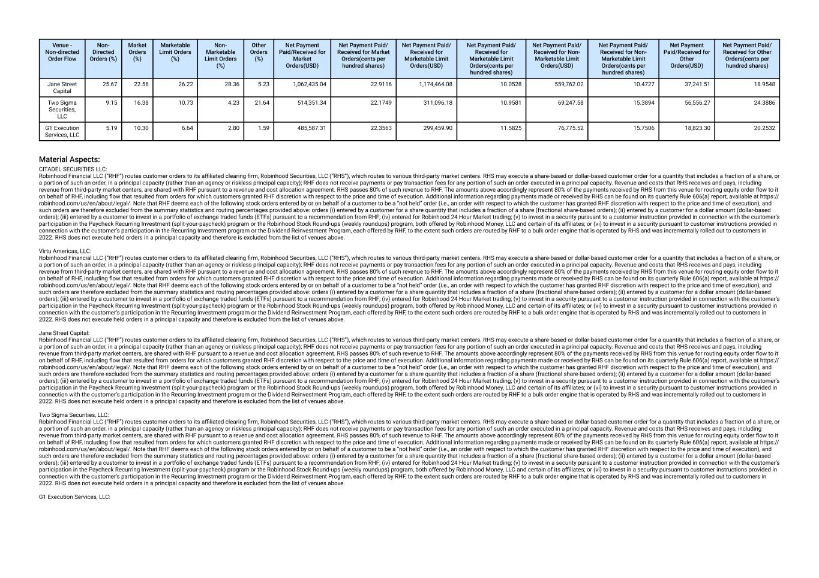
Venue - Non-directed Order Flow Non- Directed Orders (%) Market Orders (%) Marketable Limit Orders (%) Non- Marketable Limit Orders (%) Other Orders (%) Net Payment Paid/Received for Market Orders(USD) Net Payment Paid/ Received for Market Orders(cents per hundred shares) Net Payment Paid/ Received for Marketable Limit Orders(USD) Net Payment Paid/ Received for Marketable Limit Orders(cents per hundred shares) Net Payment Paid/ Received for Non- Marketable Limit Orders(USD) Net Payment Paid/ Received for Non- Marketable Limit Orders(cents per hundred shares) Net Payment Paid/Received for Other Orders(USD) Net Payment Paid/ Received for Other Orders(cents per hundred shares) Jane Street Capital 25.67 22.56 26.22 28.36 5.23 1,062,435.04 22.9116 1,174,464.08 10.0528 559,762.02 10.4727 37,241.51 18.9548 Two Sigma Securities, LLC 9.15 16.38 10.73 4.23 21.64 514,351.34 22.1749 311,096.18 10.9581 69,247.58 15.3894 56,556.27 24.3886 G1 Execution Services, LLC 5.19 10.30 6.64 2.80 1.59 485,587.31 22.3563 299,459.90 11.5825 76,775.52 15.7506 18,823.30 20.2532 Material Aspects: CITADEL SECURITIES LLC: Robinhood Financial LLC (“RHF”) routes customer orders to its affiliated clearing firm, Robinhood Securities, LLC (“RHS”), which routes to various third-party market centers. RHS may execute a share-based or dollar-based customer order for a quantity that includes a fraction of a share, or a portion of such an order, in a principal capacity (rather than an agency or riskless principal capacity); RHF does not receive payments or pay transaction fees for any portion of such an order executed in a principal capacity. Revenue and costs that RHS receives and pays, including revenue from third-party market centers, are shared with RHF pursuant to a revenue and cost allocation agreement. RHS passes 80% of such revenue to RHF. The amounts above accordingly represent 80% of the payments received by RHS from this venue for routing equity order flow to it on behalf of RHF, including flow that resulted from orders for which customers granted RHF discretion with respect to the price and time of execution. Additional information regarding payments made or received by RHS can be found on its quarterly Rule 606(a) report, available at https:// robinhood.com/us/en/about/legal/. Note that RHF deems each of the following stock orders entered by or on behalf of a customer to be a “not held” order (i.e., an order with respect to which the customer has granted RHF discretion with respect to the price and time of execution), and such orders are therefore excluded from the summary statistics and routing percentages provided above: orders (i) entered by a customer for a share quantity that includes a fraction of a share (fractional share-based orders); (ii) entered by a customer for a dollar amount (dollar-based orders); (iii) entered by a customer to invest in a portfolio of exchange traded funds (ETFs) pursuant to a recommendation from RHF; (iv) entered for Robinhood 24 Hour Market trading; (v) to invest in a security pursuant to a customer instruction provided in connection with the customer’s participation in the Paycheck Recurring Investment (split-your-paycheck) program or the Robinhood Stock Round-ups (weekly roundups) program, both offered by Robinhood Money, LLC and certain of its affiliates; or (vi) to invest in a security pursuant to customer instructions provided in connection with the customer’s participation in the Recurring Investment program or the Dividend Reinvestment Program, each offered by RHF, to the extent such orders are routed by RHF to a bulk order engine that is operated by RHS and was incrementally rolled out to customers in 2022. RHS does not execute held orders in a principal capacity and therefore is excluded from the list of venues above. Virtu Americas, LLC: Robinhood Financial LLC (“RHF”) routes customer orders to its affiliated clearing firm, Robinhood Securities, LLC (“RHS”), which routes to various third-party market centers. RHS may execute a share-based or dollar-based customer order for a quantity that includes a fraction of a share, or a portion of such an order, in a principal capacity (rather than an agency or riskless principal capacity); RHF does not receive payments or pay transaction fees for any portion of such an order executed in a principal capacity. Revenue and costs that RHS receives and pays, including revenue from third-party market centers, are shared with RHF pursuant to a revenue and cost allocation agreement. RHS passes 80% of such revenue to RHF. The amounts above accordingly represent 80% of the payments received by RHS from this venue for routing equity order flow to it on behalf of RHF, including flow that resulted from orders for which customers granted RHF discretion with respect to the price and time of execution. Additional information regarding payments made or received by RHS can be found on its quarterly Rule 606(a) report, available at https:// robinhood.com/us/en/about/legal/. Note that RHF deems each of the following stock orders entered by or on behalf of a customer to be a “not held” order (i.e., an order with respect to which the customer has granted RHF discretion with respect to the price and time of execution), and such orders are therefore excluded from the summary statistics and routing percentages provided above: orders (i) entered by a customer for a share quantity that includes a fraction of a share (fractional share-based orders); (ii) entered by a customer for a dollar amount (dollar-based orders); (iii) entered by a customer to invest in a portfolio of exchange traded funds (ETFs) pursuant to a recommendation from RHF; (iv) entered for Robinhood 24 Hour Market trading; (v) to invest in a security pursuant to a customer instruction provided in connection with the customer’s participation in the Paycheck Recurring Investment (split-your-paycheck) program or the Robinhood Stock Round-ups (weekly roundups) program, both offered by Robinhood Money, LLC and certain of its affiliates; or (vi) to invest in a security pursuant to customer instructions provided in connection with the customer’s participation in the Recurring Investment program or the Dividend Reinvestment Program, each offered by RHF, to the extent such orders are routed by RHF to a bulk order engine that is operated by RHS and was incrementally rolled out to customers in 2022. RHS does not execute held orders in a principal capacity and therefore is excluded from the list of venues above. Jane Street Capital: Robinhood Financial LLC (“RHF”) routes customer orders to its affiliated clearing firm, Robinhood Securities, LLC (“RHS”), which routes to various third-party market centers. RHS may execute a share-based or dollar-based customer order for a quantity that includes a fraction of a share, or a portion of such an order, in a principal capacity (rather than an agency or riskless principal capacity); RHF does not receive payments or pay transaction fees for any portion of such an order executed in a principal capacity. Revenue and costs that RHS receives and pays, including revenue from third-party market centers, are shared with RHF pursuant to a revenue and cost allocation agreement. RHS passes 80% of such revenue to RHF. The amounts above accordingly represent 80% of the payments received by RHS from this venue for routing equity order flow to it on behalf of RHF, including flow that resulted from orders for which customers granted RHF discretion with respect to the price and time of execution. Additional information regarding payments made or received by RHS can be found on its quarterly Rule 606(a) report, available at https:// robinhood.com/us/en/about/legal/. Note that RHF deems each of the following stock orders entered by or on behalf of a customer to be a “not held” order (i.e., an order with respect to which the customer has granted RHF discretion with respect to the price and time of execution), and such orders are therefore excluded from the summary statistics and routing percentages provided above: orders (i) entered by a customer for a share quantity that includes a fraction of a share (fractional share-based orders); (ii) entered by a customer for a dollar amount (dollar-based orders); (iii) entered by a customer to invest in a portfolio of exchange traded funds (ETFs) pursuant to a recommendation from RHF; (iv) entered for Robinhood 24 Hour Market trading; (v) to invest in a security pursuant to a customer instruction provided in connection with the customer’s participation in the Paycheck Recurring Investment (split-your-paycheck) program or the Robinhood Stock Round-ups (weekly roundups) program, both offered by Robinhood Money, LLC and certain of its affiliates; or (vi) to invest in a security pursuant to customer instructions provided in connection with the customer’s participation in the Recurring Investment program or the Dividend Reinvestment Program, each offered by RHF, to the extent such orders are routed by RHF to a bulk order engine that is operated by RHS and was incrementally rolled out to customers in 2022. RHS does not execute held orders in a principal capacity and therefore is excluded from the list of venues above. Two Sigma Securities, LLC: Robinhood Financial LLC (“RHF”) routes customer orders to its affiliated clearing firm, Robinhood Securities, LLC (“RHS”), which routes to various third-party market centers. RHS may execute a share-based or dollar-based customer order for a quantity that includes a fraction of a share, or a portion of such an order, in a principal capacity (rather than an agency or riskless principal capacity); RHF does not receive payments or pay transaction fees for any portion of such an order executed in a principal capacity. Revenue and costs that RHS receives and pays, including revenue from third-party market centers, are shared with RHF pursuant to a revenue and cost allocation agreement. RHS passes 80% of such revenue to RHF. The amounts above accordingly represent 80% of the payments received by RHS from this venue for routing equity order flow to it on behalf of RHF, including flow that resulted from orders for which customers granted RHF discretion with respect to the price and time of execution. Additional information regarding payments made or received by RHS can be found on its quarterly Rule 606(a) report, available at https:// robinhood.com/us/en/about/legal/. Note that RHF deems each of the following stock orders entered by or on behalf of a customer to be a “not held” order (i.e., an order with respect to which the customer has granted RHF discretion with respect to the price and time of execution), and such orders are therefore excluded from the summary statistics and routing percentages provided above: orders (i) entered by a customer for a share quantity that includes a fraction of a share (fractional share-based orders); (ii) entered by a customer for a dollar amount (dollar-based orders); (iii) entered by a customer to invest in a portfolio of exchange traded funds (ETFs) pursuant to a recommendation from RHF; (iv) entered for Robinhood 24 Hour Market trading; (v) to invest in a security pursuant to a customer instruction provided in connection with the customer’s participation in the Paycheck Recurring Investment (split-your-paycheck) program or the Robinhood Stock Round-ups (weekly roundups) program, both offered by Robinhood Money, LLC and certain of its affiliates; or (vi) to invest in a security pursuant to customer instructions provided in connection with the customer’s participation in the Recurring Investment program or the Dividend Reinvestment Program, each offered by RHF, to the extent such orders are routed by RHF to a bulk order engine that is operated by RHS and was incrementally rolled out to customers in 2022. RHS does not execute held orders in a principal capacity and therefore is excluded from the list of venues above. G1 Execution Services, LLC:

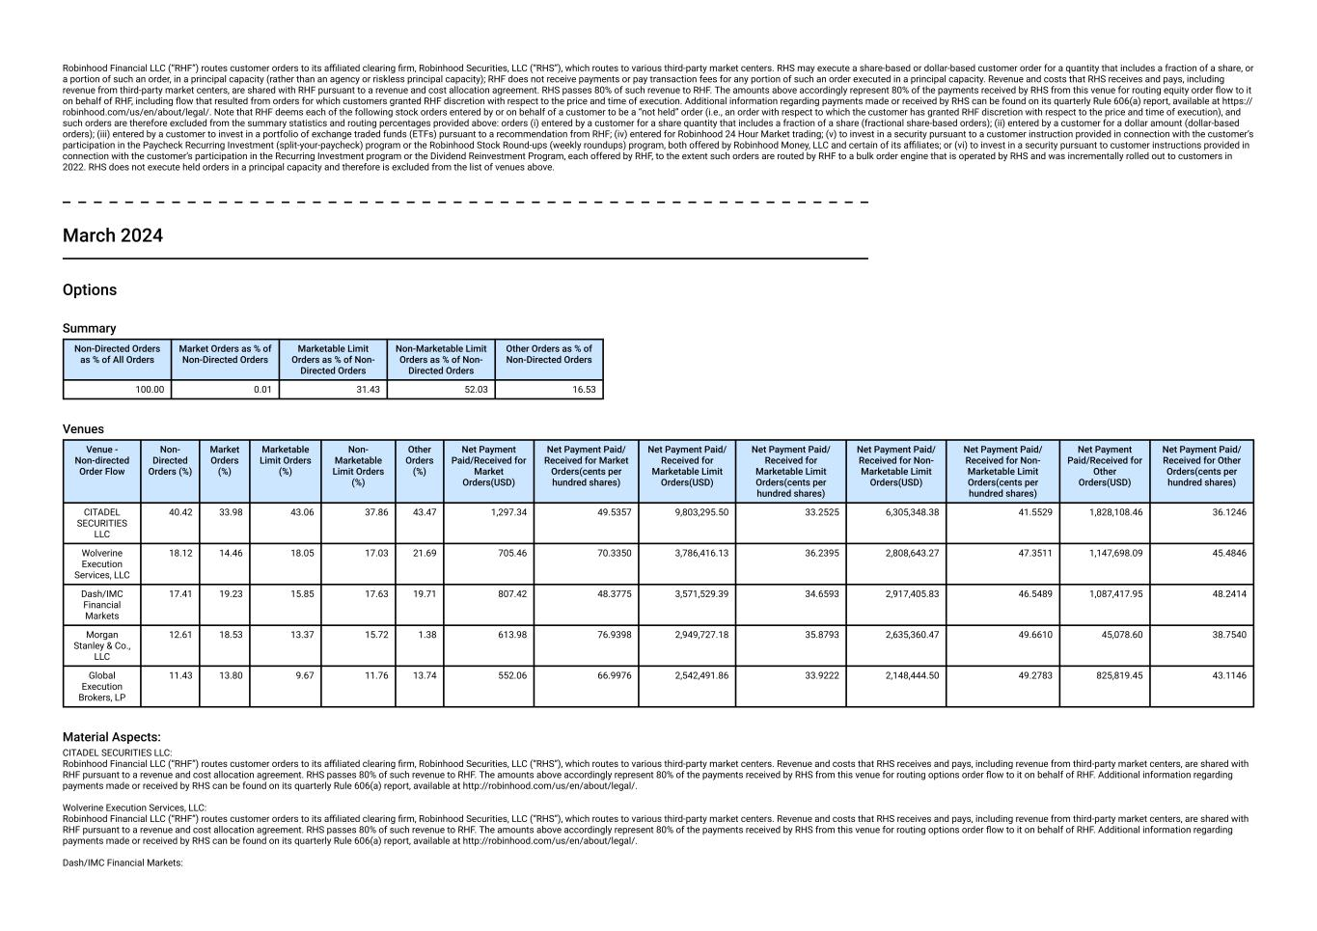
Robinhood Financial LLC (“RHF”) routes customer orders to its affiliated clearing firm, Robinhood Securities, LLC (“RHS”), which routes to various third-party market centers. RHS may execute a share-based or dollar-based customer order for a quantity that includes a fraction of a share, or a portion of such an order, in a principal capacity (rather than an agency or riskless principal capacity); RHF does not receive payments or pay transaction fees for any portion of such an order executed in a principal capacity. Revenue and costs that RHS receives and pays, including revenue from third-party market centers, are shared with RHF pursuant to a revenue and cost allocation agreement. RHS passes 80% of such revenue to RHF. The amounts above accordingly represent 80% of the payments received by RHS from this venue for routing equity order flow to it on behalf of RHF, including flow that resulted from orders for which customers granted RHF discretion with respect to the price and time of execution. Additional information regarding payments made or received by RHS can be found on its quarterly Rule 606(a) report, available at https:// robinhood.com/us/en/about/legal/. Note that RHF deems each of the following stock orders entered by or on behalf of a customer to be a “not held” order (i.e., an order with respect to which the customer has granted RHF discretion with respect to the price and time of execution), and such orders are therefore excluded from the summary statistics and routing percentages provided above: orders (i) entered by a customer for a share quantity that includes a fraction of a share (fractional share-based orders); (ii) entered by a customer for a dollar amount (dollar-based orders); (iii) entered by a customer to invest in a portfolio of exchange traded funds (ETFs) pursuant to a recommendation from RHF; (iv) entered for Robinhood 24 Hour Market trading; (v) to invest in a security pursuant to a customer instruction provided in connection with the customer’s participation in the Paycheck Recurring Investment (split-your-paycheck) program or the Robinhood Stock Round-ups (weekly roundups) program, both offered by Robinhood Money, LLC and certain of its affiliates; or (vi) to invest in a security pursuant to customer instructions provided in connection with the customer’s participation in the Recurring Investment program or the Dividend Reinvestment Program, each offered by RHF, to the extent such orders are routed by RHF to a bulk order engine that is operated by RHS and was incrementally rolled out to customers in 2022. RHS does not execute held orders in a principal capacity and therefore is excluded from the list of venues above. March 2024 Options Summary Non-Directed Orders as % of All Orders Market Orders as % of Non-Directed Orders Marketable Limit Orders as % of Non- Directed Orders Non-Marketable Limit Orders as % of Non- Directed Orders Other Orders as % of Non-Directed Orders 100.00 0.01 31.43 52.03 16.53 Venues Venue - Non-directed Order Flow Non- Directed Orders (%) Market Orders (%) Marketable Limit Orders (%) Non- Marketable Limit Orders (%) Other Orders (%) Net Payment Paid/Received for Market Orders(USD) Net Payment Paid/ Received for Market Orders(cents per hundred shares) Net Payment Paid/ Received for Marketable Limit Orders(USD) Net Payment Paid/ Received for Marketable Limit Orders(cents per hundred shares) Net Payment Paid/ Received for Non- Marketable Limit Orders(USD) Net Payment Paid/ Received for Non- Marketable Limit Orders(cents per hundred shares) Net Payment Paid/Received for Other Orders(USD) Net Payment Paid/ Received for Other Orders(cents per hundred shares) CITADEL SECURITIES LLC 40.42 33.98 43.06 37.86 43.47 1,297.34 49.5357 9,803,295.50 33.2525 6,305,348.38 41.5529 1,828,108.46 36.1246 Wolverine Execution Services, LLC 18.12 14.46 18.05 17.03 21.69 705.46 70.3350 3,786,416.13 36.2395 2,808,643.27 47.3511 1,147,698.09 45.4846 Dash/IMC Financial Markets 17.41 19.23 15.85 17.63 19.71 807.42 48.3775 3,571,529.39 34.6593 2,917,405.83 46.5489 1,087,417.95 48.2414 Morgan Stanley & Co., LLC 12.61 18.53 13.37 15.72 1.38 613.98 76.9398 2,949,727.18 35.8793 2,635,360.47 49.6610 45,078.60 38.7540 Global Execution Brokers, LP 11.43 13.80 9.67 11.76 13.74 552.06 66.9976 2,542,491.86 33.9222 2,148,444.50 49.2783 825,819.45 43.1146 Material Aspects: CITADEL SECURITIES LLC: Robinhood Financial LLC (“RHF”) routes customer orders to its affiliated clearing firm, Robinhood Securities, LLC (“RHS”), which routes to various third-party market centers. Revenue and costs that RHS receives and pays, including revenue from third-party market centers, are shared with RHF pursuant to a revenue and cost allocation agreement. RHS passes 80% of such revenue to RHF. The amounts above accordingly represent 80% of the payments received by RHS from this venue for routing options order flow to it on behalf of RHF. Additional information regarding payments made or received by RHS can be found on its quarterly Rule 606(a) report, available at http://robinhood.com/us/en/about/legal/. Wolverine Execution Services, LLC: Robinhood Financial LLC (“RHF”) routes customer orders to its affiliated clearing firm, Robinhood Securities, LLC (“RHS”), which routes to various third-party market centers. Revenue and costs that RHS receives and pays, including revenue from third-party market centers, are shared with RHF pursuant to a revenue and cost allocation agreement. RHS passes 80% of such revenue to RHF. The amounts above accordingly represent 80% of the payments received by RHS from this venue for routing options order flow to it on behalf of RHF. Additional information regarding payments made or received by RHS can be found on its quarterly Rule 606(a) report, available at http://robinhood.com/us/en/about/legal/. Dash/IMC Financial Markets:

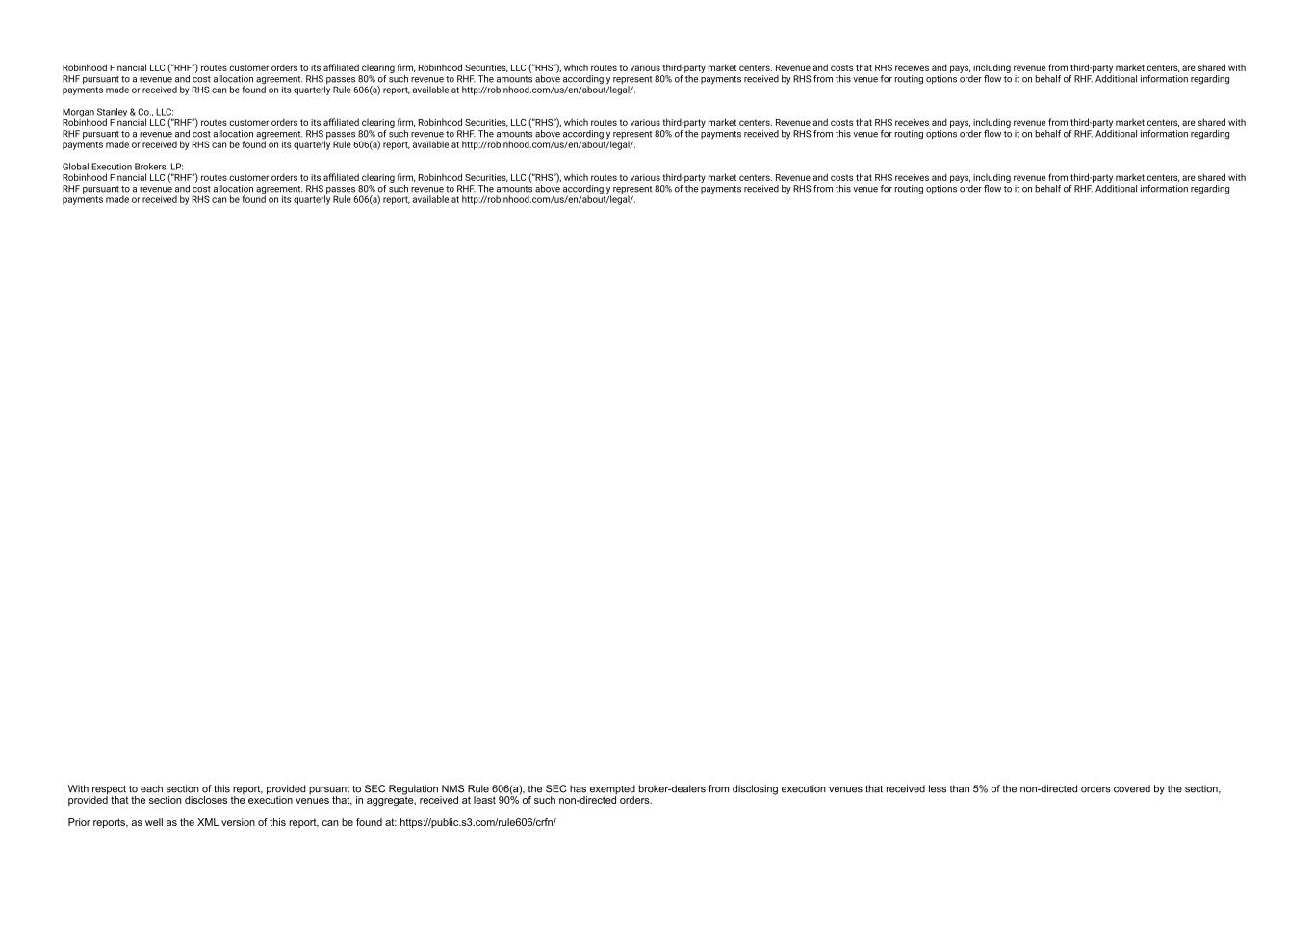
Robinhood Financial LLC (“RHF”) routes customer orders to its affiliated clearing firm, Robinhood Securities, LLC (“RHS”), which routes to various third-party market centers. Revenue and costs that RHS receives and pays, including revenue from third-party market centers, are shared with RHF pursuant to a revenue and cost allocation agreement. RHS passes 80% of such revenue to RHF. The amounts above accordingly represent 80% of the payments received by RHS from this venue for routing options order flow to it on behalf of RHF. Additional information regarding payments made or received by RHS can be found on its quarterly Rule 606(a) report, available at http://robinhood.com/us/en/about/legal/. Morgan Stanley & Co., LLC: Robinhood Financial LLC (“RHF”) routes customer orders to its affiliated clearing firm, Robinhood Securities, LLC (“RHS”), which routes to various third-party market centers. Revenue and costs that RHS receives and pays, including revenue from third-party market centers, are shared with RHF pursuant to a revenue and cost allocation agreement. RHS passes 80% of such revenue to RHF. The amounts above accordingly represent 80% of the payments received by RHS from this venue for routing options order flow to it on behalf of RHF. Additional information regarding payments made or received by RHS can be found on its quarterly Rule 606(a) report, available at http://robinhood.com/us/en/about/legal/. Global Execution Brokers, LP: Robinhood Financial LLC (“RHF”) routes customer orders to its affiliated clearing firm, Robinhood Securities, LLC (“RHS”), which routes to various third-party market centers. Revenue and costs that RHS receives and pays, including revenue from third-party market centers, are shared with RHF pursuant to a revenue and cost allocation agreement. RHS passes 80% of such revenue to RHF. The amounts above accordingly represent 80% of the payments received by RHS from this venue for routing options order flow to it on behalf of RHF. Additional information regarding payments made or received by RHS can be found on its quarterly Rule 606(a) report, available at http://robinhood.com/us/en/about/legal/.

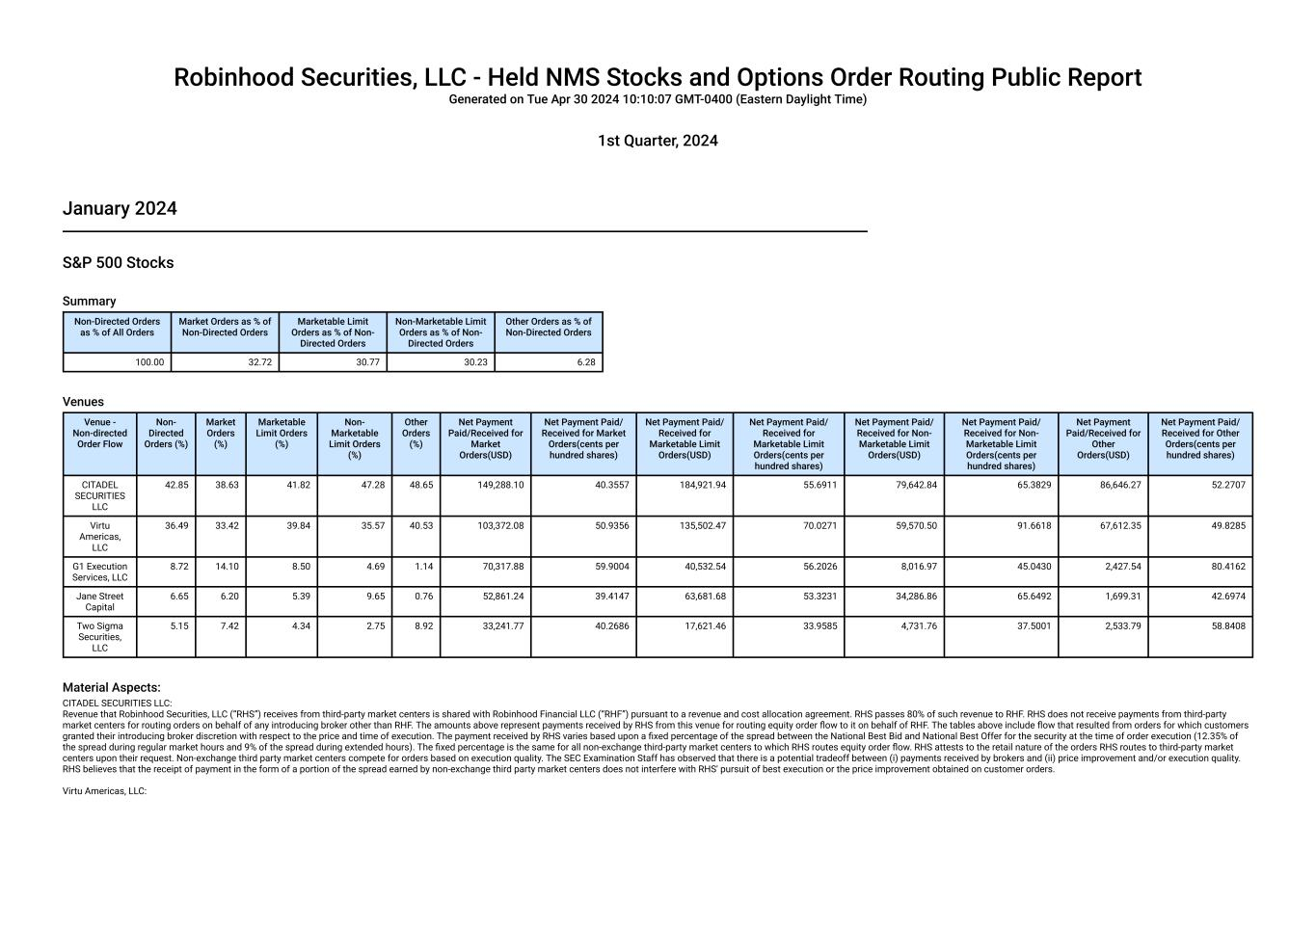
Robinhood Securities, LLC - Held NMS Stocks and Options Order Routing Public Report Generated on Tue Apr 30 2024 10:10:07 GMT-0400 (Eastern Daylight Time) 1st Quarter, 2024 January 2024 S&P 500 Stocks Summary Non-Directed Orders as % of All Orders Market Orders as % of Non-Directed Orders Marketable Limit Orders as % of Non- Directed Orders Non-Marketable Limit Orders as % of Non- Directed Orders Other Orders as % of Non-Directed Orders 100.00 32.72 30.77 30.23 6.28 Venues Venue - Non-directed Order Flow Non- Directed Orders (%) Market Orders (%) Marketable Limit Orders (%) Non- Marketable Limit Orders (%) Other Orders (%) Net Payment Paid/Received for Market Orders(USD) Net Payment Paid/ Received for Market Orders(cents per hundred shares) Net Payment Paid/ Received for Marketable Limit Orders(USD) Net Payment Paid/ Received for Marketable Limit Orders(cents per hundred shares) Net Payment Paid/ Received for Non- Marketable Limit Orders(USD) Net Payment Paid/ Received for Non- Marketable Limit Orders(cents per hundred shares) Net Payment Paid/Received for Other Orders(USD) Net Payment Paid/ Received for Other Orders(cents per hundred shares) CITADEL SECURITIES LLC 42.85 38.63 41.82 47.28 48.65 149,288.10 40.3557 184,921.94 55.6911 79,642.84 65.3829 86,646.27 52.2707 Virtu Americas, LLC 36.49 33.42 39.84 35.57 40.53 103,372.08 50.9356 135,502.47 70.0271 59,570.50 91.6618 67,612.35 49.8285 G1 Execution Services, LLC 8.72 14.10 8.50 4.69 1.14 70,317.88 59.9004 40,532.54 56.2026 8,016.97 45.0430 2,427.54 80.4162 Jane Street Capital 6.65 6.20 5.39 9.65 0.76 52,861.24 39.4147 63,681.68 53.3231 34,286.86 65.6492 1,699.31 42.6974 Two Sigma Securities, LLC 5.15 7.42 4.34 2.75 8.92 33,241.77 40.2686 17,621.46 33.9585 4,731.76 37.5001 2,533.79 58.8408 Material Aspects: CITADEL SECURITIES LLC: Revenue that Robinhood Securities, LLC (“RHS”) receives from third-party market centers is shared with Robinhood Financial LLC (“RHF”) pursuant to a revenue and cost allocation agreement. RHS passes 80% of such revenue to RHF. RHS does not receive payments from third-party market centers for routing orders on behalf of any introducing broker other than RHF. The amounts above represent payments received by RHS from this venue for routing equity order flow to it on behalf of RHF. The tables above include flow that resulted from orders for which customers granted their introducing broker discretion with respect to the price and time of execution. The payment received by RHS varies based upon a fixed percentage of the spread between the National Best Bid and National Best Offer for the security at the time of order execution (12.35% of the spread during regular market hours and 9% of the spread during extended hours). The fixed percentage is the same for all non-exchange third-party market centers to which RHS routes equity order flow. RHS attests to the retail nature of the orders RHS routes to third-party market centers upon their request. Non-exchange third party market centers compete for orders based on execution quality. The SEC Examination Staff has observed that there is a potential tradeoff between (i) payments received by brokers and (ii) price improvement and/or execution quality. RHS believes that the receipt of payment in the form of a portion of the spread earned by non-exchange third party market centers does not interfere with RHS' pursuit of best execution or the price improvement obtained on customer orders. Virtu Americas, LLC:

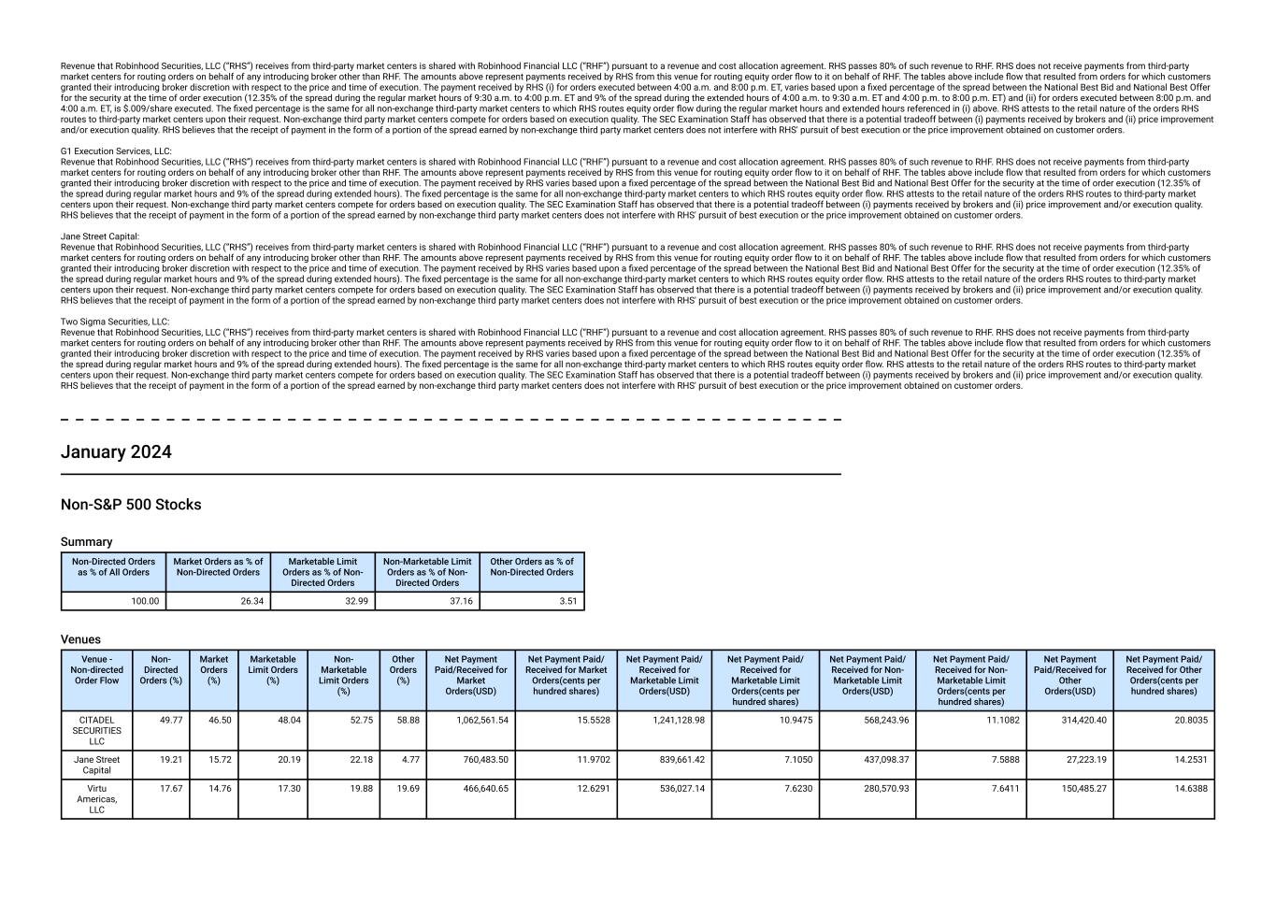
Revenue that Robinhood Securities, LLC (“RHS”) receives from third-party market centers is shared with Robinhood Financial LLC (“RHF”) pursuant to a revenue and cost allocation agreement. RHS passes 80% of such revenue to RHF. RHS does not receive payments from third-party market centers for routing orders on behalf of any introducing broker other than RHF. The amounts above represent payments received by RHS from this venue for routing equity order flow to it on behalf of RHF. The tables above include flow that resulted from orders for which customers granted their introducing broker discretion with respect to the price and time of execution. The payment received by RHS (i) for orders executed between 4:00 a.m. and 8:00 p.m. ET, varies based upon a fixed percentage of the spread between the National Best Bid and National Best Offer for the security at the time of order execution (12.35% of the spread during the regular market hours of 9:30 a.m. to 4:00 p.m. ET and 9% of the spread during the extended hours of 4:00 a.m. to 9:30 a.m. ET and 4:00 p.m. to 8:00 p.m. ET) and (ii) for orders executed between 8:00 p.m. and 4:00 a.m. ET, is $.009/share executed. The fixed percentage is the same for all non-exchange third-party market centers to which RHS routes equity order flow during the regular market hours and extended hours referenced in (i) above. RHS attests to the retail nature of the orders RHS routes to third-party market centers upon their request. Non-exchange third party market centers compete for orders based on execution quality. The SEC Examination Staff has observed that there is a potential tradeoff between (i) payments received by brokers and (ii) price improvement and/or execution quality. RHS believes that the receipt of payment in the form of a portion of the spread earned by non-exchange third party market centers does not interfere with RHS' pursuit of best execution or the price improvement obtained on customer orders. G1 Execution Services, LLC: Revenue that Robinhood Securities, LLC (“RHS”) receives from third-party market centers is shared with Robinhood Financial LLC (“RHF”) pursuant to a revenue and cost allocation agreement. RHS passes 80% of such revenue to RHF. RHS does not receive payments from third-party market centers for routing orders on behalf of any introducing broker other than RHF. The amounts above represent payments received by RHS from this venue for routing equity order flow to it on behalf of RHF. The tables above include flow that resulted from orders for which customers granted their introducing broker discretion with respect to the price and time of execution. The payment received by RHS varies based upon a fixed percentage of the spread between the National Best Bid and National Best Offer for the security at the time of order execution (12.35% of the spread during regular market hours and 9% of the spread during extended hours). The fixed percentage is the same for all non-exchange third-party market centers to which RHS routes equity order flow. RHS attests to the retail nature of the orders RHS routes to third-party market centers upon their request. Non-exchange third party market centers compete for orders based on execution quality. The SEC Examination Staff has observed that there is a potential tradeoff between (i) payments received by brokers and (ii) price improvement and/or execution quality. RHS believes that the receipt of payment in the form of a portion of the spread earned by non-exchange third party market centers does not interfere with RHS' pursuit of best execution or the price improvement obtained on customer orders. Jane Street Capital: Revenue that Robinhood Securities, LLC (“RHS”) receives from third-party market centers is shared with Robinhood Financial LLC (“RHF”) pursuant to a revenue and cost allocation agreement. RHS passes 80% of such revenue to RHF. RHS does not receive payments from third-party market centers for routing orders on behalf of any introducing broker other than RHF. The amounts above represent payments received by RHS from this venue for routing equity order flow to it on behalf of RHF. The tables above include flow that resulted from orders for which customers granted their introducing broker discretion with respect to the price and time of execution. The payment received by RHS varies based upon a fixed percentage of the spread between the National Best Bid and National Best Offer for the security at the time of order execution (12.35% of the spread during regular market hours and 9% of the spread during extended hours). The fixed percentage is the same for all non-exchange third-party market centers to which RHS routes equity order flow. RHS attests to the retail nature of the orders RHS routes to third-party market centers upon their request. Non-exchange third party market centers compete for orders based on execution quality. The SEC Examination Staff has observed that there is a potential tradeoff between (i) payments received by brokers and (ii) price improvement and/or execution quality. RHS believes that the receipt of payment in the form of a portion of the spread earned by non-exchange third party market centers does not interfere with RHS' pursuit of best execution or the price improvement obtained on customer orders. Two Sigma Securities, LLC: Revenue that Robinhood Securities, LLC (“RHS”) receives from third-party market centers is shared with Robinhood Financial LLC (“RHF”) pursuant to a revenue and cost allocation agreement. RHS passes 80% of such revenue to RHF. RHS does not receive payments from third-party market centers for routing orders on behalf of any introducing broker other than RHF. The amounts above represent payments received by RHS from this venue for routing equity order flow to it on behalf of RHF. The tables above include flow that resulted from orders for which customers granted their introducing broker discretion with respect to the price and time of execution. The payment received by RHS varies based upon a fixed percentage of the spread between the National Best Bid and National Best Offer for the security at the time of order execution (12.35% of the spread during regular market hours and 9% of the spread during extended hours). The fixed percentage is the same for all non-exchange third-party market centers to which RHS routes equity order flow. RHS attests to the retail nature of the orders RHS routes to third-party market centers upon their request. Non-exchange third party market centers compete for orders based on execution quality. The SEC Examination Staff has observed that there is a potential tradeoff between (i) payments received by brokers and (ii) price improvement and/or execution quality. RHS believes that the receipt of payment in the form of a portion of the spread earned by non-exchange third party market centers does not interfere with RHS' pursuit of best execution or the price improvement obtained on customer orders. January 2024 Non-S&P 500 Stocks Summary Non-Directed Orders as % of All Orders Market Orders as % of Non-Directed Orders Marketable Limit Orders as % of Non- Directed Orders Non-Marketable Limit Orders as % of Non- Directed Orders Other Orders as % of Non-Directed Orders 100.00 26.34 32.99 37.16 3.51 Venues Venue - Non-directed Order Flow Non- Directed Orders (%) Market Orders (%) Marketable Limit Orders (%) Non- Marketable Limit Orders (%) Other Orders (%) Net Payment Paid/Received for Market Orders(USD) Net Payment Paid/ Received for Market Orders(cents per hundred shares) Net Payment Paid/ Received for Marketable Limit Orders(USD) Net Payment Paid/ Received for Marketable Limit Orders(cents per hundred shares) Net Payment Paid/ Received for Non- Marketable Limit Orders(USD) Net Payment Paid/ Received for Non- Marketable Limit Orders(cents per hundred shares) Net Payment Paid/Received for Other Orders(USD) Net Payment Paid/ Received for Other Orders(cents per hundred shares) CITADEL SECURITIES LLC 49.77 46.50 48.04 52.75 58.88 1,062,561.54 15.5528 1,241,128.98 10.9475 568,243.96 11.1082 314,420.40 20.8035 Jane Street Capital 19.21 15.72 20.19 22.18 4.77 760,483.50 11.9702 839,661.42 7.1050 437,098.37 7.5888 27,223.19 14.2531 Virtu Americas, LLC 17.67 14.76 17.30 19.88 19.69 466,640.65 12.6291 536,027.14 7.6230 280,570.93 7.6411 150,485.27 14.6388

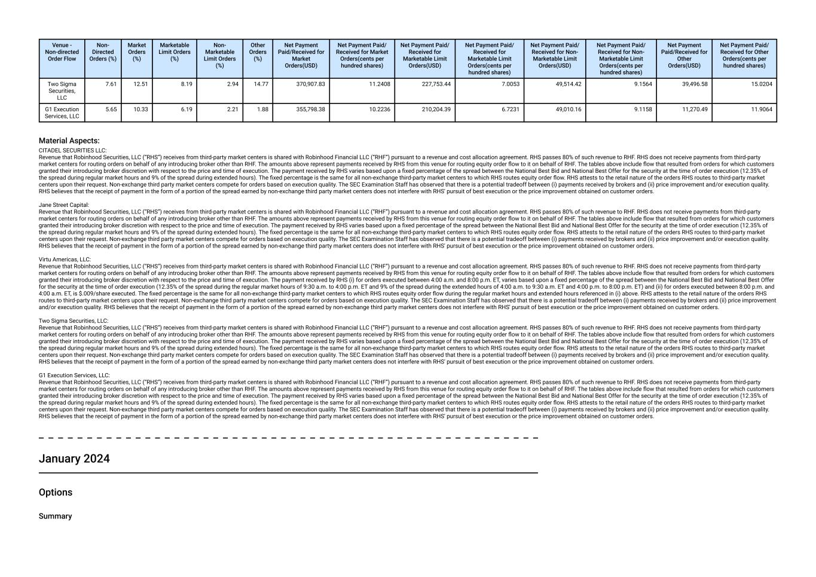
Venue - Non-directed Order Flow Non- Directed Orders (%) Market Orders (%) Marketable Limit Orders (%) Non- Marketable Limit Orders (%) Other Orders (%) Net Payment Paid/Received for Market Orders(USD) Net Payment Paid/ Received for Market Orders(cents per hundred shares) Net Payment Paid/ Received for Marketable Limit Orders(USD) Net Payment Paid/ Received for Marketable Limit Orders(cents per hundred shares) Net Payment Paid/ Received for Non- Marketable Limit Orders(USD) Net Payment Paid/ Received for Non- Marketable Limit Orders(cents per hundred shares) Net Payment Paid/Received for Other Orders(USD) Net Payment Paid/ Received for Other Orders(cents per hundred shares) Two Sigma Securities, LLC 7.61 12.51 8.19 2.94 14.77 370,907.83 11.2408 227,753.44 7.0053 49,514.42 9.1564 39,496.58 15.0204 G1 Execution Services, LLC 5.65 10.33 6.19 2.21 1.88 355,798.38 10.2236 210,204.39 6.7231 49,010.16 9.1158 11,270.49 11.9064 Material Aspects: CITADEL SECURITIES LLC: Revenue that Robinhood Securities, LLC (“RHS”) receives from third-party market centers is shared with Robinhood Financial LLC (“RHF”) pursuant to a revenue and cost allocation agreement. RHS passes 80% of such revenue to RHF. RHS does not receive payments from third-party market centers for routing orders on behalf of any introducing broker other than RHF. The amounts above represent payments received by RHS from this venue for routing equity order flow to it on behalf of RHF. The tables above include flow that resulted from orders for which customers granted their introducing broker discretion with respect to the price and time of execution. The payment received by RHS varies based upon a fixed percentage of the spread between the National Best Bid and National Best Offer for the security at the time of order execution (12.35% of the spread during regular market hours and 9% of the spread during extended hours). The fixed percentage is the same for all non-exchange third-party market centers to which RHS routes equity order flow. RHS attests to the retail nature of the orders RHS routes to third-party market centers upon their request. Non-exchange third party market centers compete for orders based on execution quality. The SEC Examination Staff has observed that there is a potential tradeoff between (i) payments received by brokers and (ii) price improvement and/or execution quality. RHS believes that the receipt of payment in the form of a portion of the spread earned by non-exchange third party market centers does not interfere with RHS' pursuit of best execution or the price improvement obtained on customer orders. Jane Street Capital: Revenue that Robinhood Securities, LLC (“RHS”) receives from third-party market centers is shared with Robinhood Financial LLC (“RHF”) pursuant to a revenue and cost allocation agreement. RHS passes 80% of such revenue to RHF. RHS does not receive payments from third-party market centers for routing orders on behalf of any introducing broker other than RHF. The amounts above represent payments received by RHS from this venue for routing equity order flow to it on behalf of RHF. The tables above include flow that resulted from orders for which customers granted their introducing broker discretion with respect to the price and time of execution. The payment received by RHS varies based upon a fixed percentage of the spread between the National Best Bid and National Best Offer for the security at the time of order execution (12.35% of the spread during regular market hours and 9% of the spread during extended hours). The fixed percentage is the same for all non-exchange third-party market centers to which RHS routes equity order flow. RHS attests to the retail nature of the orders RHS routes to third-party market centers upon their request. Non-exchange third party market centers compete for orders based on execution quality. The SEC Examination Staff has observed that there is a potential tradeoff between (i) payments received by brokers and (ii) price improvement and/or execution quality. RHS believes that the receipt of payment in the form of a portion of the spread earned by non-exchange third party market centers does not interfere with RHS' pursuit of best execution or the price improvement obtained on customer orders. Virtu Americas, LLC: Revenue that Robinhood Securities, LLC (“RHS”) receives from third-party market centers is shared with Robinhood Financial LLC (“RHF”) pursuant to a revenue and cost allocation agreement. RHS passes 80% of such revenue to RHF. RHS does not receive payments from third-party market centers for routing orders on behalf of any introducing broker other than RHF. The amounts above represent payments received by RHS from this venue for routing equity order flow to it on behalf of RHF. The tables above include flow that resulted from orders for which customers granted their introducing broker discretion with respect to the price and time of execution. The payment received by RHS (i) for orders executed between 4:00 a.m. and 8:00 p.m. ET, varies based upon a fixed percentage of the spread between the National Best Bid and National Best Offer for the security at the time of order execution (12.35% of the spread during the regular market hours of 9:30 a.m. to 4:00 p.m. ET and 9% of the spread during the extended hours of 4:00 a.m. to 9:30 a.m. ET and 4:00 p.m. to 8:00 p.m. ET) and (ii) for orders executed between 8:00 p.m. and 4:00 a.m. ET, is $.009/share executed. The fixed percentage is the same for all non-exchange third-party market centers to which RHS routes equity order flow during the regular market hours and extended hours referenced in (i) above. RHS attests to the retail nature of the orders RHS routes to third-party market centers upon their request. Non-exchange third party market centers compete for orders based on execution quality. The SEC Examination Staff has observed that there is a potential tradeoff between (i) payments received by brokers and (ii) price improvement and/or execution quality. RHS believes that the receipt of payment in the form of a portion of the spread earned by non-exchange third party market centers does not interfere with RHS' pursuit of best execution or the price improvement obtained on customer orders. Two Sigma Securities, LLC: Revenue that Robinhood Securities, LLC (“RHS”) receives from third-party market centers is shared with Robinhood Financial LLC (“RHF”) pursuant to a revenue and cost allocation agreement. RHS passes 80% of such revenue to RHF. RHS does not receive payments from third-party market centers for routing orders on behalf of any introducing broker other than RHF. The amounts above represent payments received by RHS from this venue for routing equity order flow to it on behalf of RHF. The tables above include flow that resulted from orders for which customers granted their introducing broker discretion with respect to the price and time of execution. The payment received by RHS varies based upon a fixed percentage of the spread between the National Best Bid and National Best Offer for the security at the time of order execution (12.35% of the spread during regular market hours and 9% of the spread during extended hours). The fixed percentage is the same for all non-exchange third-party market centers to which RHS routes equity order flow. RHS attests to the retail nature of the orders RHS routes to third-party market centers upon their request. Non-exchange third party market centers compete for orders based on execution quality. The SEC Examination Staff has observed that there is a potential tradeoff between (i) payments received by brokers and (ii) price improvement and/or execution quality. RHS believes that the receipt of payment in the form of a portion of the spread earned by non-exchange third party market centers does not interfere with RHS' pursuit of best execution or the price improvement obtained on customer orders. G1 Execution Services, LLC: Revenue that Robinhood Securities, LLC (“RHS”) receives from third-party market centers is shared with Robinhood Financial LLC (“RHF”) pursuant to a revenue and cost allocation agreement. RHS passes 80% of such revenue to RHF. RHS does not receive payments from third-party market centers for routing orders on behalf of any introducing broker other than RHF. The amounts above represent payments received by RHS from this venue for routing equity order flow to it on behalf of RHF. The tables above include flow that resulted from orders for which customers granted their introducing broker discretion with respect to the price and time of execution. The payment received by RHS varies based upon a fixed percentage of the spread between the National Best Bid and National Best Offer for the security at the time of order execution (12.35% of the spread during regular market hours and 9% of the spread during extended hours). The fixed percentage is the same for all non-exchange third-party market centers to which RHS routes equity order flow. RHS attests to the retail nature of the orders RHS routes to third-party market centers upon their request. Non-exchange third party market centers compete for orders based on execution quality. The SEC Examination Staff has observed that there is a potential tradeoff between (i) payments received by brokers and (ii) price improvement and/or execution quality. RHS believes that the receipt of payment in the form of a portion of the spread earned by non-exchange third party market centers does not interfere with RHS' pursuit of best execution or the price improvement obtained on customer orders. January 2024 Options Summary

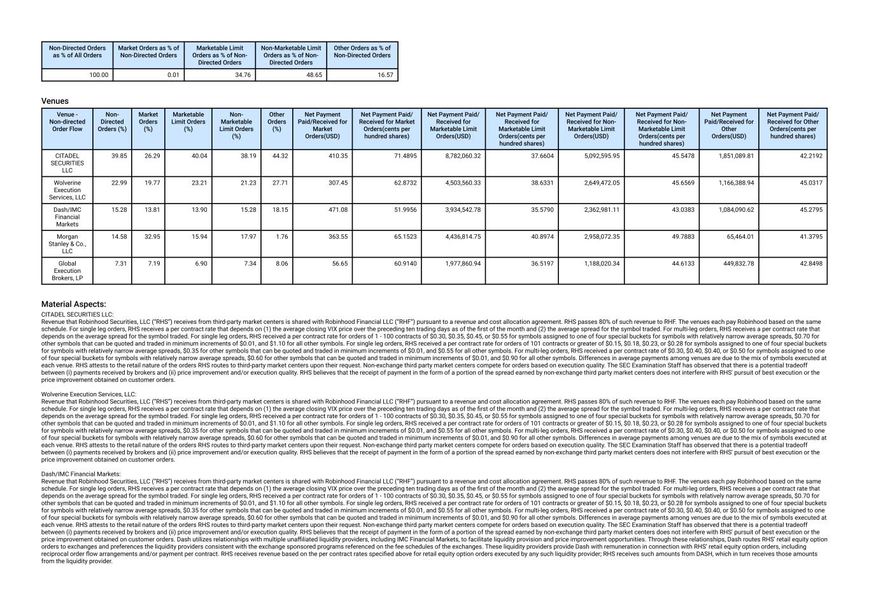
Non-Directed Orders as % of All Orders Market Orders as % of Non-Directed Orders Marketable Limit Orders as % of Non- Directed Orders Non-Marketable Limit Orders as % of Non- Directed Orders Other Orders as % of Non-Directed Orders 100.00 0.01 34.76 48.65 16.57 Venues Venue - Non-directed Order Flow Non- Directed Orders (%) Market Orders (%) Marketable Limit Orders (%) Non- Marketable Limit Orders (%) Other Orders (%) Net Payment Paid/Received for Market Orders(USD) Net Payment Paid/ Received for Market Orders(cents per hundred shares) Net Payment Paid/ Received for Marketable Limit Orders(USD) Net Payment Paid/ Received for Marketable Limit Orders(cents per hundred shares) Net Payment Paid/ Received for Non- Marketable Limit Orders(USD) Net Payment Paid/ Received for Non- Marketable Limit Orders(cents per hundred shares) Net Payment Paid/Received for Other Orders(USD) Net Payment Paid/ Received for Other Orders(cents per hundred shares) CITADEL SECURITIES LLC 39.85 26.29 40.04 38.19 44.32 410.35 71.4895 8,782,060.32 37.6604 5,092,595.95 45.5478 1,851,089.81 42.2192 Wolverine Execution Services, LLC 22.99 19.77 23.21 21.23 27.71 307.45 62.8732 4,503,560.33 38.6331 2,649,472.05 45.6569 1,166,388.94 45.0317 Dash/IMC Financial Markets 15.28 13.81 13.90 15.28 18.15 471.08 51.9956 3,934,542.78 35.5790 2,362,981.11 43.0383 1,084,090.62 45.2795 Morgan Stanley & Co., LLC 14.58 32.95 15.94 17.97 1.76 363.55 65.1523 4,436,814.75 40.8974 2,958,072.35 49.7883 65,464.01 41.3795 Global Execution Brokers, LP 7.31 7.19 6.90 7.34 8.06 56.65 60.9140 1,977,860.94 36.5197 1,188,020.34 44.6133 449,832.78 42.8498 Material Aspects: CITADEL SECURITIES LLC: Revenue that Robinhood Securities, LLC (“RHS”) receives from third-party market centers is shared with Robinhood Financial LLC (“RHF”) pursuant to a revenue and cost allocation agreement. RHS passes 80% of such revenue to RHF. The venues each pay Robinhood based on the same schedule. For single leg orders, RHS receives a per contract rate that depends on (1) the average closing VIX price over the preceding ten trading days as of the first of the month and (2) the average spread for the symbol traded. For multi-leg orders, RHS receives a per contract rate that depends on the average spread for the symbol traded. For single leg orders, RHS received a per contract rate for orders of 1 - 100 contracts of $0.30, $0.35, $0.45, or $0.55 for symbols assigned to one of four special buckets for symbols with relatively narrow average spreads, $0.70 for other symbols that can be quoted and traded in minimum increments of $0.01, and $1.10 for all other symbols. For single leg orders, RHS received a per contract rate for orders of 101 contracts or greater of $0.15, $0.18, $0.23, or $0.28 for symbols assigned to one of four special buckets for symbols with relatively narrow average spreads, $0.35 for other symbols that can be quoted and traded in minimum increments of $0.01, and $0.55 for all other symbols. For multi-leg orders, RHS received a per contract rate of $0.30, $0.40, $0.40, or $0.50 for symbols assigned to one of four special buckets for symbols with relatively narrow average spreads, $0.60 for other symbols that can be quoted and traded in minimum increments of $0.01, and $0.90 for all other symbols. Differences in average payments among venues are due to the mix of symbols executed at each venue. RHS attests to the retail nature of the orders RHS routes to third-party market centers upon their request. Non-exchange third party market centers compete for orders based on execution quality. The SEC Examination Staff has observed that there is a potential tradeoff between (i) payments received by brokers and (ii) price improvement and/or execution quality. RHS believes that the receipt of payment in the form of a portion of the spread earned by non-exchange third party market centers does not interfere with RHS' pursuit of best execution or the price improvement obtained on customer orders. Wolverine Execution Services, LLC: Revenue that Robinhood Securities, LLC (“RHS”) receives from third-party market centers is shared with Robinhood Financial LLC (“RHF”) pursuant to a revenue and cost allocation agreement. RHS passes 80% of such revenue to RHF. The venues each pay Robinhood based on the same schedule. For single leg orders, RHS receives a per contract rate that depends on (1) the average closing VIX price over the preceding ten trading days as of the first of the month and (2) the average spread for the symbol traded. For multi-leg orders, RHS receives a per contract rate that depends on the average spread for the symbol traded. For single leg orders, RHS received a per contract rate for orders of 1 - 100 contracts of $0.30, $0.35, $0.45, or $0.55 for symbols assigned to one of four special buckets for symbols with relatively narrow average spreads, $0.70 for other symbols that can be quoted and traded in minimum increments of $0.01, and $1.10 for all other symbols. For single leg orders, RHS received a per contract rate for orders of 101 contracts or greater of $0.15, $0.18, $0.23, or $0.28 for symbols assigned to one of four special buckets for symbols with relatively narrow average spreads, $0.35 for other symbols that can be quoted and traded in minimum increments of $0.01, and $0.55 for all other symbols. For multi-leg orders, RHS received a per contract rate of $0.30, $0.40, $0.40, or $0.50 for symbols assigned to one of four special buckets for symbols with relatively narrow average spreads, $0.60 for other symbols that can be quoted and traded in minimum increments of $0.01, and $0.90 for all other symbols. Differences in average payments among venues are due to the mix of symbols executed at each venue. RHS attests to the retail nature of the orders RHS routes to third-party market centers upon their request. Non-exchange third party market centers compete for orders based on execution quality. The SEC Examination Staff has observed that there is a potential tradeoff between (i) payments received by brokers and (ii) price improvement and/or execution quality. RHS believes that the receipt of payment in the form of a portion of the spread earned by non-exchange third party market centers does not interfere with RHS' pursuit of best execution or the price improvement obtained on customer orders. Dash/IMC Financial Markets: Revenue that Robinhood Securities, LLC (“RHS”) receives from third-party market centers is shared with Robinhood Financial LLC (“RHF”) pursuant to a revenue and cost allocation agreement. RHS passes 80% of such revenue to RHF. The venues each pay Robinhood based on the same schedule. For single leg orders, RHS receives a per contract rate that depends on (1) the average closing VIX price over the preceding ten trading days as of the first of the month and (2) the average spread for the symbol traded. For multi-leg orders, RHS receives a per contract rate that depends on the average spread for the symbol traded. For single leg orders, RHS received a per contract rate for orders of 1 - 100 contracts of $0.30, $0.35, $0.45, or $0.55 for symbols assigned to one of four special buckets for symbols with relatively narrow average spreads, $0.70 for other symbols that can be quoted and traded in minimum increments of $0.01, and $1.10 for all other symbols. For single leg orders, RHS received a per contract rate for orders of 101 contracts or greater of $0.15, $0.18, $0.23, or $0.28 for symbols assigned to one of four special buckets for symbols with relatively narrow average spreads, $0.35 for other symbols that can be quoted and traded in minimum increments of $0.01, and $0.55 for all other symbols. For multi-leg orders, RHS received a per contract rate of $0.30, $0.40, $0.40, or $0.50 for symbols assigned to one of four special buckets for symbols with relatively narrow average spreads, $0.60 for other symbols that can be quoted and traded in minimum increments of $0.01, and $0.90 for all other symbols. Differences in average payments among venues are due to the mix of symbols executed at each venue. RHS attests to the retail nature of the orders RHS routes to third-party market centers upon their request. Non-exchange third party market centers compete for orders based on execution quality. The SEC Examination Staff has observed that there is a potential tradeoff between (i) payments received by brokers and (ii) price improvement and/or execution quality. RHS believes that the receipt of payment in the form of a portion of the spread earned by non-exchange third party market centers does not interfere with RHS' pursuit of best execution or the price improvement obtained on customer orders. Dash utilizes relationships with multiple unaffiliated liquidity providers, including IMC Financial Markets, to facilitate liquidity provision and price improvement opportunities. Through these relationships, Dash routes RHS’ retail equity option orders to exchanges and preferences the liquidity providers consistent with the exchange sponsored programs referenced on the fee schedules of the exchanges. These liquidity providers provide Dash with remuneration in connection with RHS’ retail equity option orders, including reciprocal order flow arrangements and/or payment per contract. RHS receives revenue based on the per contract rates specified above for retail equity option orders executed by any such liquidity provider; RHS receives such amounts from DASH, which in turn receives those amounts from the liquidity provider.

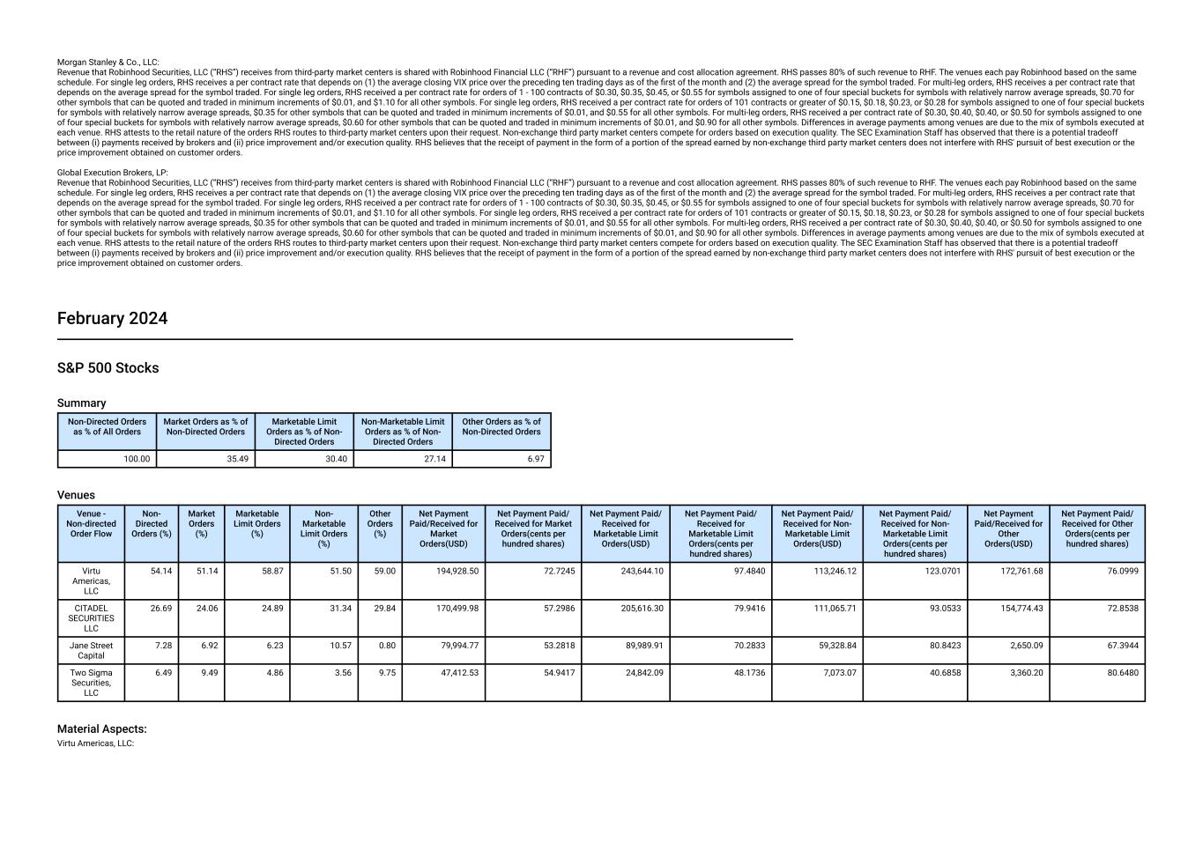
Morgan Stanley & Co., LLC: Revenue that Robinhood Securities, LLC (“RHS”) receives from third-party market centers is shared with Robinhood Financial LLC (“RHF”) pursuant to a revenue and cost allocation agreement. RHS passes 80% of such revenue to RHF. The venues each pay Robinhood based on the same schedule. For single leg orders, RHS receives a per contract rate that depends on (1) the average closing VIX price over the preceding ten trading days as of the first of the month and (2) the average spread for the symbol traded. For multi-leg orders, RHS receives a per contract rate that depends on the average spread for the symbol traded. For single leg orders, RHS received a per contract rate for orders of 1 - 100 contracts of $0.30, $0.35, $0.45, or $0.55 for symbols assigned to one of four special buckets for symbols with relatively narrow average spreads, $0.70 for other symbols that can be quoted and traded in minimum increments of $0.01, and $1.10 for all other symbols. For single leg orders, RHS received a per contract rate for orders of 101 contracts or greater of $0.15, $0.18, $0.23, or $0.28 for symbols assigned to one of four special buckets for symbols with relatively narrow average spreads, $0.35 for other symbols that can be quoted and traded in minimum increments of $0.01, and $0.55 for all other symbols. For multi-leg orders, RHS received a per contract rate of $0.30, $0.40, $0.40, or $0.50 for symbols assigned to one of four special buckets for symbols with relatively narrow average spreads, $0.60 for other symbols that can be quoted and traded in minimum increments of $0.01, and $0.90 for all other symbols. Differences in average payments among venues are due to the mix of symbols executed at each venue. RHS attests to the retail nature of the orders RHS routes to third-party market centers upon their request. Non-exchange third party market centers compete for orders based on execution quality. The SEC Examination Staff has observed that there is a potential tradeoff between (i) payments received by brokers and (ii) price improvement and/or execution quality. RHS believes that the receipt of payment in the form of a portion of the spread earned by non-exchange third party market centers does not interfere with RHS' pursuit of best execution or the price improvement obtained on customer orders. Global Execution Brokers, LP: Revenue that Robinhood Securities, LLC (“RHS”) receives from third-party market centers is shared with Robinhood Financial LLC (“RHF”) pursuant to a revenue and cost allocation agreement. RHS passes 80% of such revenue to RHF. The venues each pay Robinhood based on the same schedule. For single leg orders, RHS receives a per contract rate that depends on (1) the average closing VIX price over the preceding ten trading days as of the first of the month and (2) the average spread for the symbol traded. For multi-leg orders, RHS receives a per contract rate that depends on the average spread for the symbol traded. For single leg orders, RHS received a per contract rate for orders of 1 - 100 contracts of $0.30, $0.35, $0.45, or $0.55 for symbols assigned to one of four special buckets for symbols with relatively narrow average spreads, $0.70 for other symbols that can be quoted and traded in minimum increments of $0.01, and $1.10 for all other symbols. For single leg orders, RHS received a per contract rate for orders of 101 contracts or greater of $0.15, $0.18, $0.23, or $0.28 for symbols assigned to one of four special buckets for symbols with relatively narrow average spreads, $0.35 for other symbols that can be quoted and traded in minimum increments of $0.01, and $0.55 for all other symbols. For multi-leg orders, RHS received a per contract rate of $0.30, $0.40, $0.40, or $0.50 for symbols assigned to one of four special buckets for symbols with relatively narrow average spreads, $0.60 for other symbols that can be quoted and traded in minimum increments of $0.01, and $0.90 for all other symbols. Differences in average payments among venues are due to the mix of symbols executed at each venue. RHS attests to the retail nature of the orders RHS routes to third-party market centers upon their request. Non-exchange third party market centers compete for orders based on execution quality. The SEC Examination Staff has observed that there is a potential tradeoff between (i) payments received by brokers and (ii) price improvement and/or execution quality. RHS believes that the receipt of payment in the form of a portion of the spread earned by non-exchange third party market centers does not interfere with RHS' pursuit of best execution or the price improvement obtained on customer orders. February 2024 S&P 500 Stocks Summary Non-Directed Orders as % of All Orders Market Orders as % of Non-Directed Orders Marketable Limit Orders as % of Non- Directed Orders Non-Marketable Limit Orders as % of Non- Directed Orders Other Orders as % of Non-Directed Orders 100.00 35.49 30.40 27.14 6.97 Venues Venue - Non-directed Order Flow Non- Directed Orders (%) Market Orders (%) Marketable Limit Orders (%) Non- Marketable Limit Orders (%) Other Orders (%) Net Payment Paid/Received for Market Orders(USD) Net Payment Paid/ Received for Market Orders(cents per hundred shares) Net Payment Paid/ Received for Marketable Limit Orders(USD) Net Payment Paid/ Received for Marketable Limit Orders(cents per hundred shares) Net Payment Paid/ Received for Non- Marketable Limit Orders(USD) Net Payment Paid/ Received for Non- Marketable Limit Orders(cents per hundred shares) Net Payment Paid/Received for Other Orders(USD) Net Payment Paid/ Received for Other Orders(cents per hundred shares) Virtu Americas, LLC 54.14 51.14 58.87 51.50 59.00 194,928.50 72.7245 243,644.10 97.4840 113,246.12 123.0701 172,761.68 76.0999 CITADEL SECURITIES LLC 26.69 24.06 24.89 31.34 29.84 170,499.98 57.2986 205,616.30 79.9416 111,065.71 93.0533 154,774.43 72.8538 Jane Street Capital 7.28 6.92 6.23 10.57 0.80 79,994.77 53.2818 89,989.91 70.2833 59,328.84 80.8423 2,650.09 67.3944 Two Sigma Securities, LLC 6.49 9.49 4.86 3.56 9.75 47,412.53 54.9417 24,842.09 48.1736 7,073.07 40.6858 3,360.20 80.6480 Material Aspects: Virtu Americas, LLC:

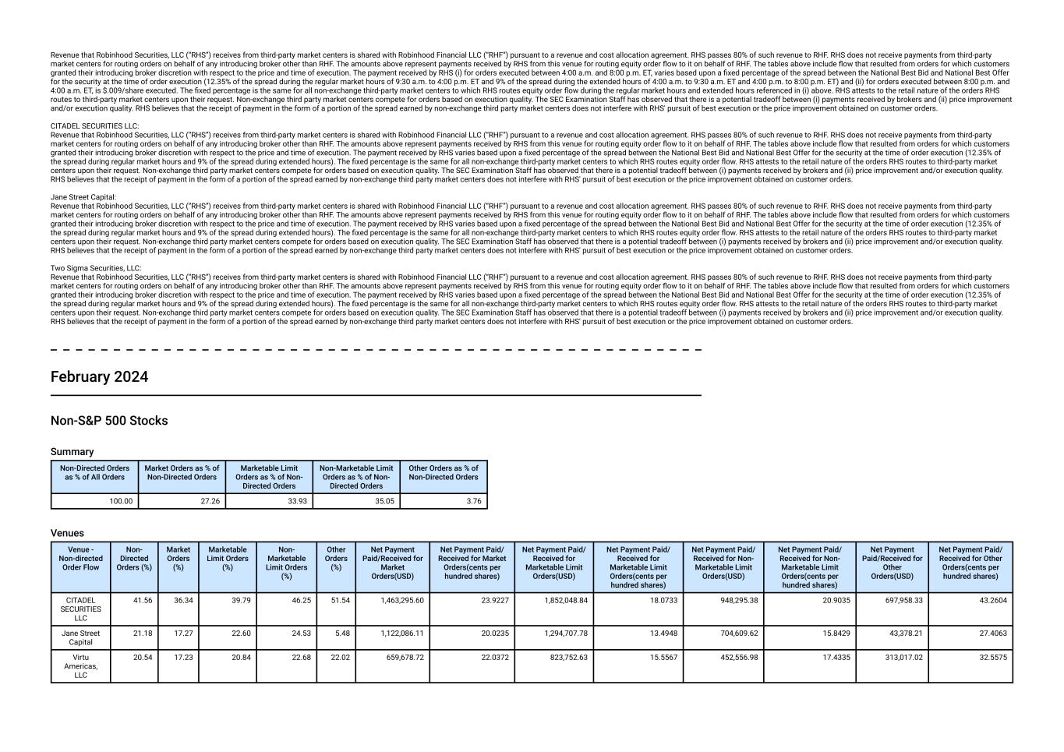
Revenue that Robinhood Securities, LLC (“RHS”) receives from third-party market centers is shared with Robinhood Financial LLC (“RHF”) pursuant to a revenue and cost allocation agreement. RHS passes 80% of such revenue to RHF. RHS does not receive payments from third-party market centers for routing orders on behalf of any introducing broker other than RHF. The amounts above represent payments received by RHS from this venue for routing equity order flow to it on behalf of RHF. The tables above include flow that resulted from orders for which customers granted their introducing broker discretion with respect to the price and time of execution. The payment received by RHS (i) for orders executed between 4:00 a.m. and 8:00 p.m. ET, varies based upon a fixed percentage of the spread between the National Best Bid and National Best Offer for the security at the time of order execution (12.35% of the spread during the regular market hours of 9:30 a.m. to 4:00 p.m. ET and 9% of the spread during the extended hours of 4:00 a.m. to 9:30 a.m. ET and 4:00 p.m. to 8:00 p.m. ET) and (ii) for orders executed between 8:00 p.m. and 4:00 a.m. ET, is $.009/share executed. The fixed percentage is the same for all non-exchange third-party market centers to which RHS routes equity order flow during the regular market hours and extended hours referenced in (i) above. RHS attests to the retail nature of the orders RHS routes to third-party market centers upon their request. Non-exchange third party market centers compete for orders based on execution quality. The SEC Examination Staff has observed that there is a potential tradeoff between (i) payments received by brokers and (ii) price improvement and/or execution quality. RHS believes that the receipt of payment in the form of a portion of the spread earned by non-exchange third party market centers does not interfere with RHS' pursuit of best execution or the price improvement obtained on customer orders. CITADEL SECURITIES LLC: Revenue that Robinhood Securities, LLC (“RHS”) receives from third-party market centers is shared with Robinhood Financial LLC (“RHF”) pursuant to a revenue and cost allocation agreement. RHS passes 80% of such revenue to RHF. RHS does not receive payments from third-party market centers for routing orders on behalf of any introducing broker other than RHF. The amounts above represent payments received by RHS from this venue for routing equity order flow to it on behalf of RHF. The tables above include flow that resulted from orders for which customers granted their introducing broker discretion with respect to the price and time of execution. The payment received by RHS varies based upon a fixed percentage of the spread between the National Best Bid and National Best Offer for the security at the time of order execution (12.35% of the spread during regular market hours and 9% of the spread during extended hours). The fixed percentage is the same for all non-exchange third-party market centers to which RHS routes equity order flow. RHS attests to the retail nature of the orders RHS routes to third-party market centers upon their request. Non-exchange third party market centers compete for orders based on execution quality. The SEC Examination Staff has observed that there is a potential tradeoff between (i) payments received by brokers and (ii) price improvement and/or execution quality. RHS believes that the receipt of payment in the form of a portion of the spread earned by non-exchange third party market centers does not interfere with RHS' pursuit of best execution or the price improvement obtained on customer orders. Jane Street Capital: Revenue that Robinhood Securities, LLC (“RHS”) receives from third-party market centers is shared with Robinhood Financial LLC (“RHF”) pursuant to a revenue and cost allocation agreement. RHS passes 80% of such revenue to RHF. RHS does not receive payments from third-party market centers for routing orders on behalf of any introducing broker other than RHF. The amounts above represent payments received by RHS from this venue for routing equity order flow to it on behalf of RHF. The tables above include flow that resulted from orders for which customers granted their introducing broker discretion with respect to the price and time of execution. The payment received by RHS varies based upon a fixed percentage of the spread between the National Best Bid and National Best Offer for the security at the time of order execution (12.35% of the spread during regular market hours and 9% of the spread during extended hours). The fixed percentage is the same for all non-exchange third-party market centers to which RHS routes equity order flow. RHS attests to the retail nature of the orders RHS routes to third-party market centers upon their request. Non-exchange third party market centers compete for orders based on execution quality. The SEC Examination Staff has observed that there is a potential tradeoff between (i) payments received by brokers and (ii) price improvement and/or execution quality. RHS believes that the receipt of payment in the form of a portion of the spread earned by non-exchange third party market centers does not interfere with RHS' pursuit of best execution or the price improvement obtained on customer orders. Two Sigma Securities, LLC: Revenue that Robinhood Securities, LLC (“RHS”) receives from third-party market centers is shared with Robinhood Financial LLC (“RHF”) pursuant to a revenue and cost allocation agreement. RHS passes 80% of such revenue to RHF. RHS does not receive payments from third-party market centers for routing orders on behalf of any introducing broker other than RHF. The amounts above represent payments received by RHS from this venue for routing equity order flow to it on behalf of RHF. The tables above include flow that resulted from orders for which customers granted their introducing broker discretion with respect to the price and time of execution. The payment received by RHS varies based upon a fixed percentage of the spread between the National Best Bid and National Best Offer for the security at the time of order execution (12.35% of the spread during regular market hours and 9% of the spread during extended hours). The fixed percentage is the same for all non-exchange third-party market centers to which RHS routes equity order flow. RHS attests to the retail nature of the orders RHS routes to third-party market centers upon their request. Non-exchange third party market centers compete for orders based on execution quality. The SEC Examination Staff has observed that there is a potential tradeoff between (i) payments received by brokers and (ii) price improvement and/or execution quality. RHS believes that the receipt of payment in the form of a portion of the spread earned by non-exchange third party market centers does not interfere with RHS' pursuit of best execution or the price improvement obtained on customer orders. February 2024 Non-S&P 500 Stocks Summary Non-Directed Orders as % of All Orders Market Orders as % of Non-Directed Orders Marketable Limit Orders as % of Non- Directed Orders Non-Marketable Limit Orders as % of Non- Directed Orders Other Orders as % of Non-Directed Orders 100.00 27.26 33.93 35.05 3.76 Venues Venue - Non-directed Order Flow Non- Directed Orders (%) Market Orders (%) Marketable Limit Orders (%) Non- Marketable Limit Orders (%) Other Orders (%) Net Payment Paid/Received for Market Orders(USD) Net Payment Paid/ Received for Market Orders(cents per hundred shares) Net Payment Paid/ Received for Marketable Limit Orders(USD) Net Payment Paid/ Received for Marketable Limit Orders(cents per hundred shares) Net Payment Paid/ Received for Non- Marketable Limit Orders(USD) Net Payment Paid/ Received for Non- Marketable Limit Orders(cents per hundred shares) Net Payment Paid/Received for Other Orders(USD) Net Payment Paid/ Received for Other Orders(cents per hundred shares) CITADEL SECURITIES LLC 41.56 36.34 39.79 46.25 51.54 1,463,295.60 23.9227 1,852,048.84 18.0733 948,295.38 20.9035 697,958.33 43.2604 Jane Street Capital 21.18 17.27 22.60 24.53 5.48 1,122,086.11 20.0235 1,294,707.78 13.4948 704,609.62 15.8429 43,378.21 27.4063 Virtu Americas, LLC 20.54 17.23 20.84 22.68 22.02 659,678.72 22.0372 823,752.63 15.5567 452,556.98 17.4335 313,017.02 32.5575

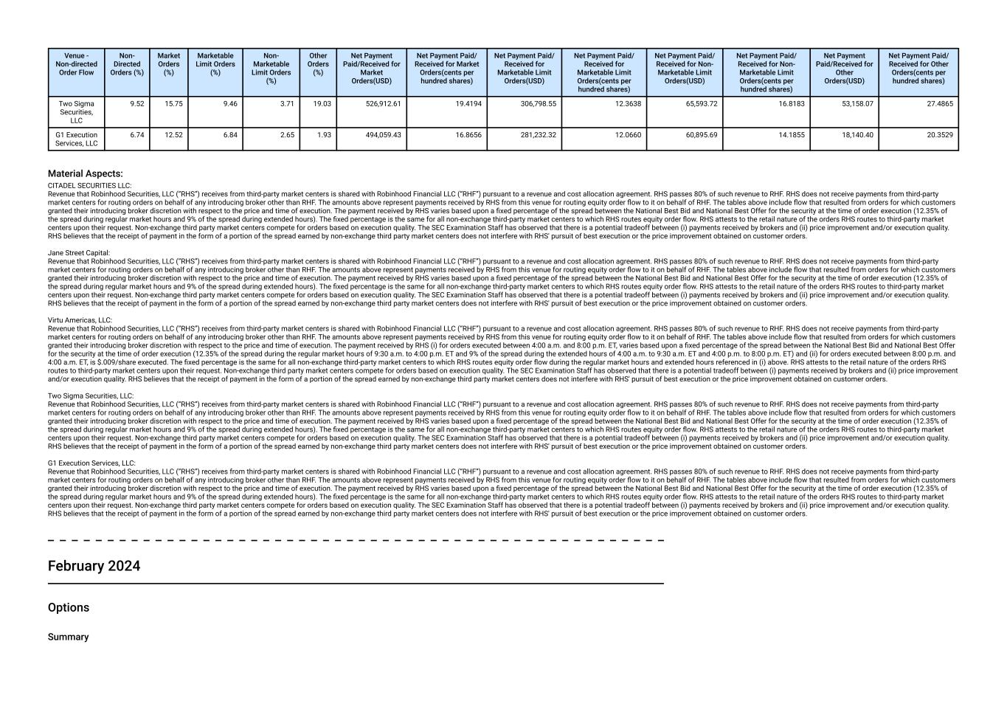
Venue - Non-directed Order Flow Non- Directed Orders (%) Market Orders (%) Marketable Limit Orders (%) Non- Marketable Limit Orders (%) Other Orders (%) Net Payment Paid/Received for Market Orders(USD) Net Payment Paid/ Received for Market Orders(cents per hundred shares) Net Payment Paid/ Received for Marketable Limit Orders(USD) Net Payment Paid/ Received for Marketable Limit Orders(cents per hundred shares) Net Payment Paid/ Received for Non- Marketable Limit Orders(USD) Net Payment Paid/ Received for Non- Marketable Limit Orders(cents per hundred shares) Net Payment Paid/Received for Other Orders(USD) Net Payment Paid/ Received for Other Orders(cents per hundred shares) Two Sigma Securities, LLC 9.52 15.75 9.46 3.71 19.03 526,912.61 19.4194 306,798.55 12.3638 65,593.72 16.8183 53,158.07 27.4865 G1 Execution Services, LLC 6.74 12.52 6.84 2.65 1.93 494,059.43 16.8656 281,232.32 12.0660 60,895.69 14.1855 18,140.40 20.3529 Material Aspects: CITADEL SECURITIES LLC: Revenue that Robinhood Securities, LLC (“RHS”) receives from third-party market centers is shared with Robinhood Financial LLC (“RHF”) pursuant to a revenue and cost allocation agreement. RHS passes 80% of such revenue to RHF. RHS does not receive payments from third-party market centers for routing orders on behalf of any introducing broker other than RHF. The amounts above represent payments received by RHS from this venue for routing equity order flow to it on behalf of RHF. The tables above include flow that resulted from orders for which customers granted their introducing broker discretion with respect to the price and time of execution. The payment received by RHS varies based upon a fixed percentage of the spread between the National Best Bid and National Best Offer for the security at the time of order execution (12.35% of the spread during regular market hours and 9% of the spread during extended hours). The fixed percentage is the same for all non-exchange third-party market centers to which RHS routes equity order flow. RHS attests to the retail nature of the orders RHS routes to third-party market centers upon their request. Non-exchange third party market centers compete for orders based on execution quality. The SEC Examination Staff has observed that there is a potential tradeoff between (i) payments received by brokers and (ii) price improvement and/or execution quality. RHS believes that the receipt of payment in the form of a portion of the spread earned by non-exchange third party market centers does not interfere with RHS' pursuit of best execution or the price improvement obtained on customer orders. Jane Street Capital: Revenue that Robinhood Securities, LLC (“RHS”) receives from third-party market centers is shared with Robinhood Financial LLC (“RHF”) pursuant to a revenue and cost allocation agreement. RHS passes 80% of such revenue to RHF. RHS does not receive payments from third-party market centers for routing orders on behalf of any introducing broker other than RHF. The amounts above represent payments received by RHS from this venue for routing equity order flow to it on behalf of RHF. The tables above include flow that resulted from orders for which customers granted their introducing broker discretion with respect to the price and time of execution. The payment received by RHS varies based upon a fixed percentage of the spread between the National Best Bid and National Best Offer for the security at the time of order execution (12.35% of the spread during regular market hours and 9% of the spread during extended hours). The fixed percentage is the same for all non-exchange third-party market centers to which RHS routes equity order flow. RHS attests to the retail nature of the orders RHS routes to third-party market centers upon their request. Non-exchange third party market centers compete for orders based on execution quality. The SEC Examination Staff has observed that there is a potential tradeoff between (i) payments received by brokers and (ii) price improvement and/or execution quality. RHS believes that the receipt of payment in the form of a portion of the spread earned by non-exchange third party market centers does not interfere with RHS' pursuit of best execution or the price improvement obtained on customer orders. Virtu Americas, LLC: Revenue that Robinhood Securities, LLC (“RHS”) receives from third-party market centers is shared with Robinhood Financial LLC (“RHF”) pursuant to a revenue and cost allocation agreement. RHS passes 80% of such revenue to RHF. RHS does not receive payments from third-party market centers for routing orders on behalf of any introducing broker other than RHF. The amounts above represent payments received by RHS from this venue for routing equity order flow to it on behalf of RHF. The tables above include flow that resulted from orders for which customers granted their introducing broker discretion with respect to the price and time of execution. The payment received by RHS (i) for orders executed between 4:00 a.m. and 8:00 p.m. ET, varies based upon a fixed percentage of the spread between the National Best Bid and National Best Offer for the security at the time of order execution (12.35% of the spread during the regular market hours of 9:30 a.m. to 4:00 p.m. ET and 9% of the spread during the extended hours of 4:00 a.m. to 9:30 a.m. ET and 4:00 p.m. to 8:00 p.m. ET) and (ii) for orders executed between 8:00 p.m. and 4:00 a.m. ET, is $.009/share executed. The fixed percentage is the same for all non-exchange third-party market centers to which RHS routes equity order flow during the regular market hours and extended hours referenced in (i) above. RHS attests to the retail nature of the orders RHS routes to third-party market centers upon their request. Non-exchange third party market centers compete for orders based on execution quality. The SEC Examination Staff has observed that there is a potential tradeoff between (i) payments received by brokers and (ii) price improvement and/or execution quality. RHS believes that the receipt of payment in the form of a portion of the spread earned by non-exchange third party market centers does not interfere with RHS' pursuit of best execution or the price improvement obtained on customer orders. Two Sigma Securities, LLC: Revenue that Robinhood Securities, LLC (“RHS”) receives from third-party market centers is shared with Robinhood Financial LLC (“RHF”) pursuant to a revenue and cost allocation agreement. RHS passes 80% of such revenue to RHF. RHS does not receive payments from third-party market centers for routing orders on behalf of any introducing broker other than RHF. The amounts above represent payments received by RHS from this venue for routing equity order flow to it on behalf of RHF. The tables above include flow that resulted from orders for which customers granted their introducing broker discretion with respect to the price and time of execution. The payment received by RHS varies based upon a fixed percentage of the spread between the National Best Bid and National Best Offer for the security at the time of order execution (12.35% of the spread during regular market hours and 9% of the spread during extended hours). The fixed percentage is the same for all non-exchange third-party market centers to which RHS routes equity order flow. RHS attests to the retail nature of the orders RHS routes to third-party market centers upon their request. Non-exchange third party market centers compete for orders based on execution quality. The SEC Examination Staff has observed that there is a potential tradeoff between (i) payments received by brokers and (ii) price improvement and/or execution quality. RHS believes that the receipt of payment in the form of a portion of the spread earned by non-exchange third party market centers does not interfere with RHS' pursuit of best execution or the price improvement obtained on customer orders. G1 Execution Services, LLC: Revenue that Robinhood Securities, LLC (“RHS”) receives from third-party market centers is shared with Robinhood Financial LLC (“RHF”) pursuant to a revenue and cost allocation agreement. RHS passes 80% of such revenue to RHF. RHS does not receive payments from third-party market centers for routing orders on behalf of any introducing broker other than RHF. The amounts above represent payments received by RHS from this venue for routing equity order flow to it on behalf of RHF. The tables above include flow that resulted from orders for which customers granted their introducing broker discretion with respect to the price and time of execution. The payment received by RHS varies based upon a fixed percentage of the spread between the National Best Bid and National Best Offer for the security at the time of order execution (12.35% of the spread during regular market hours and 9% of the spread during extended hours). The fixed percentage is the same for all non-exchange third-party market centers to which RHS routes equity order flow. RHS attests to the retail nature of the orders RHS routes to third-party market centers upon their request. Non-exchange third party market centers compete for orders based on execution quality. The SEC Examination Staff has observed that there is a potential tradeoff between (i) payments received by brokers and (ii) price improvement and/or execution quality. RHS believes that the receipt of payment in the form of a portion of the spread earned by non-exchange third party market centers does not interfere with RHS' pursuit of best execution or the price improvement obtained on customer orders. February 2024 Options Summary

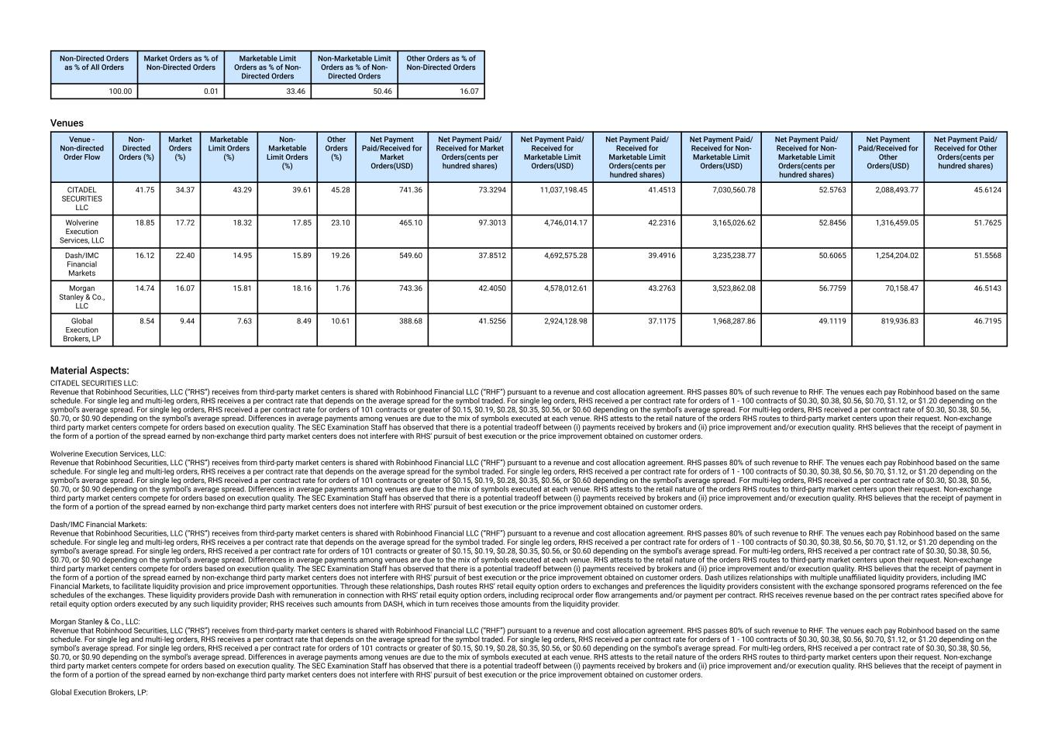
Non-Directed Orders as % of All Orders Market Orders as % of Non-Directed Orders Marketable Limit Orders as % of Non- Directed Orders Non-Marketable Limit Orders as % of Non- Directed Orders Other Orders as % of Non-Directed Orders 100.00 0.01 33.46 50.46 16.07 Venues Venue - Non-directed Order Flow Non- Directed Orders (%) Market Orders (%) Marketable Limit Orders (%) Non- Marketable Limit Orders (%) Other Orders (%) Net Payment Paid/Received for Market Orders(USD) Net Payment Paid/ Received for Market Orders(cents per hundred shares) Net Payment Paid/ Received for Marketable Limit Orders(USD) Net Payment Paid/ Received for Marketable Limit Orders(cents per hundred shares) Net Payment Paid/ Received for Non- Marketable Limit Orders(USD) Net Payment Paid/ Received for Non- Marketable Limit Orders(cents per hundred shares) Net Payment Paid/Received for Other Orders(USD) Net Payment Paid/ Received for Other Orders(cents per hundred shares) CITADEL SECURITIES LLC 41.75 34.37 43.29 39.61 45.28 741.36 73.3294 11,037,198.45 41.4513 7,030,560.78 52.5763 2,088,493.77 45.6124 Wolverine Execution Services, LLC 18.85 17.72 18.32 17.85 23.10 465.10 97.3013 4,746,014.17 42.2316 3,165,026.62 52.8456 1,316,459.05 51.7625 Dash/IMC Financial Markets 16.12 22.40 14.95 15.89 19.26 549.60 37.8512 4,692,575.28 39.4916 3,235,238.77 50.6065 1,254,204.02 51.5568 Morgan Stanley & Co., LLC 14.74 16.07 15.81 18.16 1.76 743.36 42.4050 4,578,012.61 43.2763 3,523,862.08 56.7759 70,158.47 46.5143 Global Execution Brokers, LP 8.54 9.44 7.63 8.49 10.61 388.68 41.5256 2,924,128.98 37.1175 1,968,287.86 49.1119 819,936.83 46.7195 Material Aspects: CITADEL SECURITIES LLC: Revenue that Robinhood Securities, LLC (“RHS”) receives from third-party market centers is shared with Robinhood Financial LLC (“RHF”) pursuant to a revenue and cost allocation agreement. RHS passes 80% of such revenue to RHF. The venues each pay Robinhood based on the same schedule. For single leg and multi-leg orders, RHS receives a per contract rate that depends on the average spread for the symbol traded. For single leg orders, RHS received a per contract rate for orders of 1 - 100 contracts of $0.30, $0.38, $0.56, $0.70, $1.12, or $1.20 depending on the symbol’s average spread. For single leg orders, RHS received a per contract rate for orders of 101 contracts or greater of $0.15, $0.19, $0.28, $0.35, $0.56, or $0.60 depending on the symbol’s average spread. For multi-leg orders, RHS received a per contract rate of $0.30, $0.38, $0.56, $0.70, or $0.90 depending on the symbol’s average spread. Differences in average payments among venues are due to the mix of symbols executed at each venue. RHS attests to the retail nature of the orders RHS routes to third-party market centers upon their request. Non-exchange third party market centers compete for orders based on execution quality. The SEC Examination Staff has observed that there is a potential tradeoff between (i) payments received by brokers and (ii) price improvement and/or execution quality. RHS believes that the receipt of payment in the form of a portion of the spread earned by non-exchange third party market centers does not interfere with RHS' pursuit of best execution or the price improvement obtained on customer orders. Wolverine Execution Services, LLC: Revenue that Robinhood Securities, LLC (“RHS”) receives from third-party market centers is shared with Robinhood Financial LLC (“RHF”) pursuant to a revenue and cost allocation agreement. RHS passes 80% of such revenue to RHF. The venues each pay Robinhood based on the same schedule. For single leg and multi-leg orders, RHS receives a per contract rate that depends on the average spread for the symbol traded. For single leg orders, RHS received a per contract rate for orders of 1 - 100 contracts of $0.30, $0.38, $0.56, $0.70, $1.12, or $1.20 depending on the symbol’s average spread. For single leg orders, RHS received a per contract rate for orders of 101 contracts or greater of $0.15, $0.19, $0.28, $0.35, $0.56, or $0.60 depending on the symbol’s average spread. For multi-leg orders, RHS received a per contract rate of $0.30, $0.38, $0.56, $0.70, or $0.90 depending on the symbol’s average spread. Differences in average payments among venues are due to the mix of symbols executed at each venue. RHS attests to the retail nature of the orders RHS routes to third-party market centers upon their request. Non-exchange third party market centers compete for orders based on execution quality. The SEC Examination Staff has observed that there is a potential tradeoff between (i) payments received by brokers and (ii) price improvement and/or execution quality. RHS believes that the receipt of payment in the form of a portion of the spread earned by non-exchange third party market centers does not interfere with RHS' pursuit of best execution or the price improvement obtained on customer orders. Dash/IMC Financial Markets: Revenue that Robinhood Securities, LLC (“RHS”) receives from third-party market centers is shared with Robinhood Financial LLC (“RHF”) pursuant to a revenue and cost allocation agreement. RHS passes 80% of such revenue to RHF. The venues each pay Robinhood based on the same schedule. For single leg and multi-leg orders, RHS receives a per contract rate that depends on the average spread for the symbol traded. For single leg orders, RHS received a per contract rate for orders of 1 - 100 contracts of $0.30, $0.38, $0.56, $0.70, $1.12, or $1.20 depending on the symbol’s average spread. For single leg orders, RHS received a per contract rate for orders of 101 contracts or greater of $0.15, $0.19, $0.28, $0.35, $0.56, or $0.60 depending on the symbol’s average spread. For multi-leg orders, RHS received a per contract rate of $0.30, $0.38, $0.56, $0.70, or $0.90 depending on the symbol’s average spread. Differences in average payments among venues are due to the mix of symbols executed at each venue. RHS attests to the retail nature of the orders RHS routes to third-party market centers upon their request. Non-exchange third party market centers compete for orders based on execution quality. The SEC Examination Staff has observed that there is a potential tradeoff between (i) payments received by brokers and (ii) price improvement and/or execution quality. RHS believes that the receipt of payment in the form of a portion of the spread earned by non-exchange third party market centers does not interfere with RHS' pursuit of best execution or the price improvement obtained on customer orders. Dash utilizes relationships with multiple unaffiliated liquidity providers, including IMC Financial Markets, to facilitate liquidity provision and price improvement opportunities. Through these relationships, Dash routes RHS’ retail equity option orders to exchanges and preferences the liquidity providers consistent with the exchange sponsored programs referenced on the fee schedules of the exchanges. These liquidity providers provide Dash with remuneration in connection with RHS’ retail equity option orders, including reciprocal order flow arrangements and/or payment per contract. RHS receives revenue based on the per contract rates specified above for retail equity option orders executed by any such liquidity provider; RHS receives such amounts from DASH, which in turn receives those amounts from the liquidity provider. Morgan Stanley & Co., LLC: Revenue that Robinhood Securities, LLC (“RHS”) receives from third-party market centers is shared with Robinhood Financial LLC (“RHF”) pursuant to a revenue and cost allocation agreement. RHS passes 80% of such revenue to RHF. The venues each pay Robinhood based on the same schedule. For single leg and multi-leg orders, RHS receives a per contract rate that depends on the average spread for the symbol traded. For single leg orders, RHS received a per contract rate for orders of 1 - 100 contracts of $0.30, $0.38, $0.56, $0.70, $1.12, or $1.20 depending on the symbol’s average spread. For single leg orders, RHS received a per contract rate for orders of 101 contracts or greater of $0.15, $0.19, $0.28, $0.35, $0.56, or $0.60 depending on the symbol’s average spread. For multi-leg orders, RHS received a per contract rate of $0.30, $0.38, $0.56, $0.70, or $0.90 depending on the symbol’s average spread. Differences in average payments among venues are due to the mix of symbols executed at each venue. RHS attests to the retail nature of the orders RHS routes to third-party market centers upon their request. Non-exchange third party market centers compete for orders based on execution quality. The SEC Examination Staff has observed that there is a potential tradeoff between (i) payments received by brokers and (ii) price improvement and/or execution quality. RHS believes that the receipt of payment in the form of a portion of the spread earned by non-exchange third party market centers does not interfere with RHS' pursuit of best execution or the price improvement obtained on customer orders. Global Execution Brokers, LP:

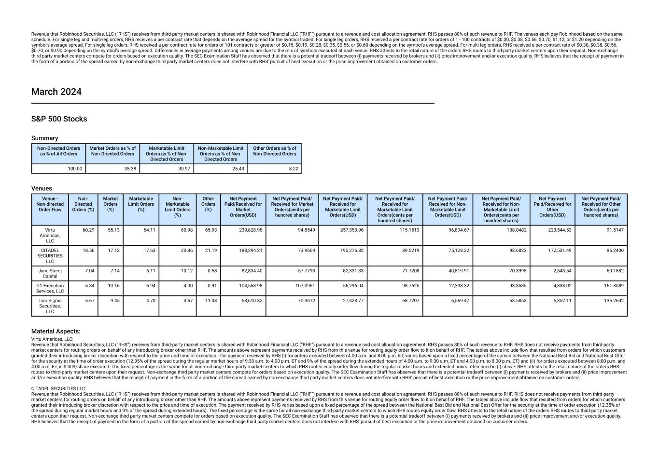
Revenue that Robinhood Securities, LLC (“RHS”) receives from third-party market centers is shared with Robinhood Financial LLC (“RHF”) pursuant to a revenue and cost allocation agreement. RHS passes 80% of such revenue to RHF. The venues each pay Robinhood based on the same schedule. For single leg and multi-leg orders, RHS receives a per contract rate that depends on the average spread for the symbol traded. For single leg orders, RHS received a per contract rate for orders of 1 - 100 contracts of $0.30, $0.38, $0.56, $0.70, $1.12, or $1.20 depending on the symbol’s average spread. For single leg orders, RHS received a per contract rate for orders of 101 contracts or greater of $0.15, $0.19, $0.28, $0.35, $0.56, or $0.60 depending on the symbol’s average spread. For multi-leg orders, RHS received a per contract rate of $0.30, $0.38, $0.56, $0.70, or $0.90 depending on the symbol’s average spread. Differences in average payments among venues are due to the mix of symbols executed at each venue. RHS attests to the retail nature of the orders RHS routes to third-party market centers upon their request. Non-exchange third party market centers compete for orders based on execution quality. The SEC Examination Staff has observed that there is a potential tradeoff between (i) payments received by brokers and (ii) price improvement and/or execution quality. RHS believes that the receipt of payment in the form of a portion of the spread earned by non-exchange third party market centers does not interfere with RHS' pursuit of best execution or the price improvement obtained on customer orders. March 2024 S&P 500 Stocks Summary Non-Directed Orders as % of All Orders Market Orders as % of Non-Directed Orders Marketable Limit Orders as % of Non- Directed Orders Non-Marketable Limit Orders as % of Non- Directed Orders Other Orders as % of Non-Directed Orders 100.00 35.38 30.97 25.43 8.22 Venues Venue - Non-directed Order Flow Non- Directed Orders (%) Market Orders (%) Marketable Limit Orders (%) Non- Marketable Limit Orders (%) Other Orders (%) Net Payment Paid/Received for Market Orders(USD) Net Payment Paid/ Received for Market Orders(cents per hundred shares) Net Payment Paid/ Received for Marketable Limit Orders(USD) Net Payment Paid/ Received for Marketable Limit Orders(cents per hundred shares) Net Payment Paid/ Received for Non- Marketable Limit Orders(USD) Net Payment Paid/ Received for Non- Marketable Limit Orders(cents per hundred shares) Net Payment Paid/Received for Other Orders(USD) Net Payment Paid/ Received for Other Orders(cents per hundred shares) Virtu Americas, LLC 60.29 55.13 64.11 60.98 65.93 239,828.98 94.8549 257,353.96 115.1513 96,894.67 138.0482 223,544.53 91.5147 CITADEL SECURITIES LLC 18.56 17.12 17.63 20.86 21.19 188,294.21 73.9664 190,276.82 89.5219 75,128.22 93.6823 172,531.49 86.2400 Jane Street Capital 7.04 7.14 6.11 10.12 0.58 82,834.40 57.7793 82,331.33 71.7208 40,819.91 70.3995 2,543.54 60.1882 G1 Execution Services, LLC 6.84 10.16 6.94 4.00 0.91 104,558.98 107.0961 56,296.04 98.7625 12,393.32 93.3535 4,838.02 161.8089 Two Sigma Securities, LLC 6.67 9.45 4.70 3.67 11.38 58,610.82 70.3612 27,428.77 68.7207 6,569.47 53.5853 5,352.11 135.2602 Material Aspects: Virtu Americas, LLC: Revenue that Robinhood Securities, LLC (“RHS”) receives from third-party market centers is shared with Robinhood Financial LLC (“RHF”) pursuant to a revenue and cost allocation agreement. RHS passes 80% of such revenue to RHF. RHS does not receive payments from third-party market centers for routing orders on behalf of any introducing broker other than RHF. The amounts above represent payments received by RHS from this venue for routing equity order flow to it on behalf of RHF. The tables above include flow that resulted from orders for which customers granted their introducing broker discretion with respect to the price and time of execution. The payment received by RHS (i) for orders executed between 4:00 a.m. and 8:00 p.m. ET, varies based upon a fixed percentage of the spread between the National Best Bid and National Best Offer for the security at the time of order execution (12.35% of the spread during the regular market hours of 9:30 a.m. to 4:00 p.m. ET and 9% of the spread during the extended hours of 4:00 a.m. to 9:30 a.m. ET and 4:00 p.m. to 8:00 p.m. ET) and (ii) for orders executed between 8:00 p.m. and 4:00 a.m. ET, is $.009/share executed. The fixed percentage is the same for all non-exchange third-party market centers to which RHS routes equity order flow during the regular market hours and extended hours referenced in (i) above. RHS attests to the retail nature of the orders RHS routes to third-party market centers upon their request. Non-exchange third party market centers compete for orders based on execution quality. The SEC Examination Staff has observed that there is a potential tradeoff between (i) payments received by brokers and (ii) price improvement and/or execution quality. RHS believes that the receipt of payment in the form of a portion of the spread earned by non-exchange third party market centers does not interfere with RHS' pursuit of best execution or the price improvement obtained on customer orders. CITADEL SECURITIES LLC: Revenue that Robinhood Securities, LLC (“RHS”) receives from third-party market centers is shared with Robinhood Financial LLC (“RHF”) pursuant to a revenue and cost allocation agreement. RHS passes 80% of such revenue to RHF. RHS does not receive payments from third-party market centers for routing orders on behalf of any introducing broker other than RHF. The amounts above represent payments received by RHS from this venue for routing equity order flow to it on behalf of RHF. The tables above include flow that resulted from orders for which customers granted their introducing broker discretion with respect to the price and time of execution. The payment received by RHS varies based upon a fixed percentage of the spread between the National Best Bid and National Best Offer for the security at the time of order execution (12.35% of the spread during regular market hours and 9% of the spread during extended hours). The fixed percentage is the same for all non-exchange third-party market centers to which RHS routes equity order flow. RHS attests to the retail nature of the orders RHS routes to third-party market centers upon their request. Non-exchange third party market centers compete for orders based on execution quality. The SEC Examination Staff has observed that there is a potential tradeoff between (i) payments received by brokers and (ii) price improvement and/or execution quality. RHS believes that the receipt of payment in the form of a portion of the spread earned by non-exchange third party market centers does not interfere with RHS' pursuit of best execution or the price improvement obtained on customer orders.

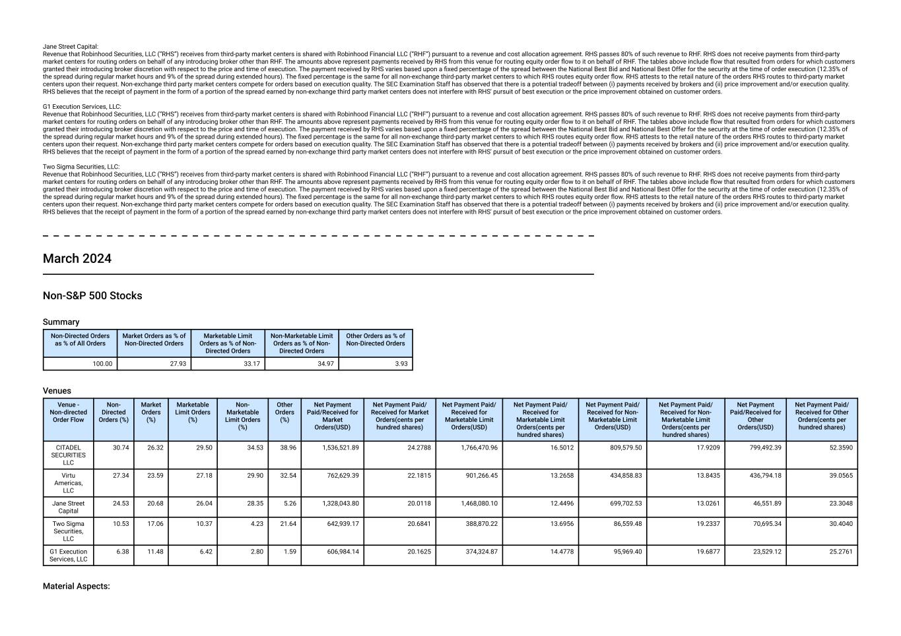
Jane Street Capital: Revenue that Robinhood Securities, LLC (“RHS”) receives from third-party market centers is shared with Robinhood Financial LLC (“RHF”) pursuant to a revenue and cost allocation agreement. RHS passes 80% of such revenue to RHF. RHS does not receive payments from third-party market centers for routing orders on behalf of any introducing broker other than RHF. The amounts above represent payments received by RHS from this venue for routing equity order flow to it on behalf of RHF. The tables above include flow that resulted from orders for which customers granted their introducing broker discretion with respect to the price and time of execution. The payment received by RHS varies based upon a fixed percentage of the spread between the National Best Bid and National Best Offer for the security at the time of order execution (12.35% of the spread during regular market hours and 9% of the spread during extended hours). The fixed percentage is the same for all non-exchange third-party market centers to which RHS routes equity order flow. RHS attests to the retail nature of the orders RHS routes to third-party market centers upon their request. Non-exchange third party market centers compete for orders based on execution quality. The SEC Examination Staff has observed that there is a potential tradeoff between (i) payments received by brokers and (ii) price improvement and/or execution quality. RHS believes that the receipt of payment in the form of a portion of the spread earned by non-exchange third party market centers does not interfere with RHS' pursuit of best execution or the price improvement obtained on customer orders. G1 Execution Services, LLC: Revenue that Robinhood Securities, LLC (“RHS”) receives from third-party market centers is shared with Robinhood Financial LLC (“RHF”) pursuant to a revenue and cost allocation agreement. RHS passes 80% of such revenue to RHF. RHS does not receive payments from third-party market centers for routing orders on behalf of any introducing broker other than RHF. The amounts above represent payments received by RHS from this venue for routing equity order flow to it on behalf of RHF. The tables above include flow that resulted from orders for which customers granted their introducing broker discretion with respect to the price and time of execution. The payment received by RHS varies based upon a fixed percentage of the spread between the National Best Bid and National Best Offer for the security at the time of order execution (12.35% of the spread during regular market hours and 9% of the spread during extended hours). The fixed percentage is the same for all non-exchange third-party market centers to which RHS routes equity order flow. RHS attests to the retail nature of the orders RHS routes to third-party market centers upon their request. Non-exchange third party market centers compete for orders based on execution quality. The SEC Examination Staff has observed that there is a potential tradeoff between (i) payments received by brokers and (ii) price improvement and/or execution quality. RHS believes that the receipt of payment in the form of a portion of the spread earned by non-exchange third party market centers does not interfere with RHS' pursuit of best execution or the price improvement obtained on customer orders. Two Sigma Securities, LLC: Revenue that Robinhood Securities, LLC (“RHS”) receives from third-party market centers is shared with Robinhood Financial LLC (“RHF”) pursuant to a revenue and cost allocation agreement. RHS passes 80% of such revenue to RHF. RHS does not receive payments from third-party market centers for routing orders on behalf of any introducing broker other than RHF. The amounts above represent payments received by RHS from this venue for routing equity order flow to it on behalf of RHF. The tables above include flow that resulted from orders for which customers granted their introducing broker discretion with respect to the price and time of execution. The payment received by RHS varies based upon a fixed percentage of the spread between the National Best Bid and National Best Offer for the security at the time of order execution (12.35% of the spread during regular market hours and 9% of the spread during extended hours). The fixed percentage is the same for all non-exchange third-party market centers to which RHS routes equity order flow. RHS attests to the retail nature of the orders RHS routes to third-party market centers upon their request. Non-exchange third party market centers compete for orders based on execution quality. The SEC Examination Staff has observed that there is a potential tradeoff between (i) payments received by brokers and (ii) price improvement and/or execution quality. RHS believes that the receipt of payment in the form of a portion of the spread earned by non-exchange third party market centers does not interfere with RHS' pursuit of best execution or the price improvement obtained on customer orders. March 2024 Non-S&P 500 Stocks Summary Non-Directed Orders as % of All Orders Market Orders as % of Non-Directed Orders Marketable Limit Orders as % of Non- Directed Orders Non-Marketable Limit Orders as % of Non- Directed Orders Other Orders as % of Non-Directed Orders 100.00 27.93 33.17 34.97 3.93 Venues Venue - Non-directed Order Flow Non- Directed Orders (%) Market Orders (%) Marketable Limit Orders (%) Non- Marketable Limit Orders (%) Other Orders (%) Net Payment Paid/Received for Market Orders(USD) Net Payment Paid/ Received for Market Orders(cents per hundred shares) Net Payment Paid/ Received for Marketable Limit Orders(USD) Net Payment Paid/ Received for Marketable Limit Orders(cents per hundred shares) Net Payment Paid/ Received for Non- Marketable Limit Orders(USD) Net Payment Paid/ Received for Non- Marketable Limit Orders(cents per hundred shares) Net Payment Paid/Received for Other Orders(USD) Net Payment Paid/ Received for Other Orders(cents per hundred shares) CITADEL SECURITIES LLC 30.74 26.32 29.50 34.53 38.96 1,536,521.89 24.2788 1,766,470.96 16.5012 809,579.50 17.9209 799,492.39 52.3590 Virtu Americas, LLC 27.34 23.59 27.18 29.90 32.54 762,629.39 22.1815 901,266.45 13.2658 434,858.83 13.8435 436,794.18 39.0565 Jane Street Capital 24.53 20.68 26.04 28.35 5.26 1,328,043.80 20.0118 1,468,080.10 12.4496 699,702.53 13.0261 46,551.89 23.3048 Two Sigma Securities, LLC 10.53 17.06 10.37 4.23 21.64 642,939.17 20.6841 388,870.22 13.6956 86,559.48 19.2337 70,695.34 30.4040 G1 Execution Services, LLC 6.38 11.48 6.42 2.80 1.59 606,984.14 20.1625 374,324.87 14.4778 95,969.40 19.6877 23,529.12 25.2761 Material Aspects:

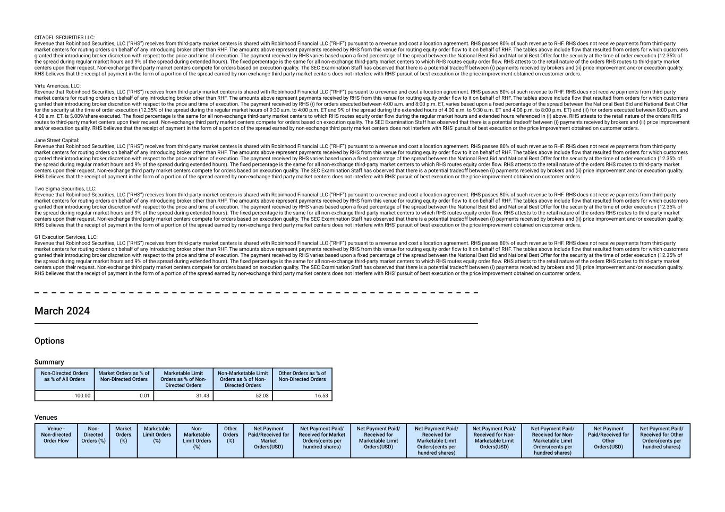
CITADEL SECURITIES LLC: Revenue that Robinhood Securities, LLC (“RHS”) receives from third-party market centers is shared with Robinhood Financial LLC (“RHF”) pursuant to a revenue and cost allocation agreement. RHS passes 80% of such revenue to RHF. RHS does not receive payments from third-party market centers for routing orders on behalf of any introducing broker other than RHF. The amounts above represent payments received by RHS from this venue for routing equity order flow to it on behalf of RHF. The tables above include flow that resulted from orders for which customers granted their introducing broker discretion with respect to the price and time of execution. The payment received by RHS varies based upon a fixed percentage of the spread between the National Best Bid and National Best Offer for the security at the time of order execution (12.35% of the spread during regular market hours and 9% of the spread during extended hours). The fixed percentage is the same for all non-exchange third-party market centers to which RHS routes equity order flow. RHS attests to the retail nature of the orders RHS routes to third-party market centers upon their request. Non-exchange third party market centers compete for orders based on execution quality. The SEC Examination Staff has observed that there is a potential tradeoff between (i) payments received by brokers and (ii) price improvement and/or execution quality. RHS believes that the receipt of payment in the form of a portion of the spread earned by non-exchange third party market centers does not interfere with RHS' pursuit of best execution or the price improvement obtained on customer orders. Virtu Americas, LLC: Revenue that Robinhood Securities, LLC (“RHS”) receives from third-party market centers is shared with Robinhood Financial LLC (“RHF”) pursuant to a revenue and cost allocation agreement. RHS passes 80% of such revenue to RHF. RHS does not receive payments from third-party market centers for routing orders on behalf of any introducing broker other than RHF. The amounts above represent payments received by RHS from this venue for routing equity order flow to it on behalf of RHF. The tables above include flow that resulted from orders for which customers granted their introducing broker discretion with respect to the price and time of execution. The payment received by RHS (i) for orders executed between 4:00 a.m. and 8:00 p.m. ET, varies based upon a fixed percentage of the spread between the National Best Bid and National Best Offer for the security at the time of order execution (12.35% of the spread during the regular market hours of 9:30 a.m. to 4:00 p.m. ET and 9% of the spread during the extended hours of 4:00 a.m. to 9:30 a.m. ET and 4:00 p.m. to 8:00 p.m. ET) and (ii) for orders executed between 8:00 p.m. and 4:00 a.m. ET, is $.009/share executed. The fixed percentage is the same for all non-exchange third-party market centers to which RHS routes equity order flow during the regular market hours and extended hours referenced in (i) above. RHS attests to the retail nature of the orders RHS routes to third-party market centers upon their request. Non-exchange third party market centers compete for orders based on execution quality. The SEC Examination Staff has observed that there is a potential tradeoff between (i) payments received by brokers and (ii) price improvement and/or execution quality. RHS believes that the receipt of payment in the form of a portion of the spread earned by non-exchange third party market centers does not interfere with RHS' pursuit of best execution or the price improvement obtained on customer orders. Jane Street Capital: Revenue that Robinhood Securities, LLC (“RHS”) receives from third-party market centers is shared with Robinhood Financial LLC (“RHF”) pursuant to a revenue and cost allocation agreement. RHS passes 80% of such revenue to RHF. RHS does not receive payments from third-party market centers for routing orders on behalf of any introducing broker other than RHF. The amounts above represent payments received by RHS from this venue for routing equity order flow to it on behalf of RHF. The tables above include flow that resulted from orders for which customers granted their introducing broker discretion with respect to the price and time of execution. The payment received by RHS varies based upon a fixed percentage of the spread between the National Best Bid and National Best Offer for the security at the time of order execution (12.35% of the spread during regular market hours and 9% of the spread during extended hours). The fixed percentage is the same for all non-exchange third-party market centers to which RHS routes equity order flow. RHS attests to the retail nature of the orders RHS routes to third-party market centers upon their request. Non-exchange third party market centers compete for orders based on execution quality. The SEC Examination Staff has observed that there is a potential tradeoff between (i) payments received by brokers and (ii) price improvement and/or execution quality. RHS believes that the receipt of payment in the form of a portion of the spread earned by non-exchange third party market centers does not interfere with RHS' pursuit of best execution or the price improvement obtained on customer orders. Two Sigma Securities, LLC: Revenue that Robinhood Securities, LLC (“RHS”) receives from third-party market centers is shared with Robinhood Financial LLC (“RHF”) pursuant to a revenue and cost allocation agreement. RHS passes 80% of such revenue to RHF. RHS does not receive payments from third-party market centers for routing orders on behalf of any introducing broker other than RHF. The amounts above represent payments received by RHS from this venue for routing equity order flow to it on behalf of RHF. The tables above include flow that resulted from orders for which customers granted their introducing broker discretion with respect to the price and time of execution. The payment received by RHS varies based upon a fixed percentage of the spread between the National Best Bid and National Best Offer for the security at the time of order execution (12.35% of the spread during regular market hours and 9% of the spread during extended hours). The fixed percentage is the same for all non-exchange third-party market centers to which RHS routes equity order flow. RHS attests to the retail nature of the orders RHS routes to third-party market centers upon their request. Non-exchange third party market centers compete for orders based on execution quality. The SEC Examination Staff has observed that there is a potential tradeoff between (i) payments received by brokers and (ii) price improvement and/or execution quality. RHS believes that the receipt of payment in the form of a portion of the spread earned by non-exchange third party market centers does not interfere with RHS' pursuit of best execution or the price improvement obtained on customer orders. G1 Execution Services, LLC: Revenue that Robinhood Securities, LLC (“RHS”) receives from third-party market centers is shared with Robinhood Financial LLC (“RHF”) pursuant to a revenue and cost allocation agreement. RHS passes 80% of such revenue to RHF. RHS does not receive payments from third-party market centers for routing orders on behalf of any introducing broker other than RHF. The amounts above represent payments received by RHS from this venue for routing equity order flow to it on behalf of RHF. The tables above include flow that resulted from orders for which customers granted their introducing broker discretion with respect to the price and time of execution. The payment received by RHS varies based upon a fixed percentage of the spread between the National Best Bid and National Best Offer for the security at the time of order execution (12.35% of the spread during regular market hours and 9% of the spread during extended hours). The fixed percentage is the same for all non-exchange third-party market centers to which RHS routes equity order flow. RHS attests to the retail nature of the orders RHS routes to third-party market centers upon their request. Non-exchange third party market centers compete for orders based on execution quality. The SEC Examination Staff has observed that there is a potential tradeoff between (i) payments received by brokers and (ii) price improvement and/or execution quality. RHS believes that the receipt of payment in the form of a portion of the spread earned by non-exchange third party market centers does not interfere with RHS' pursuit of best execution or the price improvement obtained on customer orders. March 2024 Options Summary Non-Directed Orders as % of All Orders Market Orders as % of Non-Directed Orders Marketable Limit Orders as % of Non- Directed Orders Non-Marketable Limit Orders as % of Non- Directed Orders Other Orders as % of Non-Directed Orders 100.00 0.01 31.43 52.03 16.53 Venues Venue - Non-directed Order Flow Non- Directed Orders (%) Market Orders (%) Marketable Limit Orders (%) Non- Marketable Limit Orders (%) Other Orders (%) Net Payment Paid/Received for Market Orders(USD) Net Payment Paid/ Received for Market Orders(cents per hundred shares) Net Payment Paid/ Received for Marketable Limit Orders(USD) Net Payment Paid/ Received for Marketable Limit Orders(cents per hundred shares) Net Payment Paid/ Received for Non- Marketable Limit Orders(USD) Net Payment Paid/ Received for Non- Marketable Limit Orders(cents per hundred shares) Net Payment Paid/Received for Other Orders(USD) Net Payment Paid/ Received for Other Orders(cents per hundred shares)

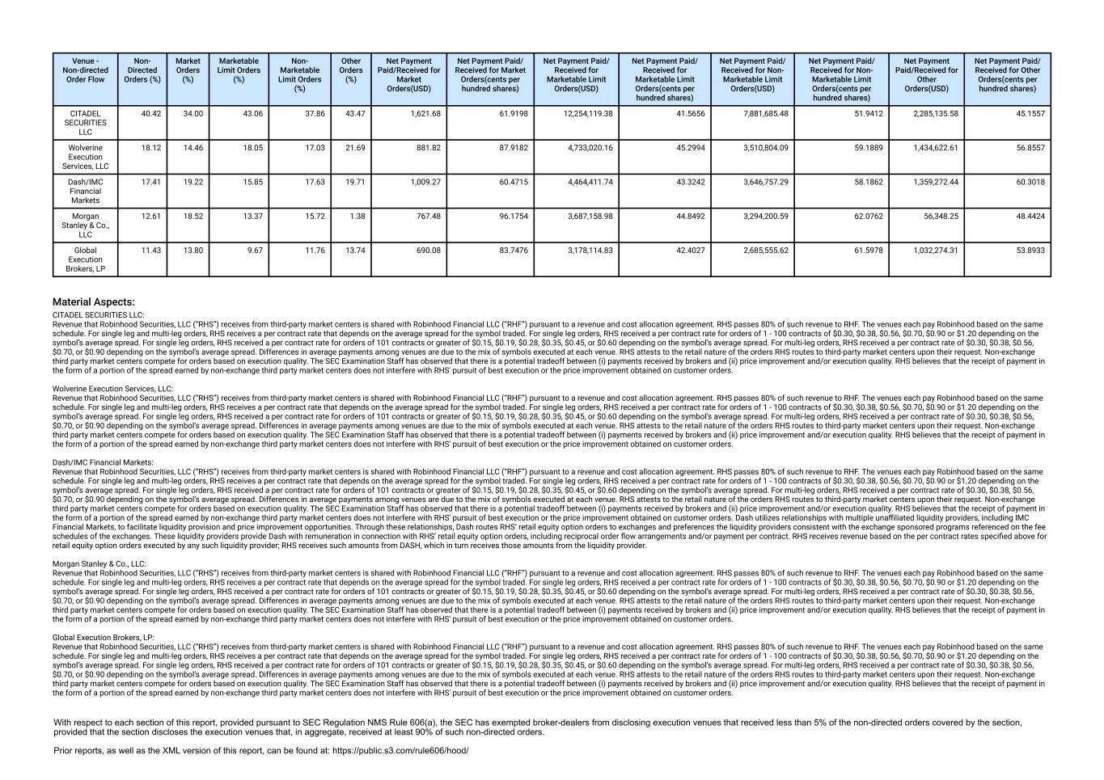
Venue - Non-directed Order Flow Non- Directed Orders (%) Market Orders (%) Marketable Limit Orders (%) Non- Marketable Limit Orders (%) Other Orders (%) Net Payment Paid/Received for Market Orders(USD) Net Payment Paid/ Received for Market Orders(cents per hundred shares) Net Payment Paid/ Received for Marketable Limit Orders(USD) Net Payment Paid/ Received for Marketable Limit Orders(cents per hundred shares) Net Payment Paid/ Received for Non- Marketable Limit Orders(USD) Net Payment Paid/ Received for Non- Marketable Limit Orders(cents per hundred shares) Net Payment Paid/Received for Other Orders(USD) Net Payment Paid/ Received for Other Orders(cents per hundred shares) CITADEL SECURITIES LLC 40.42 34.00 43.06 37.86 43.47 1,621.68 61.9198 12,254,119.38 41.5656 7,881,685.48 51.9412 2,285,135.58 45.1557 Wolverine Execution Services, LLC 18.12 14.46 18.05 17.03 21.69 881.82 87.9182 4,733,020.16 45.2994 3,510,804.09 59.1889 1,434,622.61 56.8557 Dash/IMC Financial Markets 17.41 19.22 15.85 17.63 19.71 1,009.27 60.4715 4,464,411.74 43.3242 3,646,757.29 58.1862 1,359,272.44 60.3018 Morgan Stanley & Co., LLC 12.61 18.52 13.37 15.72 1.38 767.48 96.1754 3,687,158.98 44.8492 3,294,200.59 62.0762 56,348.25 48.4424 Global Execution Brokers, LP 11.43 13.80 9.67 11.76 13.74 690.08 83.7476 3,178,114.83 42.4027 2,685,555.62 61.5978 1,032,274.31 53.8933 Material Aspects: CITADEL SECURITIES LLC: Revenue that Robinhood Securities, LLC (“RHS”) receives from third-party market centers is shared with Robinhood Financial LLC (“RHF”) pursuant to a revenue and cost allocation agreement. RHS passes 80% of such revenue to RHF. The venues each pay Robinhood based on the same schedule. For single leg and multi-leg orders, RHS receives a per contract rate that depends on the average spread for the symbol traded. For single leg orders, RHS received a per contract rate for orders of 1 - 100 contracts of $0.30, $0.38, $0.56, $0.70, $0.90 or $1.20 depending on the symbol’s average spread. For single leg orders, RHS received a per contract rate for orders of 101 contracts or greater of $0.15, $0.19, $0.28, $0.35, $0.45, or $0.60 depending on the symbol’s average spread. For multi-leg orders, RHS received a per contract rate of $0.30, $0.38, $0.56, $0.70, or $0.90 depending on the symbol’s average spread. Differences in average payments among venues are due to the mix of symbols executed at each venue. RHS attests to the retail nature of the orders RHS routes to third-party market centers upon their request. Non-exchange third party market centers compete for orders based on execution quality. The SEC Examination Staff has observed that there is a potential tradeoff between (i) payments received by brokers and (ii) price improvement and/or execution quality. RHS believes that the receipt of payment in the form of a portion of the spread earned by non-exchange third party market centers does not interfere with RHS' pursuit of best execution or the price improvement obtained on customer orders. Wolverine Execution Services, LLC: Revenue that Robinhood Securities, LLC (“RHS”) receives from third-party market centers is shared with Robinhood Financial LLC (“RHF”) pursuant to a revenue and cost allocation agreement. RHS passes 80% of such revenue to RHF. The venues each pay Robinhood based on the same schedule. For single leg and multi-leg orders, RHS receives a per contract rate that depends on the average spread for the symbol traded. For single leg orders, RHS received a per contract rate for orders of 1 - 100 contracts of $0.30, $0.38, $0.56, $0.70, $0.90 or $1.20 depending on the symbol’s average spread. For single leg orders, RHS received a per contract rate for orders of 101 contracts or greater of $0.15, $0.19, $0.28, $0.35, $0.45, or $0.60 depending on the symbol’s average spread. For multi-leg orders, RHS received a per contract rate of $0.30, $0.38, $0.56, $0.70, or $0.90 depending on the symbol’s average spread. Differences in average payments among venues are due to the mix of symbols executed at each venue. RHS attests to the retail nature of the orders RHS routes to third-party market centers upon their request. Non-exchange third party market centers compete for orders based on execution quality. The SEC Examination Staff has observed that there is a potential tradeoff between (i) payments received by brokers and (ii) price improvement and/or execution quality. RHS believes that the receipt of payment in the form of a portion of the spread earned by non-exchange third party market centers does not interfere with RHS' pursuit of best execution or the price improvement obtained on customer orders. Dash/IMC Financial Markets: Revenue that Robinhood Securities, LLC (“RHS”) receives from third-party market centers is shared with Robinhood Financial LLC (“RHF”) pursuant to a revenue and cost allocation agreement. RHS passes 80% of such revenue to RHF. The venues each pay Robinhood based on the same schedule. For single leg and multi-leg orders, RHS receives a per contract rate that depends on the average spread for the symbol traded. For single leg orders, RHS received a per contract rate for orders of 1 - 100 contracts of $0.30, $0.38, $0.56, $0.70, $0.90 or $1.20 depending on the symbol’s average spread. For single leg orders, RHS received a per contract rate for orders of 101 contracts or greater of $0.15, $0.19, $0.28, $0.35, $0.45, or $0.60 depending on the symbol’s average spread. For multi-leg orders, RHS received a per contract rate of $0.30, $0.38, $0.56, $0.70, or $0.90 depending on the symbol’s average spread. Differences in average payments among venues are due to the mix of symbols executed at each venue. RHS attests to the retail nature of the orders RHS routes to third-party market centers upon their request. Non-exchange third party market centers compete for orders based on execution quality. The SEC Examination Staff has observed that there is a potential tradeoff between (i) payments received by brokers and (ii) price improvement and/or execution quality. RHS believes that the receipt of payment in the form of a portion of the spread earned by non-exchange third party market centers does not interfere with RHS' pursuit of best execution or the price improvement obtained on customer orders. Dash utilizes relationships with multiple unaffiliated liquidity providers, including IMC Financial Markets, to facilitate liquidity provision and price improvement opportunities. Through these relationships, Dash routes RHS’ retail equity option orders to exchanges and preferences the liquidity providers consistent with the exchange sponsored programs referenced on the fee schedules of the exchanges. These liquidity providers provide Dash with remuneration in connection with RHS’ retail equity option orders, including reciprocal order flow arrangements and/or payment per contract. RHS receives revenue based on the per contract rates specified above for retail equity option orders executed by any such liquidity provider; RHS receives such amounts from DASH, which in turn receives those amounts from the liquidity provider. Morgan Stanley & Co., LLC: Revenue that Robinhood Securities, LLC (“RHS”) receives from third-party market centers is shared with Robinhood Financial LLC (“RHF”) pursuant to a revenue and cost allocation agreement. RHS passes 80% of such revenue to RHF. The venues each pay Robinhood based on the same schedule. For single leg and multi-leg orders, RHS receives a per contract rate that depends on the average spread for the symbol traded. For single leg orders, RHS received a per contract rate for orders of 1 - 100 contracts of $0.30, $0.38, $0.56, $0.70, $0.90 or $1.20 depending on the symbol’s average spread. For single leg orders, RHS received a per contract rate for orders of 101 contracts or greater of $0.15, $0.19, $0.28, $0.35, $0.45, or $0.60 depending on the symbol’s average spread. For multi-leg orders, RHS received a per contract rate of $0.30, $0.38, $0.56, $0.70, or $0.90 depending on the symbol’s average spread. Differences in average payments among venues are due to the mix of symbols executed at each venue. RHS attests to the retail nature of the orders RHS routes to third-party market centers upon their request. Non-exchange third party market centers compete for orders based on execution quality. The SEC Examination Staff has observed that there is a potential tradeoff between (i) payments received by brokers and (ii) price improvement and/or execution quality. RHS believes that the receipt of payment in the form of a portion of the spread earned by non-exchange third party market centers does not interfere with RHS' pursuit of best execution or the price improvement obtained on customer orders. Global Execution Brokers, LP: Revenue that Robinhood Securities, LLC (“RHS”) receives from third-party market centers is shared with Robinhood Financial LLC (“RHF”) pursuant to a revenue and cost allocation agreement. RHS passes 80% of such revenue to RHF. The venues each pay Robinhood based on the same schedule. For single leg and multi-leg orders, RHS receives a per contract rate that depends on the average spread for the symbol traded. For single leg orders, RHS received a per contract rate for orders of 1 - 100 contracts of $0.30, $0.38, $0.56, $0.70, $0.90 or $1.20 depending on the symbol’s average spread. For single leg orders, RHS received a per contract rate for orders of 101 contracts or greater of $0.15, $0.19, $0.28, $0.35, $0.45, or $0.60 depending on the symbol’s average spread. For multi-leg orders, RHS received a per contract rate of $0.30, $0.38, $0.56, $0.70, or $0.90 depending on the symbol’s average spread. Differences in average payments among venues are due to the mix of symbols executed at each venue. RHS attests to the retail nature of the orders RHS routes to third-party market centers upon their request. Non-exchange third party market centers compete for orders based on execution quality. The SEC Examination Staff has observed that there is a potential tradeoff between (i) payments received by brokers and (ii) price improvement and/or execution quality. RHS believes that the receipt of payment in the form of a portion of the spread earned by non-exchange third party market centers does not interfere with RHS' pursuit of best execution or the price improvement obtained on customer orders.

