SEC Form 4
FORM 4 |  | UNITED STATES SECURITIES AND EXCHANGE COMMISSION  Washington, D.C. 20549  STATEMENT OF CHANGES IN BENEFICIAL OWNERSHIP  Filed pursuant to Section 16(a) of the Securities Exchange Act of 1934  or Section 30(h) of the Investment Company Act of 1940
  OMB APPROVAL
  OMB Number: | 3235-0287
  Estimated average burden
  hours per response: | 0.5
 | Check this box if no longer subject to Section 16. Form 4 or Form 5 obligations may continue. See Instruction 1(b).
 | Check this box to indicate that a transaction was made pursuant to a contract, instruction or written plan for the purchase or sale of equity securities of the issuer that is intended to satisfy the affirmative defense conditions of Rule 10b5-1(c). See Instruction 10.
1. Name and Address of Reporting Person*  (Street) | 2. Issuer Name and Ticker or Trading Symbol  Robinhood Markets, Inc. [ HOOD ]  Foreign Trading Symbol | 5. Relationship of Reporting Person(s) to Issuer  (Check all applicable)
  Quirk Steven M.
  (Last) | (First) | (Middle)
  C/O ROBINHOOD MARKETS, INC.
  85 WILLOW ROAD
  MENLO PARK | CA | 94025
  (City) | (State) | (Zip)
   | Director |  | 10% Owner
   | Officer (give title below) |  | Other (specify below)
  Chief Brokerage Officer
3. Date of Earliest Transaction (Month/Day/Year)
09/01/2026
 | 4. If Amendment, Date of Original Filed (Month/Day/Year) | 6. Individual or Joint/Group Filing (Check Applicable Line)
  Form filed by One Reporting Person
  Form filed by More than One Reporting Person
Table I - Non-Derivative Securities Acquired, Disposed of, or Beneficially Owned
1. Title of Security (Instr. 3) | 2. Transaction Date (Month/Day/Year) | 2A. Deemed Execution Date, if any (Month/Day/Year) | 3. Transaction Code (Instr. 8) |  | 4. Securities Acquired (A) or Disposed Of (D) (Instr. 3, 4 and 5) |  |  | 5. Amount of Securities Beneficially Owned Following Reported Transaction(s) (Instr. 3 and 4) | 6. Ownership Form: Direct (D) or Indirect (I) (Instr. 4) | 7. Nature of Indirect Beneficial Ownership (Instr. 4)
1. Title of Security (Instr. 3) | 2. Transaction Date (Month/Day/Year) | 2A. Deemed Execution Date, if any (Month/Day/Year) | Code | V | Amount | (A) or (D) | Price |  | 6. Ownership Form: Direct (D) or Indirect (I) (Instr. 4) | 7. Nature of Indirect Beneficial Ownership (Instr. 4)
Class A Common Stock | 09/01/2026 |  | M |  | 71,176 | A | (1) | 133,788 | D
Class A Common Stock | 09/01/2026 |  | F |  | 31,533(2) | D | $104.81 | 102,255 | D
Table II - Derivative Securities Acquired, Disposed of, or Beneficially Owned
(e.g., puts, calls, warrants, options, convertible securities)
1. Title of Derivative Security (Instr. 3) | 2. Conversion or Exercise Price of Derivative Security | 3. Transaction Date (Month/Day/Year) | 3A. Deemed Execution Date, if any (Month/Day/Year) | 4. Transaction Code (Instr. 8) |  | 5. Number of Derivative Securities Acquired (A) or Disposed of (D) (Instr. 3, 4 and 5) |  | 6. Date Exercisable and Expiration Date (Month/Day/Year) |  | 7. Title and Amount of Securities Underlying Derivative Security (Instr. 3 and 4) |  | 8. Price of Derivative Security (Instr. 5) | 9. Number of derivative Securities Beneficially Owned Following Reported Transaction(s) (Instr. 4) | 10. Ownership Form: Direct (D) or Indirect (I) (Instr. 4) | 11. Nature of Indirect Beneficial Ownership (Instr. 4)
 |  |  |  | Code | V | (A) | (D) | Date Exercisable | Expiration Date | Title | Amount or Number of Shares
Restricted Stock Units | (1) | 09/01/2026 |  | M |  |  | 27,995 | (3) | (3) | Class A Common Stock | 27,995 | $0 | 55,992 | D
Restricted Stock Units | (1) | 09/01/2026 |  | M |  |  | 16,838 | (4) | (4) | Class A Common Stock | 16,838 | $0 | 101,024 | D
Restricted Stock Units | (1) | 09/01/2026 |  | M |  |  | 16,497 | (5) | (5) | Class A Common Stock | 16,497 | $0 | 164,972 | D
Restricted Stock Units | (1) | 09/01/2026 |  | M |  |  | 9,846 | (6) | (6) | Class A Common Stock | 9,846 | $0 | 137,847 | D
Explanation of Responses:
1. Restricted stock units ("RSUs") convert into Class A Common Stock on a one-for-one basis upon vesting and settlement.
2. Represents shares withheld by Robinhood Markets, Inc. ("Robinhood") to satisfy tax withholding obligations in connection with the vesting and settlement of 71,176 RSUs and does not represent a sale by the Reporting Person.
3. On March 22, 2023, the Reporting Person was granted 447,929 RSUs under Robinhood's 2021 Omnibus Incentive Plan (the "2021 Plan"). One-sixteenth (1/16) of these RSUs vested on June 1, 2023, with the remainder scheduled to vest in fifteen (15) equal quarterly installments thereafter, in each case subject to the Reporting Person's continued service with Robinhood through the applicable vesting date and subject to accelerated vesting in certain circumstances.
4. On March 20, 2024, the Reporting Person was granted 269,397 RSUs under the 2021 Plan. One-sixteenth (1/16) of these RSUs vested on June 1, 2024, with the remainder scheduled to vest in fifteen (15) equal quarterly installments thereafter, in each case subject to the Reporting Person's continued service with Robinhood through the applicable vesting date and subject to accelerated vesting in certain circumstances.
5. On March 20, 2025, the Reporting Person was granted 263,954 RSUs under the 2021 Plan. One-sixteenth (1/16) of these RSUs vested on June 1, 2025, with the remainder scheduled to vest in fifteen (15) equal quarterly installments thereafter, in each case subject to the Reporting Person's continued service with Robinhood through the applicable vesting date and subject to accelerated vesting in certain circumstances.
6. On March 19, 2026, the Reporting Person was granted 157,539 RSUs under the 2021 Plan. One-sixteenth (1/16) of these RSUs vested on June 1, 2026, with the remainder scheduled to vest in fifteen (15) equal quarterly installments thereafter, in each case subject to the Reporting Person's continued service with Robinhood through the applicable vesting date and subject to accelerated vesting in certain circumstances.
Remarks:
Exhibit 24 - Power of Attorney
 | /s/ Maureen Montgomery, attorney-in-fact for Steven M. Quirk | 09/03/2026
 | ** Signature of Reporting Person | Date
Reminder: Report on a separate line for each class of securities beneficially owned directly or indirectly.
* If the form is filed by more than one reporting person, see Instruction 4 (b)(v).
** Intentional misstatements or omissions of facts constitute Federal Criminal Violations See 18 U.S.C. 1001 and 15 U.S.C. 78ff(a).
Note: File three copies of this Form, one of which must be manually signed. If space is insufficient, see Instruction 6 for procedure.
Persons who respond to the collection of information contained in this form are not required to respond unless the form displays a currently valid OMB Number.
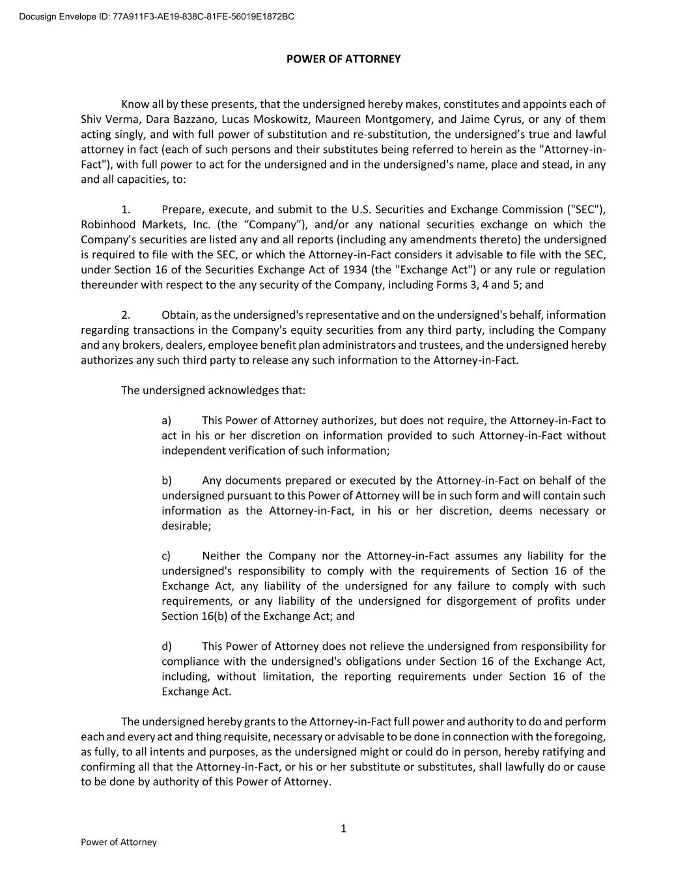
1 Power of Attorney POWER OF ATTORNEY Know all by these presents, that the undersigned hereby makes, constitutes and appoints each of Shiv Verma, Dara Bazzano, Lucas Moskowitz, Maureen Montgomery, and Jaime Cyrus, or any of them acting singly, and with full power of substitution and re-substitution, the undersigned’s true and lawful attorney in fact (each of such persons and their substitutes being referred to herein as the "Attorney-in- Fact"), with full power to act for the undersigned and in the undersigned's name, place and stead, in any and all capacities, to: 1. Prepare, execute, and submit to the U.S. Securities and Exchange Commission ("SEC"), Robinhood Markets, Inc. (the “Company”), and/or any national securities exchange on which the Company’s securities are listed any and all reports (including any amendments thereto) the undersigned is required to file with the SEC, or which the Attorney-in-Fact considers it advisable to file with the SEC, under Section 16 of the Securities Exchange Act of 1934 (the "Exchange Act") or any rule or regulation thereunder with respect to the any security of the Company, including Forms 3, 4 and 5; and 2. Obtain, as the undersigned's representative and on the undersigned's behalf, information regarding transactions in the Company's equity securities from any third party, including the Company and any brokers, dealers, employee benefit plan administrators and trustees, and the undersigned hereby authorizes any such third party to release any such information to the Attorney-in-Fact. The undersigned acknowledges that: a) This Power of Attorney authorizes, but does not require, the Attorney-in-Fact to act in his or her discretion on information provided to such Attorney-in-Fact without independent verification of such information; b) Any documents prepared or executed by the Attorney-in-Fact on behalf of the undersigned pursuant to this Power of Attorney will be in such form and will contain such information as the Attorney-in-Fact, in his or her discretion, deems necessary or desirable; c) Neither the Company nor the Attorney-in-Fact assumes any liability for the undersigned's responsibility to comply with the requirements of Section 16 of the Exchange Act, any liability of the undersigned for any failure to comply with such requirements, or any liability of the undersigned for disgorgement of profits under Section 16(b) of the Exchange Act; and d) This Power of Attorney does not relieve the undersigned from responsibility for compliance with the undersigned's obligations under Section 16 of the Exchange Act, including, without limitation, the reporting requirements under Section 16 of the Exchange Act. The undersigned hereby grants to the Attorney-in-Fact full power and authority to do and perform each and every act and thing requisite, necessary or advisable to be done in connection with the foregoing, as fully, to all intents and purposes, as the undersigned might or could do in person, hereby ratifying and confirming all that the Attorney-in-Fact, or his or her substitute or substitutes, shall lawfully do or cause to be done by authority of this Power of Attorney. Docusign Envelope ID: 77A911F3-AE19-838C-81FE-56019E1872BC

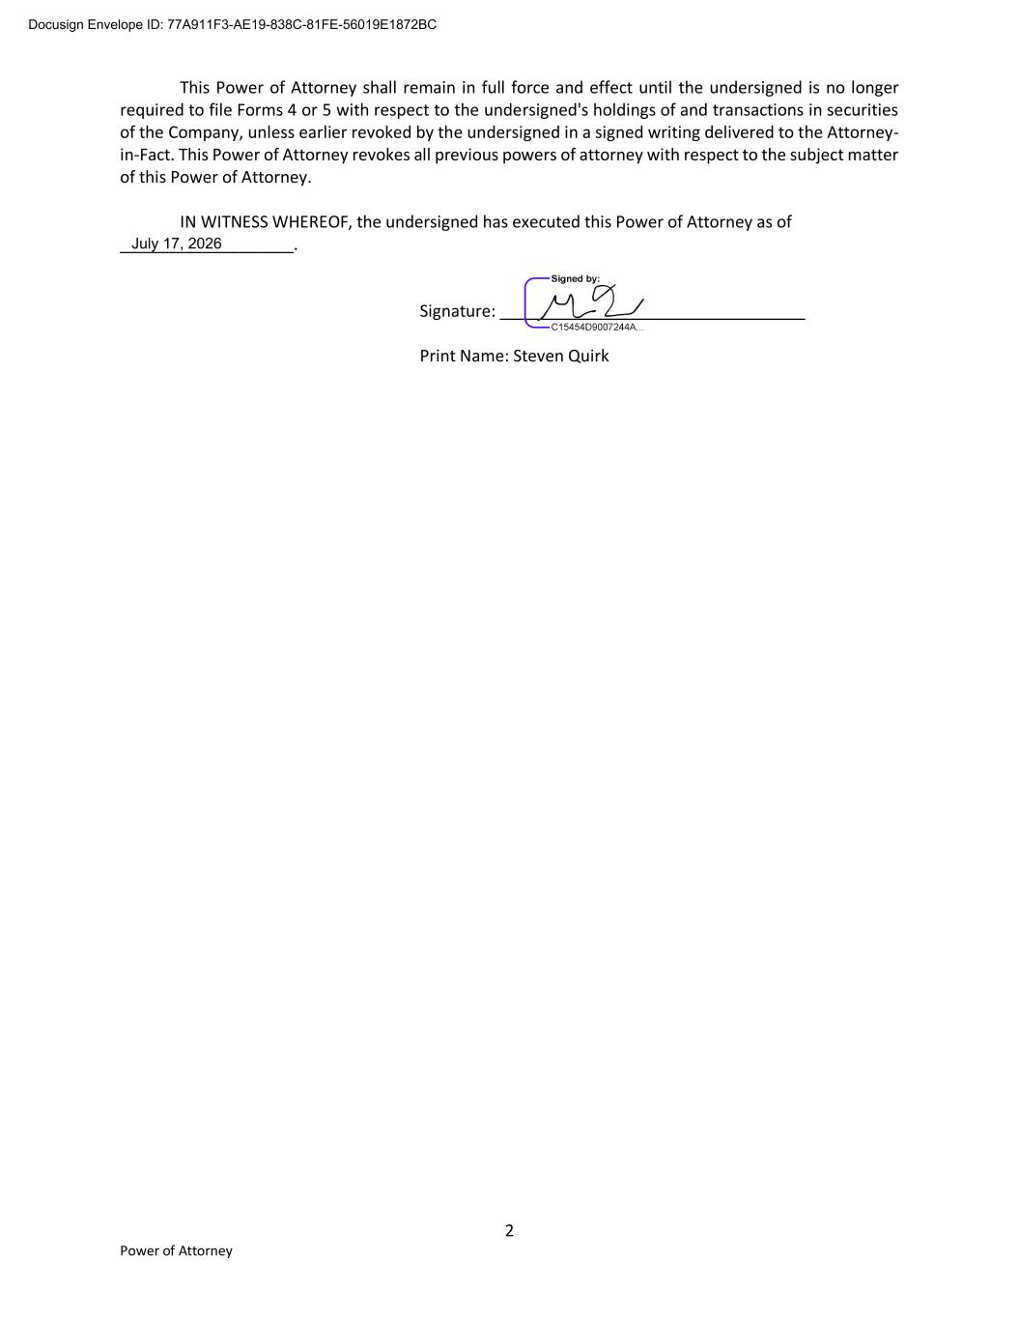
2 Power of Attorney This Power of Attorney shall remain in full force and effect until the undersigned is no longer required to file Forms 4 or 5 with respect to the undersigned's holdings of and transactions in securities of the Company, unless earlier revoked by the undersigned in a signed writing delivered to the Attorney- in-Fact. This Power of Attorney revokes all previous powers of attorney with respect to the subject matter of this Power of Attorney. IN WITNESS WHEREOF, the undersigned has executed this Power of Attorney as of ___________________. Signature: _________________________________ Print Name: Steven Quirk Docusign Envelope ID: 77A911F3-AE19-838C-81FE-56019E1872BC July 17, 2026

